**(Emi) Nami’s younger sister**

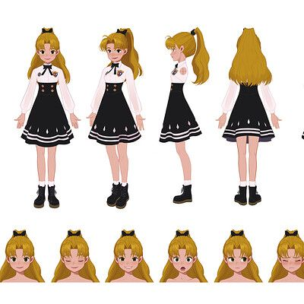

**(Ren) Nami and Emi’s father**

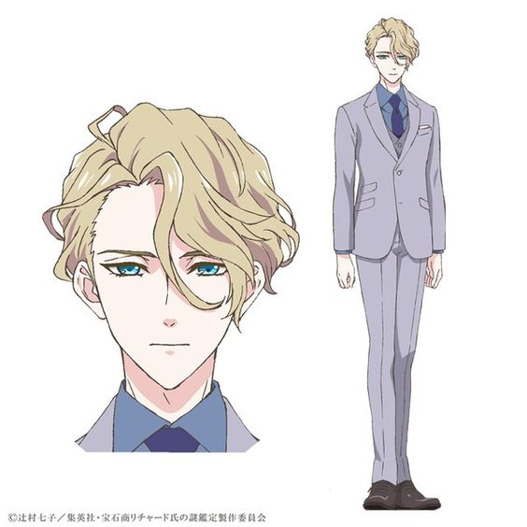

**Kenji - Shin’s childhood best friend (Male)**

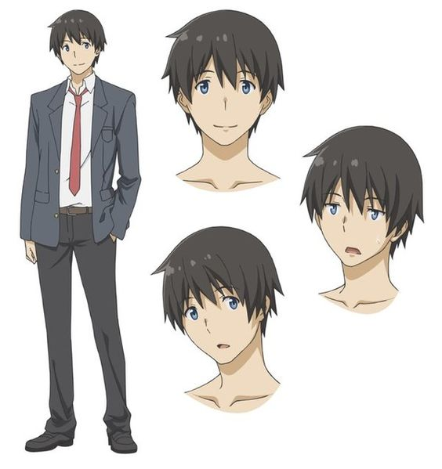

**Chiyo - Kenji’s younger sister**

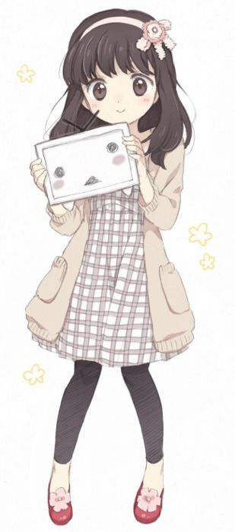

**Kenzo - Kenji and Chiyo’s father (the director of the only hospital in Sado)**

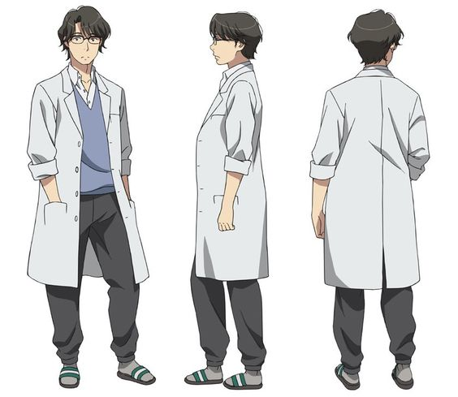

**Lekra Sato- A young boy**

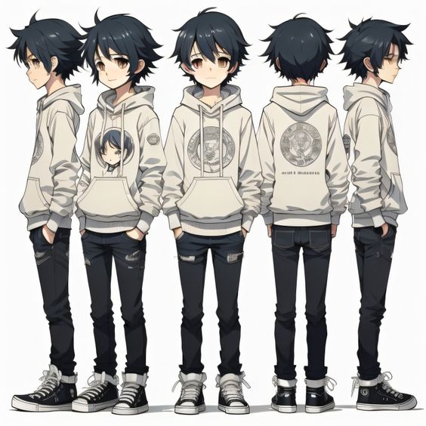

**Akira Sato - Lekra’s mother**

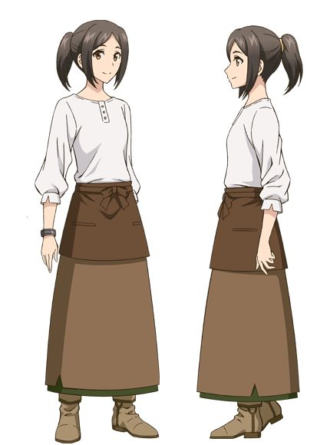

**Kairi Sato- Lekra’s father**

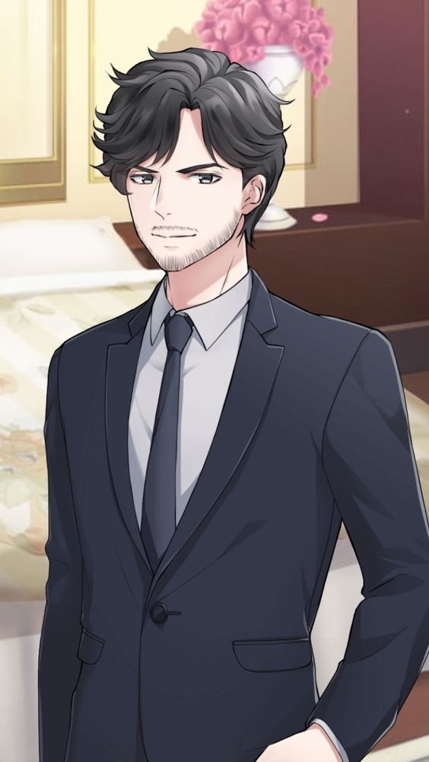

**Amaya - A Mysterious Woman (a girl with eyeglasses)**

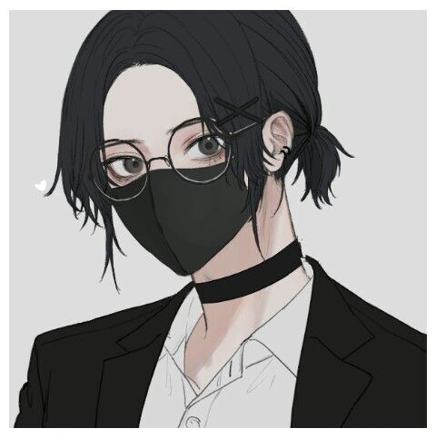

**Daisuke - An elderly hunter who carries a rifle (Male)**

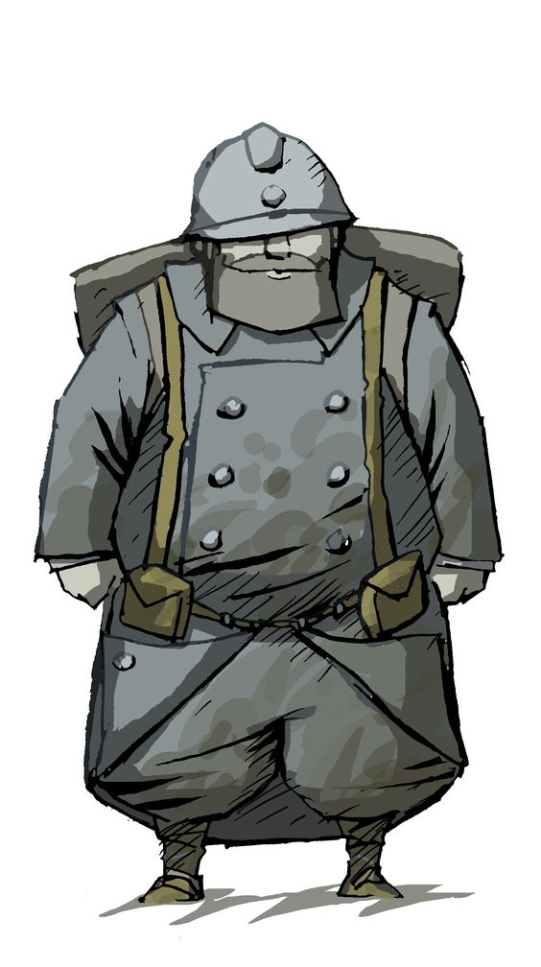

**Haruto - Police Officer (Male)**

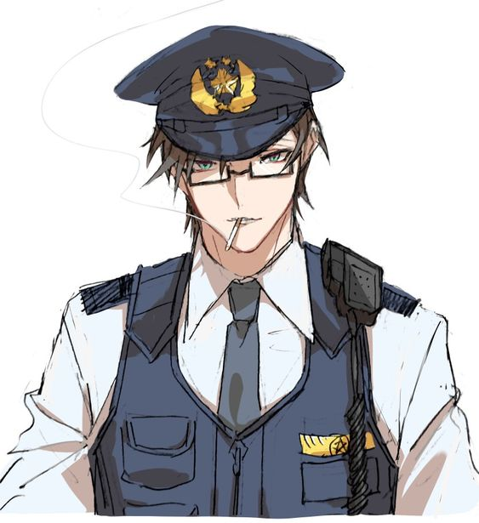

**Fuji - Chief Priest (Male)**

