James Taylor

Exercise 6

**Introduction**

The dependent variable is called ‘class’. It represents if a patient’s spine is considered normal or abnormal (Disk Hernia or Spondylolisthesis). The independent variables are pelvic incidence, pelvic tilt, lumbar lordosis angle, sacral slope, pelvic radius and grade of spondylolisthesis. These are different measures of spine and pelvis.

I expect the neural network to be trained on the training set and with reasonable accuracy (certainly better than chance) predict which observations have normal and abnormal spines.

**Preprocessing**

The neural network need all input variables to have the same scale.

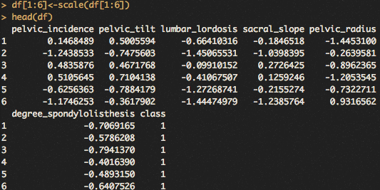

Above shows the output, looking like all variables have the same scale.

**Split Data**

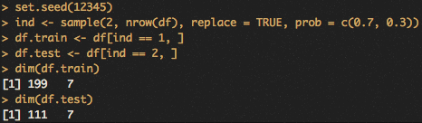

Above is splitting the data into training and test sets. This is to test the accuracy of the model on observations it has not seen before. This is testing the model in a way that it will be used in the real world.

**Run Model**

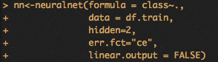

Above is how the model was trained on training data. All independent variables were utilized. The formula parameter specifies which variables are used. The data variable specifies the source of the data. The hidden variable has how many hidden layers and nodes, so this has one hidden layer with 2 nodes. Linear output is false because our dependent variable is for classification.

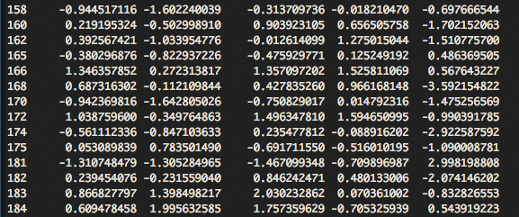

Above is a sample of the output of the nn. It is very large.

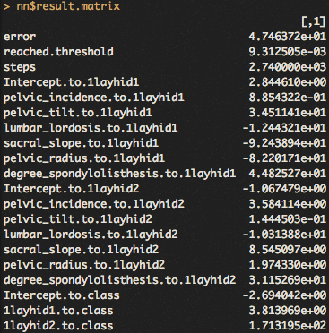

Above show the amount of error, reach thresholds and number of steps. It also show the weights at the hidden nodes.

../../Desktop/6.png

The above are the likelihood of the first 10 observations being abnormal based on the model. The above are likely abnormal.

**Network Visualizations**

**../../Desktop/7.png**

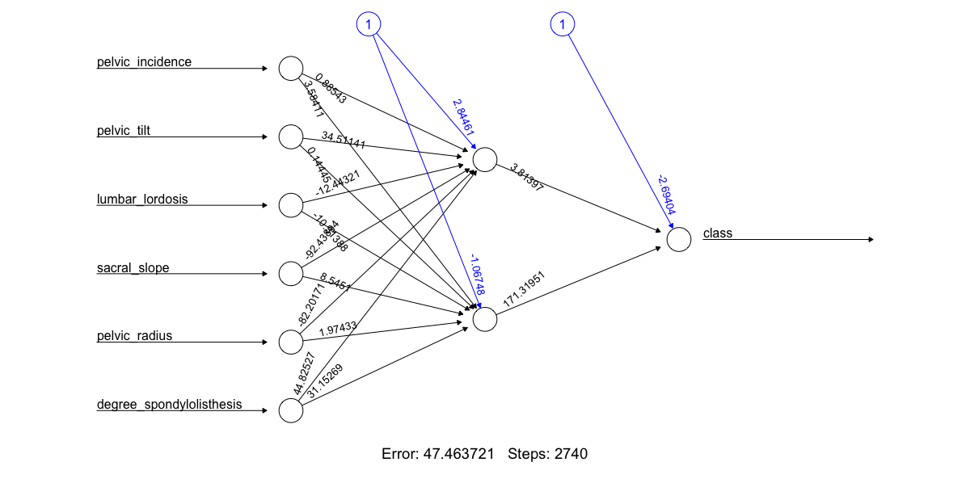

The above is the plot of the model. It takes in an observation’s variables on the left, applies the weights to them to return a value similar to the categorical value.

**Confusion Matrix**

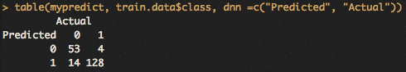

The above is a confusion matrix on the predictions. It rounded marked 128 abnormal patients correctly and 53 normal patients correctly. It made 18 incorrect predictions.

**Confusion Matrix**

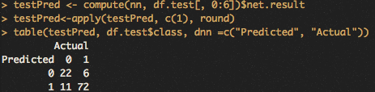

Above is the confusion matrix on the test data. The model on the test data was about 5% less accurate than on the train data (90% compared to 85%).

**Different Parameters**

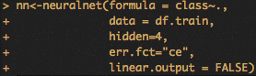

Above is the new neural network with 4 hidden nodes.

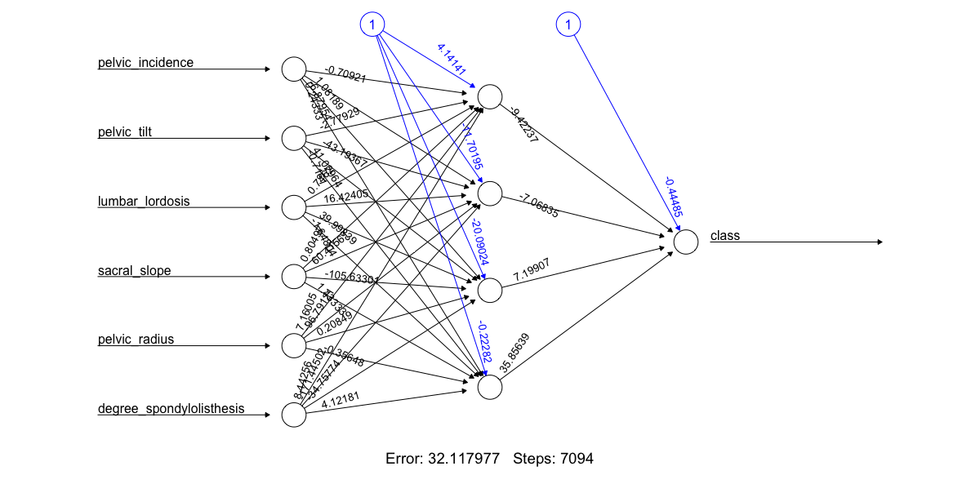

Above is the plot of the neural network.

The model with 4 hidden nodes has a confusion matrix on the train data below. 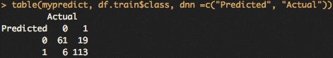

It has an accuracy of 87%.

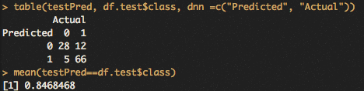

The above is a confusion matrix on the test data. The environment accidentally got reset, so the two models did not have the exact same observations in their train/test datasets. The accuracy on the test data was nearly the same as the previous model.

**Summary**

Neural network has nodes and layers like a decision tree but it returns a probability unlike a decision tree. The most challenging part of the assignment was interpreting the outputs of the model. All the weights and layers and what they mean were new and different.