James Taylor

Assignment 4

University of Maryland University College

DATA650-9041 Spring 2021

Dr. Gortcheva

jtaylor380@student.umgc.edu

**Introduction**

­­­The purpose of this chat-bot is to help people determine if they may have Lyme disease. Lyme disease is a bacterial infection that is mostly introduced to humans by a tick bite. Gone untreated, it often causes damage to the nervous system, joints and heart. This chat bot is for people who already suspect they have Lyme and have at least one symptom. The users will talk about their symptoms and be shown other symptoms they may have if Lyme is present. End users will benefit by getting instant advice on when their symptom(s) are a serious concern. Users won’t have to research on their own or visit a physician for advice. This can also easy demand on the medical system as the bot would answer some questions for users, meaning those users won’t have to visit a clinic/hospital for answers. It acts like a screening questionnaire in that way.

The figure below is a diagram of how the chat-bot works. The recommendations the chat-bot ultimately give are to either go to a physician or monitor your health and go if another Lyme symptom appears. Square nodes are things the chat-bot asks for or says. Circular nodes are what the chat-bot detects in the user’s answer.

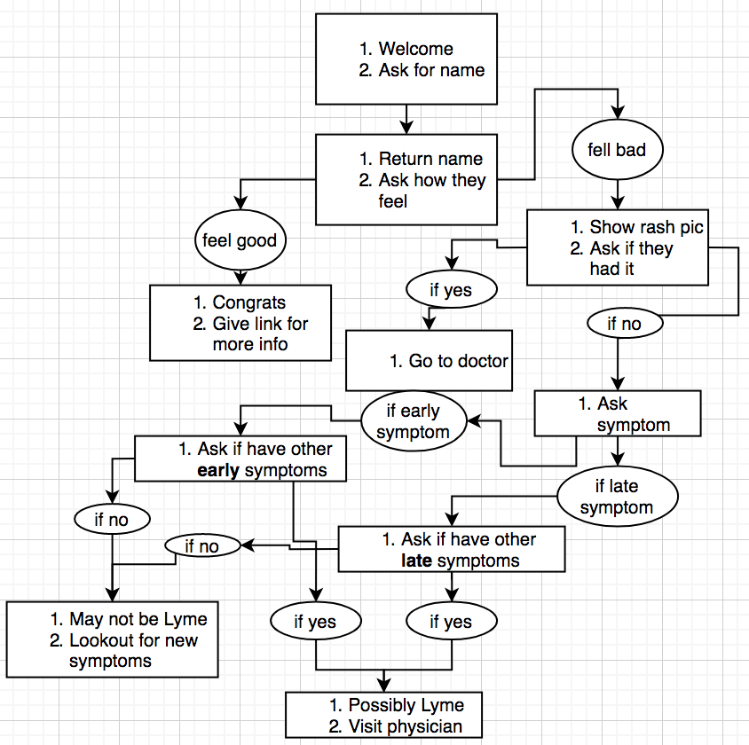

**Implementation**

The chat-bot welcomes the user and asks their name. Their name is stored in a variable. The ask how the user is feeling and returns their inputted name in the question. The chat-bot tries to categories the user’s response into feeling good or feeling bad, two intents of the model. If the chat-bot detects the user’s input as they feel good, then the chat is ended and more Lyme info is outputted. If the user’s input looks like they feel bad, the chat-bot moves on.

A rash is common in Lyme disease where the tick bite happened. Since the user suspects they have Lyme and feels ill, a picture of this rash is shown. This rash occurs in 70-80% of Lyme cases. The user see the rash picture and is asked if they have seen the rash recently on their body. If the user had they are directed to visit a physician because the rash is highly correlated with Lyme disease. If the user hadn’t the chat-moves onto symptoms.

The chat-bot ask the user to write give a symptom they are having. The bot categorizes the symptom based on early and late Lyme disease. These are based on the CDC listed symptoms with early being the first 30 days and late after that. Early and late symptoms are two separate entities with their symptoms listed as its values. If the input provided does not fit either an early or late symptom the chat-bot will ask them to rephrase it.

Once the user inputs something that is recognized as an early or late symptom, the bot will ask the user if they have other symptoms. If a user’s input was detected to be an early symptom, the bot asks if the user has other symptoms that can arise in the early phases of Lyme (symptoms sourced from CDC). The same is true if the user entered a late symptom, they would be asked if they have other late Lyme symptoms.

If the user says they have multiple symptoms from the list provided (either early or late depending on their initially entered symptom), they are directed to visit a physician. Because they are showing more than one sign of Lyme it is possible the user has it. If the user says they don’t have any of the other symptoms listed (meaning they only have the one symptom they inputted earlier), the bot recommends they pay attention to their health but not to go to a physician yet. One symptom is not evidence enough for the bot to recommend going to a doctor.

**Intents and Entities**

The intents used were to determine if the user felt good or bad when asked. Examples were thing like “bad”, “good”, “I feel bad”, “I feel normal”, “I’m not good” and some others. The entities used were to determine if the symptom the user inputted was an early or late symptom. The synonyms were the symptoms that were noted on the CDC website on Lyme disease and their own synonyms. For example, dizziness was a late Lyme symptom, so “dizziness” and “dizzy” were both used as synonyms of late Lyme entity. Another example is “arthritis” and “joint pain”.

**Using the chat-bot**

The chat-bot asked pointed questions. It should be able to recognize instances when the user responds in a way not related to the question. One example is below, where the user enters a input that does not fit into feeling good, feeling bad or goodbye intent it asks for rephrasing. Once the bot detects a response that fit into one of those three intents it moves on to another node. The goal of asking specific questions is to make it obvious what the bot is looking for, thus reducing the error rate.

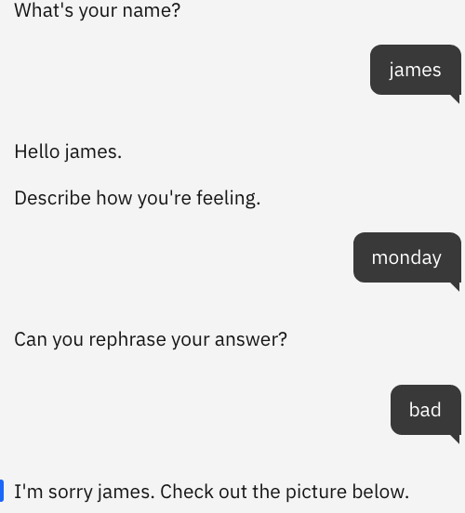

When the skills search was included in the chat-bot it started handling erroneous inputs differently. For example, when the user is prompted for a symptom they are having they have to enter a symptom that is recognized by the bot as either early or late Lyme. The user will be asked to rephrase until a Lyme symptom is entered. After the search skill was introduced, if a symptom not early or late Lyme is inputted it returns its searches on the CDC website on Lyme even when there is no search skill in that node. It may not be all that bad since the user can find more info on the possible symptom they are having from the CDC (they may have a rare but recognizable symptom), but it isn’t working as I had envisioned.

**Watson Discovery**

The reason for the search skill is to access much more information rather than the information the designer can give. There just abut no way a designer of this sort of Lyme chat-bot could design the chat-bot to handle every instance for every user perfectly. It is too complex and complicated. To alleviate this, the search skill provides links to relevant websites that contain information about what the user may be talking about. It leverages the vast amounts of information on the internet and lets it be accessible through the bot.

To make the search skill more useful, it can be specified which URLs it will scan. That way, for our example, it will only be looking at Lyme disease and not others like Rocky Mountain Spotted Fever or Tularemia. The search skill can also look for specific things related to a topic within the URLs, like symptoms or treatment.

**Conversation Trial – Day 1**

Below is a screenshot of the Overview of the chat-bot analytics.

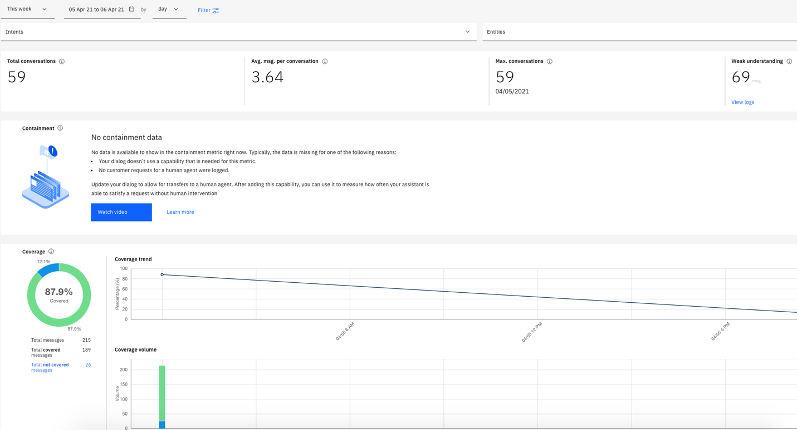

The issue of unrecognized intents and entities was mostly not from users answering the questions posed to the Bot. It mostly comes from users talking about something else or asking the bot an unrelated question. Many of the users asked the bot questions following the recommendation. These were questions like how soon they should visit the doctor, is a rash a problem and how dangerous is Lyme. These questions should be well-handled by the search skill. The CDC website certainly has information on these topics. The was one example that should have been detected was the user’s input to the symptoms. Their response was “the usual aches and pains” which went unrecognized. This is a regular expression that should have been recognized. This answer is handled later in the conversation however, because the bot talks about ‘unexplained symptoms’. This is to handle scenarios where someone has fatigue as a symptom but ran 10 miles they day before. The symptom can likely be explained by the exercise making Lyme a less likely explanation. The usual ‘aches and pains’ can be explained away in this way, making it apparent these aren’t likely Lyme related.

**Conversation Trial – Day 2**

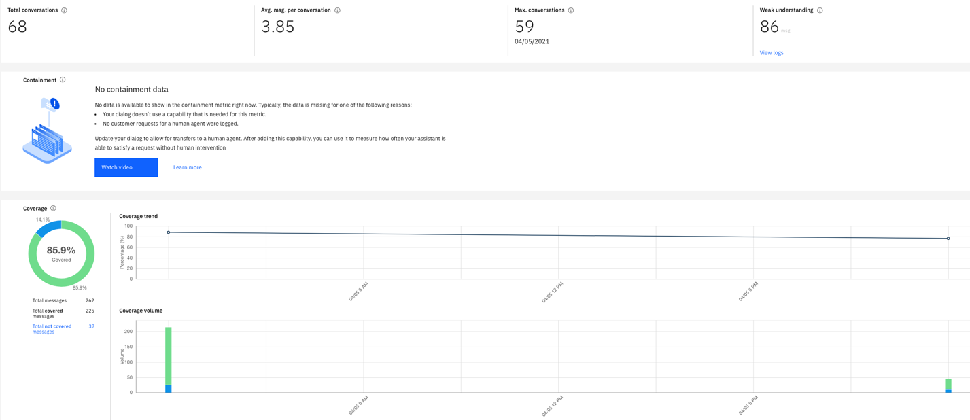

The second day of trials showed some issues with word choice on the symptoms. One example was the symptom ‘muscle pain’ was not being captured as fitting either early or late Lyme disease. This is correct considering the CDC listed symptoms but people may be confusing tendon or nerve pain with muscle pain. Although the user is prompted for one symptom, it is handling two symptoms at a time. Of all the instances, they were both either early or late symptoms, so I’m unsure what would occur if an early and late symptom are inputted. It should be noted that the bot was being test on people who knew what Lyme disease were but are healthy. People who are actually experiencing Lyme may answer things differently.

A third day would have provided more examples of intents and entities. Things like ‘a little feverish’ would be considered fever, I would include ‘thanks’ as a conversation-ending term. It was obvious that people were testing the limits of the model because I told them to test it, so they may have been using it in ways attempting to find where it would break the model. In deployment, a real user probably won’t have this same approach, possibly making the bot preform better than these trials.

**Enhancements**

The chat-bot is personalized with using the user’s name and it’s responses. The name is self-explanatory and feels more personal. The responses to user’s inputs attempt to make it feel like a conversation. For example, the bot will say “that may be a symptom of early Lyme disease, what other symptoms do you have” It could be less conversational, like “Symptom detected – early. Confirm existence of other symptoms.”

I would incorporate Natural Language Classifier and Understanding from the IBM catalog. These would help understand the user’s inputs better. Understanding the user’s inputs will lead to more accurate responses and detection from the bot. I would likely use the Intercom messaging platform. It would be on a doctor’s or hospital’s website meant to screen who likely has Lyme and needs attention. There may be some legal concerns about automatically giving medical advice posing as a medically licensed healthcare provider, but I don’t know the rules. To continue to improve the bot after deployment is to consistently watch the analytics and conversations. If user’s are not using the bot properly or want more information the bot can be redesign to fit their need better. Also, more intents and entities and their examples can be added to improve recognition of them in the conversations.

**Conclusion**

One challenge in creating this bot was handling the symptom input. The CDC breaks the symptoms down into two parts, early and late. In reality, it may not be that simple. The bot was designed to detect if the provided symptom is early or late Lyme. This is because the bot will ask them later if they have other symptoms related to if they provided an early or late symptom. Some of these symptoms will be hard to obvious place into early and late. For example, a headache was an early symptom but severe headaches and migraines were a late symptom. People may also have both an early and late symptom, at which point I’m not sure how the bot would respond. Another challenge was to confirm if the user had other symptoms. The bot tries to have the user admit if they have another symptom in addition to the one they listed previously. Users may still get confused and say yes to the other symptoms question (since they see their one symptom in the list they may just say yes without reading fully). Another challenge is how to handle user inputted symptoms that are not Lyme. As of now it will prompt the user to rephrase, but ideally the bot should say it’s likely not Lyme.

One improvement is to ask for all the symptoms a user has up front. The bot could then figure out if its more likely an early or late case. The bot should still show the other symptoms related to the likely Lyme timeframe incase the user recognizes themselves as having another symptom they didn’t realize yet. Another recommendation is to remove the already provided symptoms (from the user) from the list of other possible symptoms. That way there would be a lower error rate for the users to confirm the existence of other symptoms they didn’t list. The bot should be better at handling symptoms that are not Lyme, recommending the user to look somewhere else. In cases where there are Lyme symptoms along with other symptoms needs to be handle correctly as well. The bot should avoid pre-empting the user with symptoms whenever possible. This is when a user is asked if they have one of the symptoms listed and they now have a biased view because they know what signs the bot are looking for. This leads to user admitting to more symptoms then they otherwise would not have.

([link](https://web-chat.global.assistant.watson.cloud.ibm.com/preview.html?region=us-south&integrationID=f83d4a09-a2fb-4f4c-8349-3e774da66174&serviceInstanceID=b09e1b72-90ea-4408-ad5a-c154b9b6a620) to the chat-bot)