Observations

1. The age group 20-24 by far makes up the majority of players  
   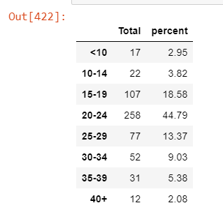
2. Although age groups differ in regards to Purchase Count, the Average purchase Price is very close for all the age groups. Likely there is price sensitivity as around $3 per item. The age group 35-39 appears to be the least sensitive to price spending on average about $0.5-0.6 more than the other age groups.  
   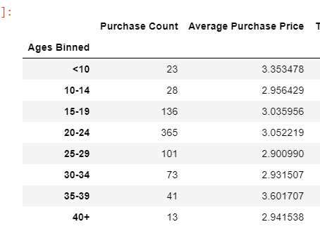
3. Males make up the vast majority of players with 84%

