2014

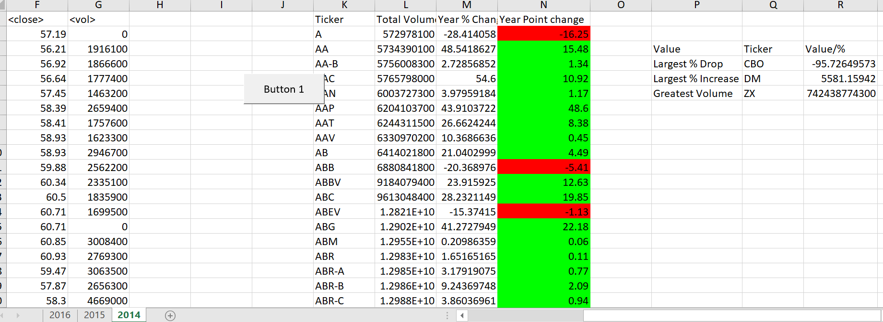

2015

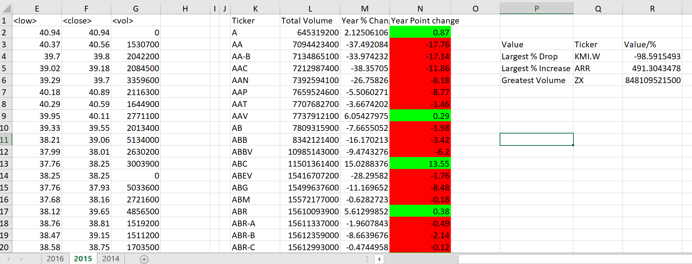

2016

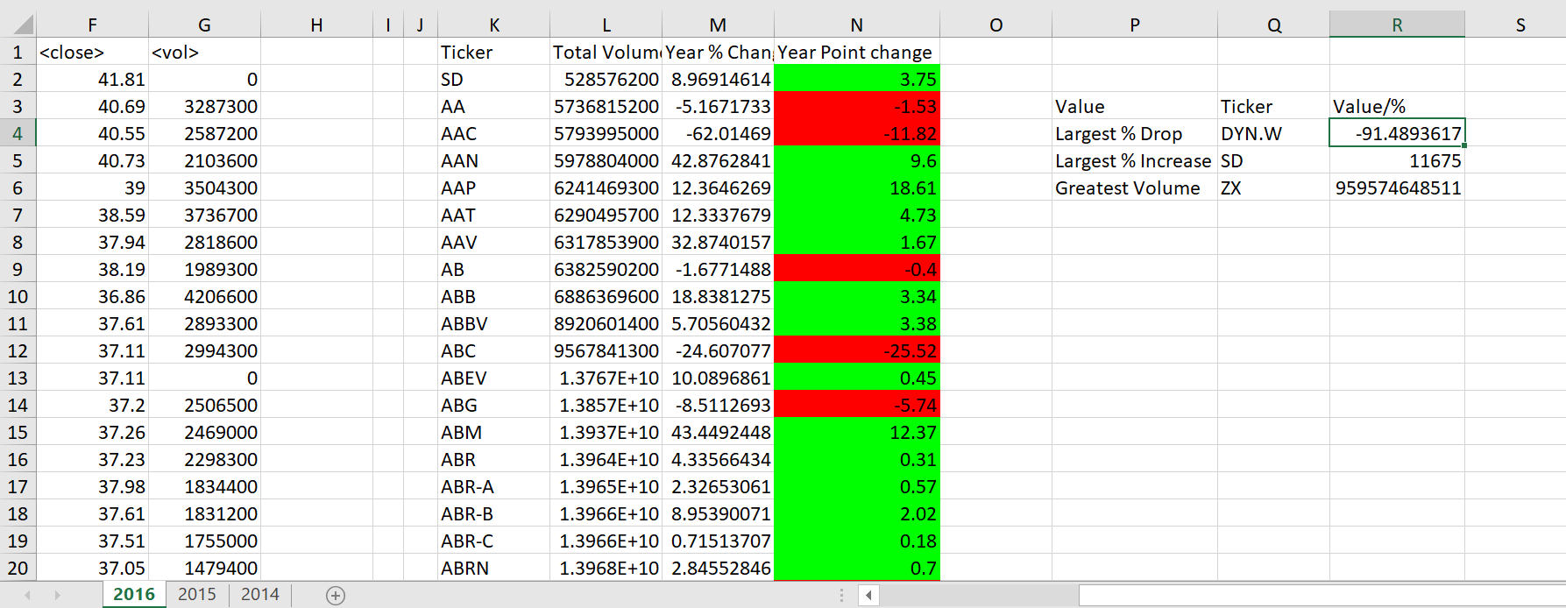

VBA SCRIPT

Sub Button1_Click()

For Each ws In Worksheets

Dim OpenPrice As Double

Dim ClosePrice As Double

Dim PercentChange As Double

Dim PointChange As Double

Dim lrow As Long

Dim volSum As Double

Dim row_count As Long

ws.Cells(1, 11) = "Ticker"

ws.Cells(1, 12) = "Total Volume"

ws.Cells(1, 16) = "Year Point change"

ws.Cells(1, 15) = "Year % Change"

ws.Cells(2, 14) = ws.Cells(2, 3).Value

lrow = ws.Cells(Rows.Count, 1).End(xlUp).Row

volSum = 0

RowCount = 2

For i = 2 To lrow

volSum = ws.Cells(i, 7).Value + volSum

If ws.Cells(i, 1) <> ws.Cells(i + 1, 1) Then

ws.Cells(RowCount, 11).Value = ws.Cells(i, 1).Value

'Get the closing Price

ws.Cells(RowCount, 13).Value = ws.Cells(i, 6).Value

'Get the open price for the year---

ws.Cells(RowCount + 1, 14).Value = ws.Cells(i + 1, 3).Value

'CALCULATE THE DIFFERENCE

'Cells(RowCount + 1, 15).Value = Cells(i + 1, 3).Value - Cells(i, 6).Value

ws.Cells(RowCount, 12) = volSum

RowCount = RowCount + 1

'get close for the year

amt = 0

End If

Next i

'Cleanup

lrow = ws.Cells(Rows.Count, 14).End(xlUp).Row

For i = 2 To lrow

If ws.Cells(i, 13).Value <> 0 And ws.Cells(i, 14).Value <> 0 Then

PercentChange = ((ws.Cells(i, 13).Value - ws.Cells(i, 14).Value) / ws.Cells(i, 14).Value) * 100

PointChange = (ws.Cells(i, 13).Value - ws.Cells(i, 14).Value)

ws.Cells(i, 15).Value = PercentChange

ws.Cells(i, 16).Value = PointChange

ElseIf ws.Cells(i, 13).Value = 0 Or ws.Cells(i, 14).Value = 0 Then

ws.Cells(i, 15).Value = 0

End If

Next i

ws.Range("M1").EntireColumn.Delete

ws.Range("M1").EntireColumn.Delete

'volume

Max = 0

lrow2 = ws.Cells(Rows.Count, 12).End(xlUp).Row

For i = 2 To lrow2

If ws.Cells(i, 12) > Max Then

Max = ws.Cells(i, 12)

ws.Cells(6, 17) = ws.Cells(i, 11)

ws.Cells(6, 18).Value = Max

End If

Next i

' Max %

maxPercent = 0

For i = 2 To lrow2

If ws.Cells(i, 13) > maxPercent Then

maxPercent = ws.Cells(i, 13)

ws.Cells(5, 17) = ws.Cells(i, 11)

ws.Cells(5, 18).Value = maxPercent

End If

Next i

' Largest Drop %

Maxdrop = 0

For i = 2 To lrow2

If ws.Cells(i, 13) < Maxdrop Then

Maxdrop = ws.Cells(i, 13)

ws.Cells(4, 17) = ws.Cells(i, 11)

ws.Cells(4, 18).Value = Maxdrop

End If

Next i

ws.Cells(4, 16) = "Largest % Drop"

ws.Cells(5, 16) = "Largest % Increase"

ws.Cells(6, 16) = "Greatest Volume"

ws.Cells(3, 17) = "Ticker"

ws.Cells(3, 18) = "Value"

'color the positive and negative cells

For i = 2 To lrow2

If ws.Cells(i, 14) > 0 Then

ws.Cells(i, 14).Interior.ColorIndex = 4

ElseIf ws.Cells(i, 14) < 0 Then

ws.Cells(i, 14).Interior.ColorIndex = 3

End If

Next i

Next ws

End Sub