Cards

Use Cases:
I have several hours to work. I log onto the system and view cards in progress. I work on them and complete one. I move this card into the completed stack. Then I select one from the ready category and put them into the ready stack.
I now have knowledge of another piece of work I need to do. I log into the system and create another card. Then, the card is placed into the ready stack.
I click the stats button after logging in. I see the following things: #Cards in each stack; mean stats for card completion; Graph showing the following: At each week have this number (cards completed – cards created).

Possible Features:
Card tags. When creating a card, have a tags field. These tags could be used by a filtering agent (example, filter by subject)
Email notifications

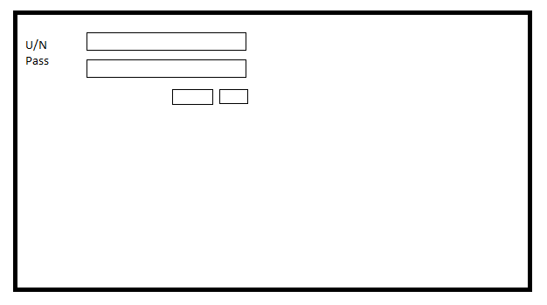
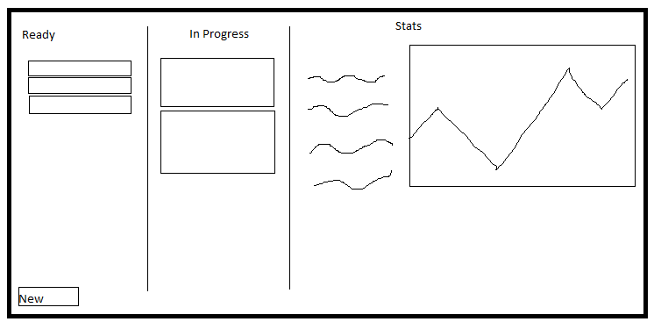

JSON format
{
“username”: “password”
“ready”: {
“title”: {
“body”: “text”
“acceptance”: “text”
}
}
“progress”: {

}
“verified”: {

}
}

