Homework
BNF Grammar

Do this homework alone or in a group of 2 students.

1 | 10
2 | 20
3 | 20
4 | 10
5 | 10
6 | 10
7 | 20
8 (optional) | 10
Total / 110

- In the Java Specification manual (latest version), find the BNF rules for assignments. Copy / paste the URL and the rule(s) here. https://docs.oracle.com/javase/specs

https://docs.oracle.com/javase/specs/jls/se20/html/jls-15.html#jls-15.26

- We consider the following grammar for assignmentstatement.

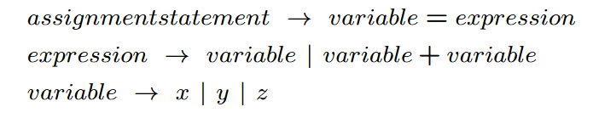
- What is the start symbol?
‘assignmentstatement’
- What are the non-terminals?
‘assignmentstatement’, ‘expression’, ‘variable’
- What are the terminals?
‘x’, ‘y’, ‘z’, ‘=’, ‘+’
- Write a rightmost derivation to show that x = y + z is an assignmentstatement.
assignmentstatement => variable = expression => variable = variable + variable => variable = variable + z => variable = y + z => x = y + z

- Write a leftmost derivation to show that x = y + z is an assignmentstatement.
assignmentstatement => variable = expression => x = expression => x = variable + variable => x = y + variable => x = y + z

- Draw the parse tree that show that x = y + z is an assignmentstatement.

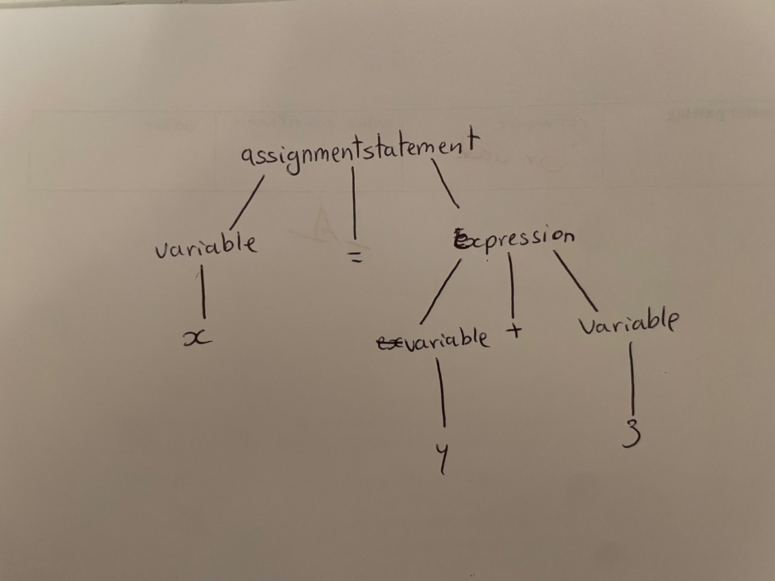

- Write a list of 6 ” expressions that are not recognized by the grammar.
- ‘x + y = z’
- ‘x == y + z’
- ‘x + z’
- ‘x = y – z’
- ‘x = y*z’
- ‘x + y = x + y’

- We consider the following grammar for assignmentstatement.
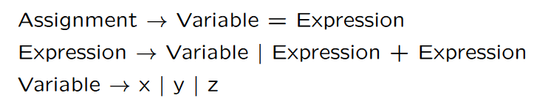
  - What is/are the difference/s between this grammar and the previous one?
- The root is different, in the first it’s ‘assignmentstatement’ and the second one is “Assignment’.
- ‘Expression’ can lead to a ‘variable’ or ‘variable + variable’ in the first case. In the second case ‘expression’ can lead to a ‘variable’ or ‘expression + expression’
- The second grammar also allows for recursion.
  - Draw the parse trees of x = y + z?

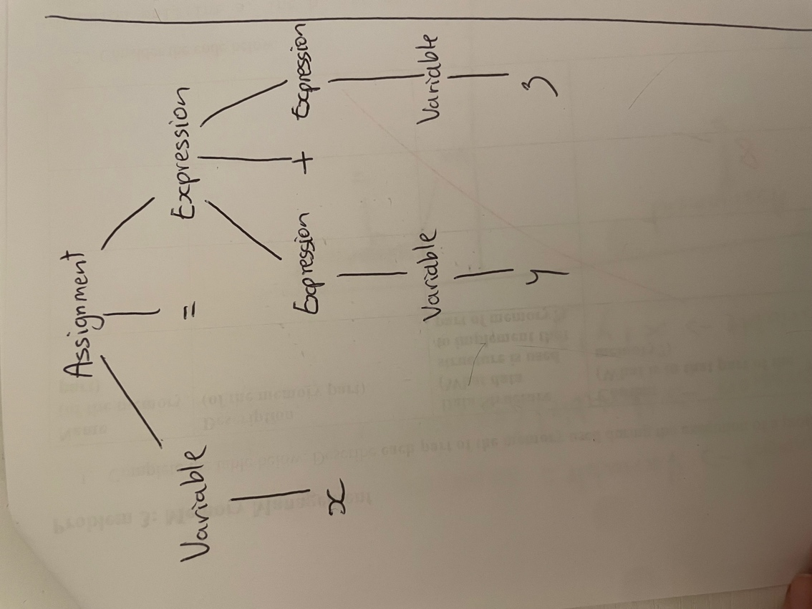

  - The grammar is ambiguous. Why?
- Because the ‘Expression’ rule allows for multiple parse trees. In the case of ‘x = y + z’ there is no ambiguity since there are not enough variables but in the case of ‘x = x + y + z’ there would be ambiguity as there could be two parse trees. There ‘(x + y)’ could be grouped together and then ‘z’ or ‘x’ could be alone and ‘(y + z)’ could be grouped together.
  - How can we remove the ambiguity in the grammar?
We need to make the grammar more specific.

Assignment → Variable = Expression
Expression → Symbol | Expression + Symbol
Symbol → Variable
Variable → x | y | z

- We consider the following grammar:

EXPRESSION -> NUMERAL | ( EXPRESSION OPERATOR EXPRESSION )
NUMERAL -> 0 | 1 | 2 | 3 | 4 | 5 | 6 | 7 | 8 | 9
OPERATORS -> + | -

Show that (4 - (3 + 2)) is a legal EXPRESSION using a parse tree.

(This works assuming there is a typo in the word ‘OPERATORS’)
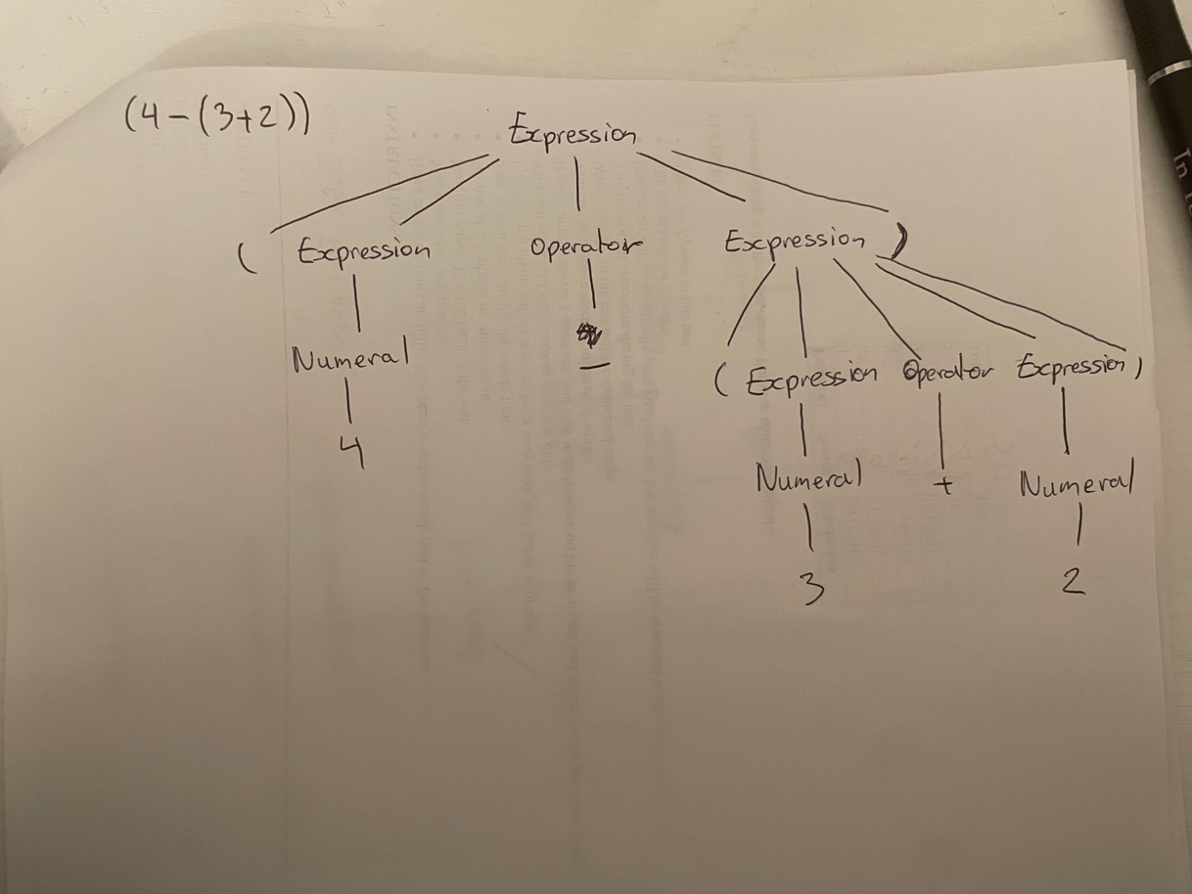

- Design a BNF grammar that recognized odd binary numbers.

<oddnumber> :: = <number> <odd> | <odd>
<number> :: = <number> <digit> | <digit>
<odd> :: = 1
<digit> :: = 0 | 1

- Write a BNF grammar and a regular expression that describes the structure of US telephone numbers, which can either be (xxx)xxx-xxxx or xxx-xxxx, where x is a digit from 0 to 9.

<phone> :: = <Area> <Num> <Num> <Num> - <Num> <Num> <Num> <Num>
<Area> :: = (<Num> <Num> <Num>) |
<Num> :: = 1 | 2 | 3 | 4 | 5 | 6 | 7 | 8 | 9

