# Information Visualization

# CHECKPOINT III: Visualization Sketch

G22 - A

1. **Overview**

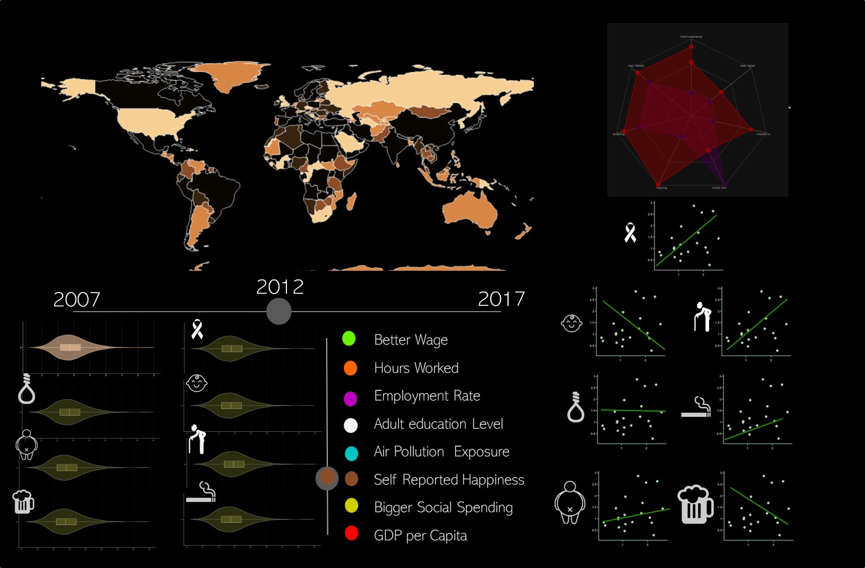We start by having a slicer where the user can select the health influencers he wants to analyse. And a slider to limit the years being analysed.

The data being shown is all connected, which means that when a user moves a slicer or slider the data being shown changes in all the idioms.

We have the following idioms:

1. Choropleth map

This map will change the colour based on the health factors selected on the slicer described above.

The user can then use the map as a slicer, where he can click a country to highlight the data being shown to that country.

1. Scatter plot

We’ll have 1 scatter plot per each variable of health being analysed. This means we have 7 different scatter plots piled on top of each other. On the x axis we have the health factor and on the y axis we have the habit selected on the slicer described above. The point of the country selected on the choropleth map will glow so the user can identify the country selected and compare it to the rest of the countries. You can also click or hover over a dot to see what country it is.

1. Star plot

In this plot we’ll have the correlation coefficient of each health variable with the variable selected on the slicer.

1. Violin plot

Here once again we’ll have a violin plot per each health variable, which means we’ll have seven different violin plots. Each violin plot will show the distribution of countries in relation with one of the health variables.

1. Health influencer slider

You can use this to select the health influencer you want to analyze with more care.

1. Health influencer label

This serves as a label for the icons close to the plots, so the user can understand which data is in the plots

1. Years slider

This allows the user to select the year he wants to analyze.

**2. Visual Encoding**

1. **Choropleth map**

Map -> Colour: filling each country with the colour of the selected variable.

Channel -> colour -> hue: a higher value for the hue represents a higher value of the selected variable.

Channel -> colour -> lightness: if a point from a country is selected on a scatter plot, the lightness goes up on the map.

1. **Scatter plot**

Marks -> Point: represents a pair (health variable, health influencer)

Marks -> Line: represents the linear approximation of the scatterplot between the 2 variables.

Channel -> position: represents the position of the point in a Cartesian axis.

Pictograph -> Represents the respective health variable being correlated with health influencer

1. **Star plot**

Marks -> Point: represents the correlation coefficient normalized between 0 and 1.

Channel -> colour -> hue: The colour of the area between the points in the start chart represents the variable being analyzed.

Pictograph -> Represents the respective health variable being correlated with health influencer

Channel -> Colour: coulor represents the selected variable.

1. **Violin plot**

Pictograph -> Represents the respective health variable

Curve -> Represents the distribution of each of the health variables and the selected health influencer

Size -> Is proportional to cardinality countries of the value interval

Channel -> Colour: the colour of the first violin plot represents the selected variable

1. **Health influencer slider**

Channel -> position: represents the health influencer being displayed

Channel -> colour: represents the health influencer being displayed

1. **Health influencer label**

Channel -> position: represents the year being displayed

Channel -> colour: represents the relation between the coulor with each influencer (word on its right)

1. **Years slider**Channel -> position: represents the year being displayed  
   Channel -> colour: represents the relation between the coulor with each influencer (word on its right)
2. **Health influencer legend**Channel -> colour: represents the relation between the coulor with each influencer (word on its right)

**3. Answering the questions**

* + - 1. **Question 1:** Does a better wage mean a healthier life or a longer life expectancy?
         1. - You can see this by selecting the wage mean on the slicer and looking at the scatter chart of life expectancy.

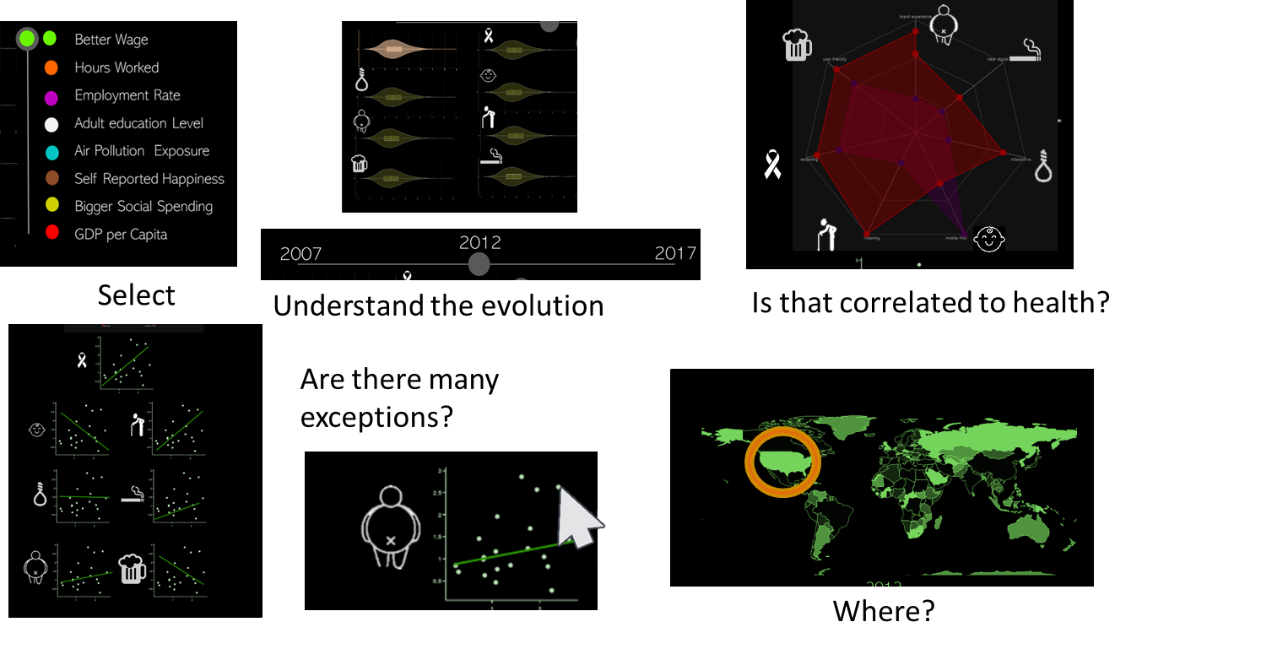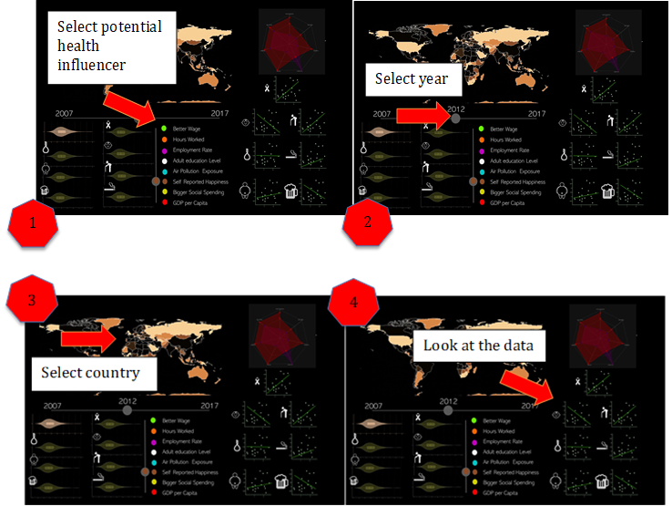

* + 1. **Question 2:** What is the optimal number of hours to work that lead to a healthier life or more life expectancy?
       1. - You can see this by selecting the hours worked on the slicer and looking at the violin chart of life expectancy to see the tendency.
       2. **Question 3:** What is the relationship between, more people working and being healthier and live more?
       3. - You can see this by selecting the employment rate on the slicer and looking at the scatter chart to compare the countries, and then to the violin chart to see the tendency.
       4. **Question 4:** How does adult education influence our health?
       5. - You can see this by selecting adult education on the slicer and looking at the scatter charts and the violin charts.
       6. **Question 5:** How does air exposure affect our health?
       7. - You can see this by selecting air exposure on the slicer and looking at the violin charts to see the tendency.
       8. **Question 6:** How does self-reported happiness corelates to Alcohol consumption, Smoking habits and Suicide rates?

- You can see this by selecting self-reported happiness on the slicer and looking at the scatter chart for comparison between countries of alcohol consumption, smoking habits and suicide rates. And in the violin chart to analyse tendencies

**Question 7:** Does a bigger social spending or a higher GDP in general influences people to live more and suicide, smoke and drink less?

- You can see this by selecting social spending or GDP on the slicer and looking at the scatter chart of life expectancy, suicide rate

**Other questions:**

Where is the wage higher?

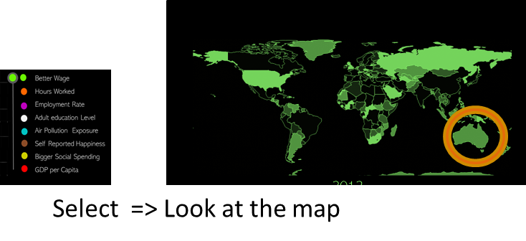

Are Is there a good correlation between Self reported happiness and drinking alcohol?

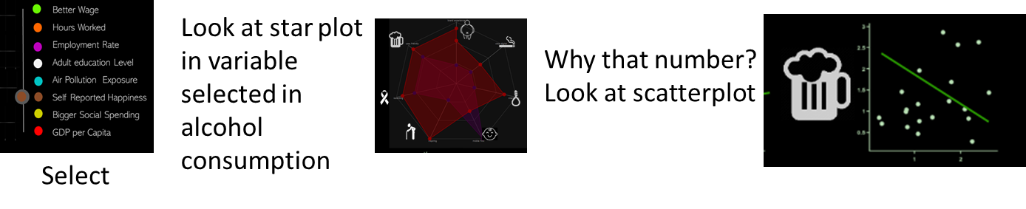

Are people getting unhappier?

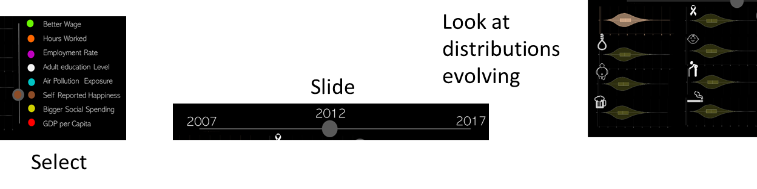

Are people in Asia Working more hours?

