# Information Visualization

# CHECKPOINT IV: First Prototype

G22 - A

**1. Layout**

In the last checkpoint we defined a high-level definition of what our interface would look like (Fig. 1).

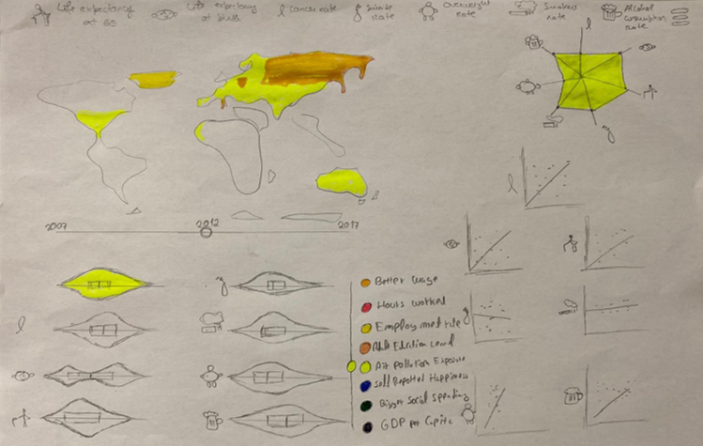In this interface we have 4 idioms and 2 slicing mechanisms.

Figure

For the idioms we have the choropleth map, a violin plot, a star plot and a scatter plot. For the slicing mechanisms we have a slider with the years, and a list with the potential health influencers.

The data being shown is all connected so a move in one of the slicers will change the data on the idioms.

From this interface we implemented only 2 idioms. The **scatter plot** and the **star plot**. In addition to the implemented idioms, we also implemented the **time slider** slicing mechanism and the health potential influencer slicer. This last one is only visual and offers no interactivity as of now. We describe how these work in the next section.

We think this implementation gives a good idea how the visualization will work when it’s finished.

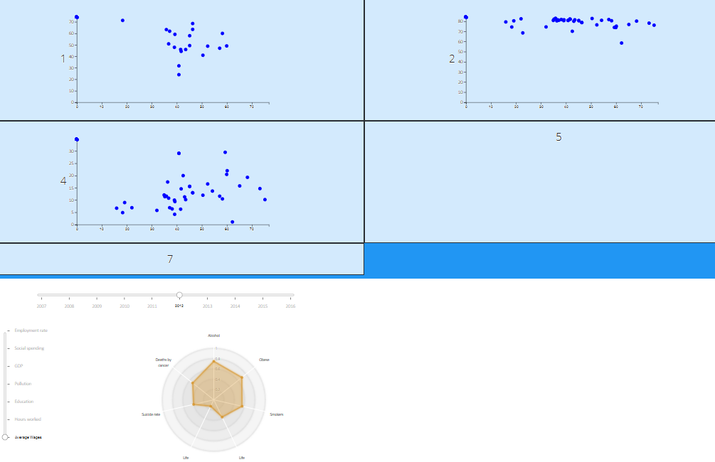

Scatter Plots

Year Slicer

Star Plot

Potential Health Influencer Slicer

Figure

**2. Implemented Idioms**

There are 2 idioms implemented.

1. Scatter Plot

Description:

There is 1 scatter plot per each variable of health being analysed. On the x axis we have the health factor and on the y axis we have the habit selected on the list slicer. Since we have not yet implemented this list slicer, for now the y axis only has the average wage as potential health influencer. Each dot in the graphic corresponds to a country

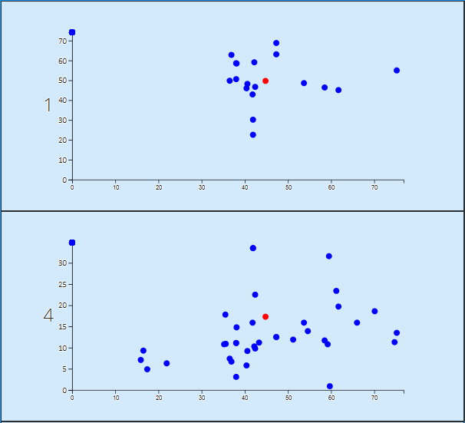Interactivity:

Figure

If you mouse over a point in the scatter plot. All the points in the other scatter plots that correspond to the same country will also turn red. In this scatter plot we can see the red dot when we hover over a country. If we were to change the mouse to another point in figure 3, scatter plot 1 to another point, a different point on scatter plot 4 would turn red.

Changing the year slider seen in figure 4 also changes the data being shown in the scatter plots.

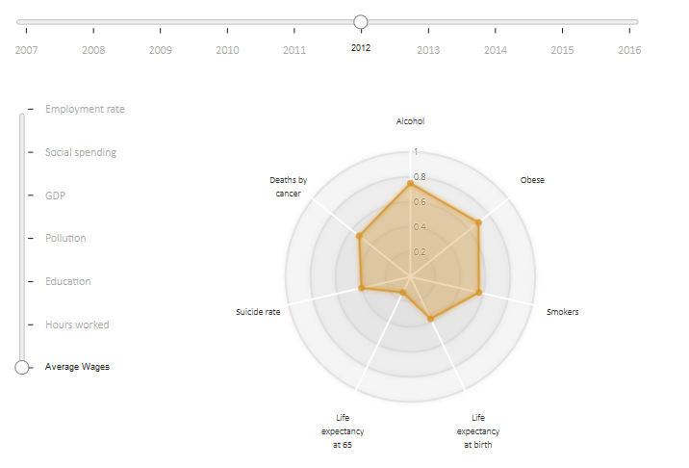

1. Star Plot

By changing this slicer

Description:

In this plot we’ll have the correlation coefficient between each health variable and the variable selected on the list slicer.

Interactivity:

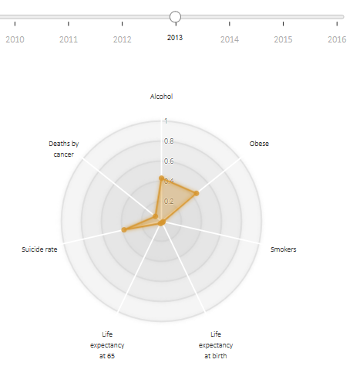The interactivity in this idiom is very simple. By moving the year slicer slider, this idiom changes the data shown according to the year being analysed.

Figure

We change the data being shown

Notice in the figures 4 and 5 the slicer has a different value selected which results in a different visualization

Figure

**3. Implementation of Linking Mechanism**

Right now, we have 2 views implemented. The interactivity between them is still limited. But in the final version we’ll have 4 views, each of them will be influenced by the 2 slicers, of which we have 1 implemented right now. One of the slicers will allow the user to choose the year which will be shown. This is the slicer implemented in our prototype. And the other, the potential health influencer we want to analyse. All the views will change according to the year and potential health influencer selected by the user. On top of this the user can select or hover over a country in one of the graphs, which will result in the highlight of this country on all the other idioms. We already have a small implementation of this functionality in our prototype. Where you hover over a country point in one of the scatter plots and the same country points in the other scatter plots get highlighted.

In the storyboard bellow we can have an idea of the level of interaction between the views we’ll have in the final version.

Select year

2

Select potential health influencer

1

Look at the data

4

Select country

3

Figure

By looking at figure 6 and figure 7 we can have a good idea of our progress. The slicers are already implemented as described above, and the year slicer already influences the data being shown. The scatter plots also interact a little bit between them.

Figure

Overall, we still have to implement the 2 missing idioms and finish the interactions between them.