# Information Visualization

# CHECKPOINT IV: First Prototype

G22 - A

**1. Layout**

In the last checkpoint we defined a low-fidelity prototype of what our interface would look like (Fig. 1).

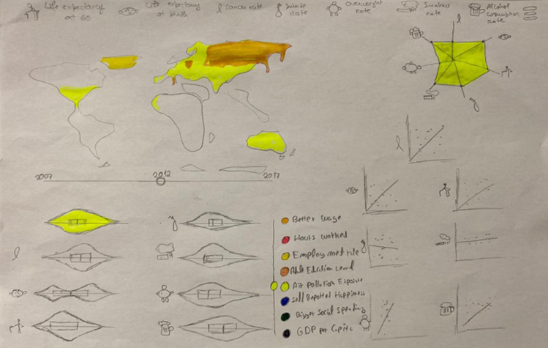In this interface we have 4 idioms and 2 slicing mechanisms.

For the idioms we have the choropleth map, a violin plot, a star plot and a scatter plot. For the slicing mechanisms we have a slider with the years, and a list with the potential health influencers.

The data being shown is all connected so a move in one of the slicers will change the data on the idioms.

Fig. 1

From this interface we implemented only 2 idioms. The **scatter plot** and the **star plot**. We also implemented **time slider** and **potential heath influencer (list) slider**. How these work are described in the next section.

**2. Implemented Idioms**

There are 2 idioms implemented:

There is one **scatter plot** per each variable of health being analysed. On the x axis we have the health factor and on the y axis we have the potential health influencer selected on the list slicer. Since we have not yet implemented this list slicer, for now the y axis only has the average wage as potential health influencer.

* + Interactivity: If you mouse over a point in the scatter plot, all the points in the other scatter plots that correspond to the same country will also turn red. However this is not perfectly implemented because when hover over a point, more than one in the same scatter plot turn red, and this must not happen, since the country must be represented by only one point.

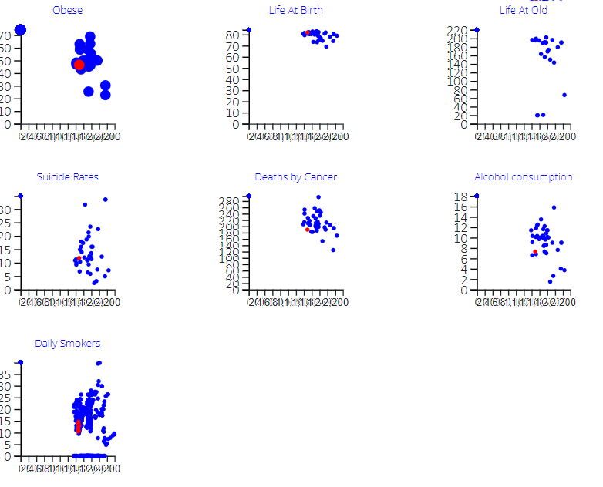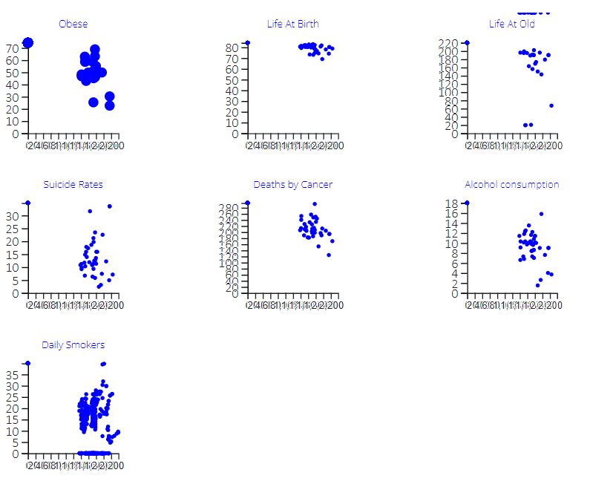

Scatter plots

Scatter plots with hover

In the **star plot** we have the correlation coefficient between each health variable and the variable selected on the list slicer.

* + Interactivity: In this star plot it only changes the opacity when hovering with the mouse, however, the goal is, for each point in the star plot, is showing a tooltip that indicates the value of the correlation coefficient.

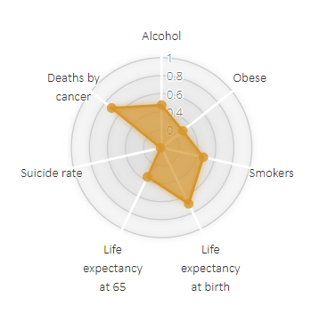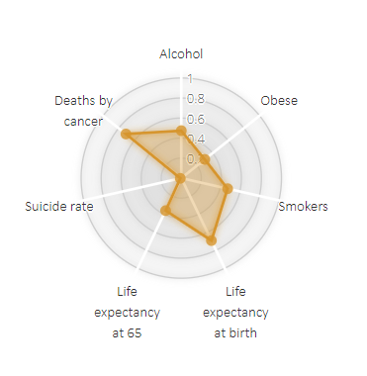

Star plot

Star plot with hover

**3.Implementation of Linking Mechanism**

Right now, we have 2 views implemented, that update their data when sliders change, however in the final version we’ll have 4 views (each of them will be influenced by these 2 slicers). One of the slicers will allow the user to choose the year which will be shown. And the other, the potential health influencer we want to analyse. All the views will change according to the year and potential health influencer selected by the user.

When hover with the mouse over a point in the scatter plot, the country in the map will be highlighted and vice-versa.

We well have colours in the list slider and with that colour, the map will display that colour with different intensities (depending on the country and time).

Each violin plot will show the distribution of countries in relation with one of the health variables. We will also have an 8th violin plot to understand the evolution of the selected variable, as well as the health factors (by using year slider).

In the storyboard bellow we can have an idea of the level of interaction between the views we’ll have in the final version.

1

Select potential health influencer

2

Select year

Select country

3

4

Look at the data