Om Shanti Emojis: Three Facets of Digital Hinduism

The following essay responds to three scholars’ contributions to the edited volume *Digital Hinduism* (2020) by situating their pronouncements regarding the role of digital media in contemporary religious practice into the contexts of two Hindu new religious movements: the Brahma Kumaris and the Gayatri Pariwar. These institutions are underrepresented in studies of Hinduism, and their members engage with digital media in ways that reinforce, and sometimes challenge, the conclusions of existing scholarship on digital Hinduism. The following analysis of several case studies wherein members of the Gayatri Pariwar and the Brahma Kumaris use digital media will demonstrate three things: (1) an increasing supply of digital religious resources reinforces and sometimes creates new expectations for proper religious conduct (i.e. new demands); (2) social media forums serve as venues for both the performance and policing of piety; and (3) the digital content that populates these forums exists at the threshold of deliberate ritual practice and what has been called “automatic” or “accidental” ritual (see Haberman 2014; Karapanagiotis 2019).

## Supply and Demand

Attention to the role of digital media in religious practice is no longer new. The recently published volume *Digital Hinduism* begins from the premise that all forthcoming analyses of contemporary Hinduism must account for how their religious subjects make use of social media, websites, smartphone applications, or other technological innovations. Three contributions address three facets of online religious practice that bear further consideration in the contexts of the Brahma Kumaris and the Gayatri Pariwar. First, Vineet Sinha describes the online sale of Hindu ritual items and how the religious character of these items rests uneasily with the depersonalized and capitalistic qualities of e-commerce. She resists the conclusion that internet transactions can only be economic by drawing attention to the inclusion of instructional booklets meant to replace the “over the counter” conversations about proper usage which are lost when buying online (Sinha 2019, 179). In other words, she insists that e-commerce does not necessarily foreclose the ethical projects of vendors who sell their products for more than monetary reasons, since merchants persist in guiding consumers toward the “correct” use of their wares. More importantly for this study, however, Sinha argues that the Internet not only fulfills consumer needs, but “creates new needs through the introduction of novel products and services using innovative technologies, not only sustaining the businesses but also feeding back into and impacting in practice the domain of worship” (Sinha 2019, 178).

Although Sinha writes about material goods sold online, her remarks about the generation of new religious needs through e-commerce also apply to thoroughly digital products such as smartphone apps. Both the Brahma Kumaris and the Gayatri Pariwar offer their members an array of cell phone applications for free download on “app stores” such as Google Play and the Apple App Store. These apps operate as curations of the multimedia offerings of their respective organizations, and they either reinforce existing expectations for proper religious conduct or create new ones. For example the Gayatri Pariwar, the founder of which is believed to have written over 3200 books in his lifetime, offers an app by which members can access the bulk of that literature for free. The organization has long placed a premium on self-study, but the online offering leverages the appeal of digital media in an attempt to revive the dwindling reading habits of the youngest generation of members.[1] Similarly, the organization offers a smartphone app to assist with the correct procedures and chants required to perform household rituals. A longstanding aim of the organization has been to revive Hindu ritual traditions at the household level by making them accessible to the masses, and this app works toward that end (although not all have access to smartphones). Again, for the Gayatri Pariwar, their apps reinforce existing expectations by offering users new means of fulfilling them.

The Brahma Kumaris, for their part, offer over fifty cell phone apps on the Google Play Store alone, many with overlapping features. Two of these features are most common: (1) daily sermons translated into various languages, and (2) a meditation aid called “traffic control,” which acts as an alarm clock that notifies users when it is time to pause one’s daily tasks in order to stop and remember God. Users can often choose the tune of their alarm from among several Brahma Kumari songs preloaded on such apps. The expectation for members to read the day’s sermon and practice traffic control preexisted these apps as well – Brahma Kumaris are encouraged to attend an in-person sermon every morning, and most of their campuses feature speaker systems that remind members when to practice traffic control. Yet the transition of these services onto mobile devices shifts the context in which members can fulfil these expectations.

In other cases, apps create new expectations for religious conduct altogether. Consider several apps which include Brahma Kumari themed WhatsApp stickers. Automatically integrated into the WhatsApp messaging app, these stickers allow users to choose alternative versions of popular emojis coded with Brahma Kumari flair.

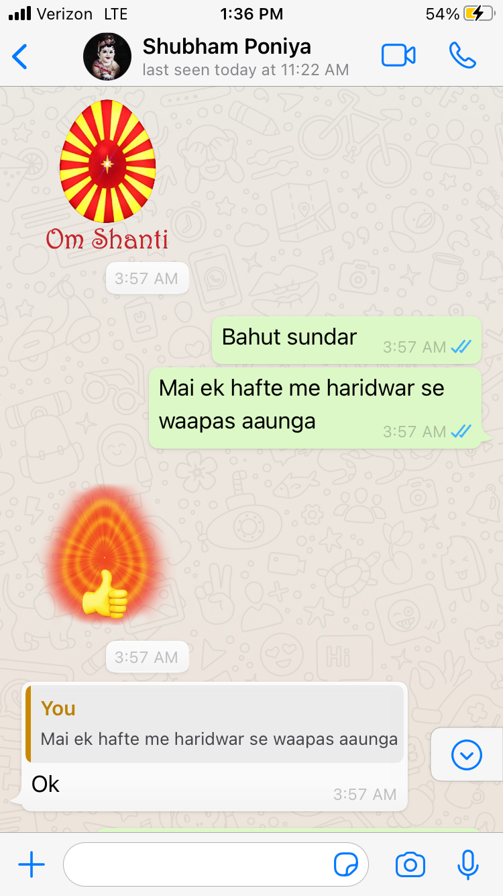

Fig. 1: WhatsApp Stickers

By adorning popular emojis with Brahma Kumari backgrounds and logos, the app affords users the ability to code their conversations with religious significance. More importantly, the app sets an expectation that good Brahma Kumaris will use these stickers in their WhatsApp conversations, for when Brahma Kumaris take part in exchanges that make use of such stickers, a new standard of religious behavior is set. In this respect, the sticker app creates the need for itself.

For both the Gayatri Pariwar and the Brahma Kumaris, participation in the realm of e-commerce is much more than an attempt to turn a profit. All of the apps mentioned are free for download by anyone who possess the proper device, and this is by design. Both groups pursue eschatological projects by which a world deemed morally bankrupt can begin to transition into an approaching age of righteousness. Both groups critique Western modernity for facilitating people’s disregard for religious propriety, but rather than forsake consumer culture, smartphones, or social media – staple accessories of Western modernity – these religious organizations engage with them. By doing so, the Gayatri Pariwar and the Brahma Kumaris attempt to transform digital media from an irreligious temptation into a tool for the religious invigoration of their memberships. In a phrase, these groups use digital media not in order to use religion in the service of capital, but rather to use e-commerce in the service of religion.

## Performing and Policing Piety

Aparajita De and Rajib Nandi detail a second facet of online religious practice when writing about how the messaging platform WhatsApp fosters vibrant religious community among Bengali Hindus during Kolkata’s Durga Puja, a days-long festival dedicated to the goddess Durga. In particular, De and Nandi emphasize that WhatsApp enables community members who are not physically present to feel connected to the preparations and main events of the holiday (De and Nandi 2019, 29). Steady streams of messages update those absent participants in real time, thereby facilitating a feeling of community that transcends the spatial boundaries of religious practice. Moreover, the ability for WhatsApp groups to exist well-past the duration of the holiday sustains religious community outside of its ritual context.

The aforementioned smartphone apps already demonstrate how digital media offer new contexts in which religious conduct can be (and should be) undertaken. It should be no surprise, then, that social media platforms have become sites for the vibrant community life among members of the Gayatri Pariwar and the Brahma Kumaris. Most of the features described by De and Nandi are visible in these organizations’ WhatsApp groups and exchanges, insofar as local events and happenings are reported to one another with relative consistency. Yet the Gayatri Pariwar and the Brahma Kumaris also utilize social media platforms and forums in order to both perform their own piety and police that of their peers.

One example of this, stunning due to its blending of digital and non-digital elements, is the Facebook page named the “Divine Exercise of Writing Gayatri Mantra.” The Gayatri mantra is perhaps the most widely known Sanskrit scriptural verse among North Indian Hindus. Dating back to the *R̥g Veda*, the Gayatri mantra is an invocation that beseeches the Sun god Savitr for inspiration. The Gayatri Pariwar translates the verse from Sanskrit into English as such: “May the Almighty illuminate our intellect and inspire us toward the righteous path” (Brahmavarchas 2014, iii). Gayatri Pariwar members recite the mantra regularly in their daily rituals, but the practice of writing the Gayatri Mantra was popularized in the group as far back as the 1950s, as part of an effort to consecrate the headquarters that was at that time still under construction. Today, one can observe many members of the group writing out the mantra in blank notebooks during otherwise idle moments in their day. For the nearly two-hundred members of the Facebook group, their written mantras enjoy a second life online, where other members see, like, and sometimes comment on them.

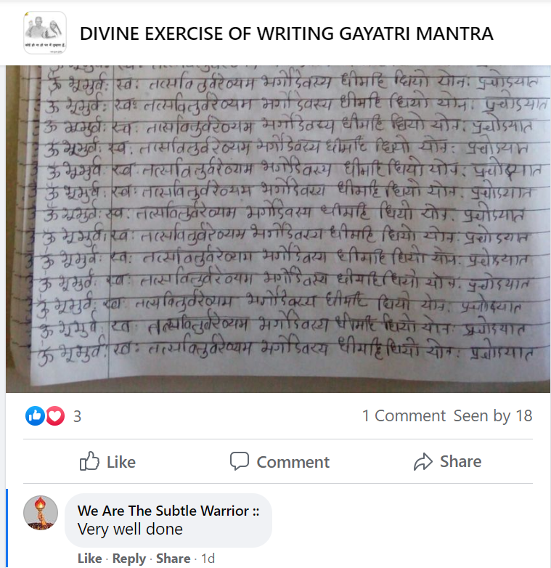

Fig. 2: Comments on Gayatri mantra Facebook group post

Although the writing of these mantras takes place with paper and pen, Facebook offers a venue by which the private act of writing is made public. In this respect, it is a performance of piety. Consider a second example, wherein a user adds a digital label to the photograph of a day’s mantra writing. The superimposition of a banner titled “Wednesday” onto the image suggests that this user fills a page with mantras every day. It thereby serves as a performance of this member’s piety for others to see.

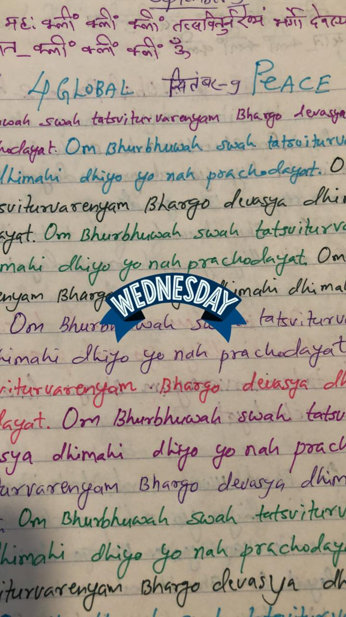

Fig. 3: Use of digital adornment on Facebook post photos

The Brahma Kumaris, for their part, also utilize social media to celebrate and account for proper religious practice. One means of doing this is by using Brahma Kumari themed WhatsApp stickers, as stated earlier. Even without such an app however, the Brahma Kumaris have co-opted two standard emojis which are used to code user messages as pertaining to the group. The Brahma Kumaris believe God to exist ultimately as a point of light from which many rays emanate. The group developed a flag and a logo on this theme: an egg-shaped light from which rays emanate, against a red background. Because of its similar design, the Macedonian flag emoji often adorns Brahma Kumari WhatsApp messages. An emoji denoting a spark or explosion is similarly used to represent God as a point of light.

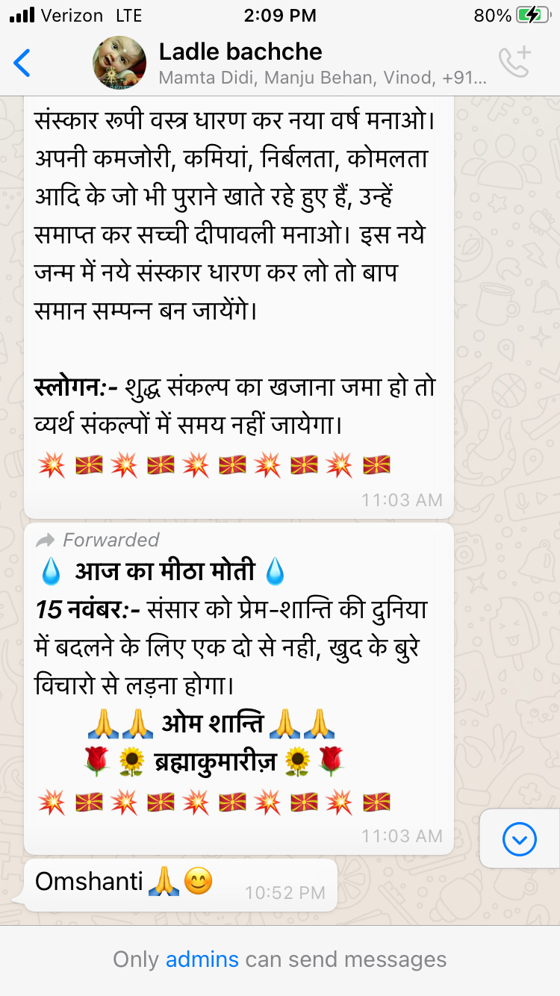

Fig. 4: Brahma Kumaris WhatsApp emoji use

Both the custom stickers included in special apps and the standard emojis repurposed by Brahma Kumaris serve as digital acts of “flag-waving,” which call attention to the religious tone in which the message should be read.

Although the Brahma Kumaris regularly celebrate and signify their religious identities by adorning their messages with stickers and emojis, they also use digital media platforms in order to police one another on religious conduct. For one Brahma Kumaris community in Mathura, a city one-hour West of the Taj Mahal by car, the use of the phrase, “Om Shanti,” at once constitutes a performance of piety and an act of policing fellow members.

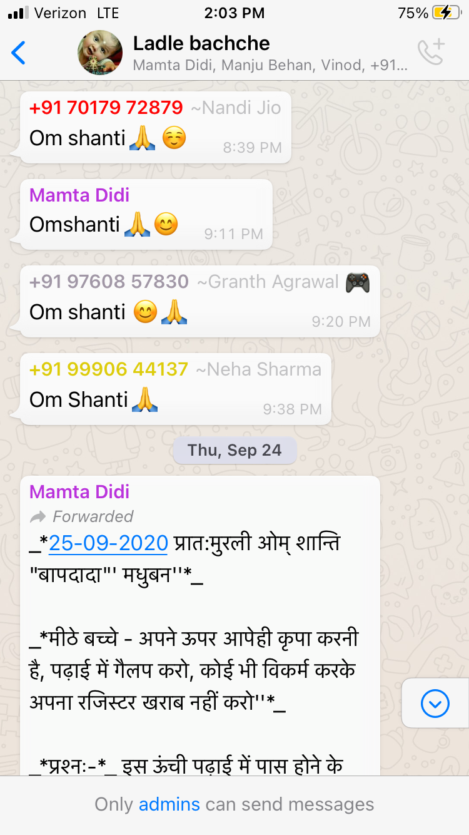

Fig. 5: Brahma Kumaris WhatsApp “Om shanti” exchanges

The Brahma Kumaris as a whole are enjoined to rise at 4:30 a.m. during a time they call “*amrit vela*,” or “moment of nectar,” “sweet moment,” or “undying moment.” During this period of time, Brahma Kumaris are supposed to meditate upon their connection to God. It is not uncommon for members of this community to message their usual greeting, “Om shanti” to one another at 4:30 a.m., via WhatsApp. To receive a message at this hour indicates to other community members that the sender has risen at the appropriate hour. Conversely, those who fail to respond may be presumed to have slept through their morning contemplative practice altogether. Although I never witnessed any outright accusations based on WhatsApp messages, during my time in Mathura I did overhear several in-person exchanges wherein one Brahma Kumari would chide another community member for failing to meet the attendance required for morning sermons.

## Deliberate and “Automatic” Rituals

A third facet of digital Hinduism is raised by Nicole Karapanagiotis when writing about the Facebook posts of members of ISKCON, or the International Society of Krishna Consciousness, popularly known in the United States as the Hare Krishna Movement. Karapanagiotis argues that the organization can fulfil its proselytizing goals through Facebook posts containing photos of the deity Krishna, since according to ISKCON devotees, even inadvertently viewing photos of God “will automatically rouse love in viewers’ hearts” (Karapanagiotis 2019, 58). The idea that digital media can act as accessories to ritual practice has been made already, in the context of apps that assist in correct ritual procedure. Yet Karapanagiotis argues that these media can themselves be ritual contexts that connect even the unwitting observer to the power of a religious object, act, or mantra. In this respect she draws on the work of David Haberman, who analyzed textual descriptions of such “accidental ritualists” in order to make the case that Hindu ritual efficacy has as much to do with correct procedure as it does intention (Haberman 2014).

Such automatic rituals also take place in the digital media used by members of the Gayatri Pariwar and the Brahma Kumaris. As described earlier, both the Gayatri Pariwar and the Brahma Kumaris anticipate and prepare for the moral renewal of the world. Their respective preparations differ in style, but they rest upon the notion that substantive change follows from relatively subtle shifts in energy and vibration. The digital media used by these organizations do sometimes serve as ritual contexts, even if they cannot be said to function entirely “automatically,” since both organizations emphasize the power of conscientious and aware action. Rather, their digital ritual contexts exist at the threshold of deliberate and automatic ritual – a chicken-and-egg phenomenon in which cognizance empowers ritual and ritual awakens consciousness.

For the Gayatri Pariwar, the intentions or resolutions (*saṁkalp*) of practitioners is the bedrock of the movement. Without the direction provided by having clearly stated ideals and goals, members of the Gayatri Pariwar feel that their efforts would be largely wasted. With this in mind, let us return once more to the Gayatri Pariwar Facebook group “Divine Exercise of Writing Gayatri Mantra.” Although the Gayatri Pariwar does not proselytize as actively as ISKCON, they do believe in the inherent power of their ritual components, including the Gayatri Mantra. The vibrations elicited by reciting the Gayatri mantra are the subject of one the most popular books of the organization, titled *Super Science of Gayatri*. An excerpt from the beginning of the English translation details the ritual efficacy of the mantra:

There are twenty-four letters in *Gayatri-Mantra* which are related to twenty-four…glands located in the body which, on getting stimulated, activate and awaken the powers of righteous wisdom. By uttering *Gayatri Mantra* the sitar of subtle (*Sookshma*) body of the *Sadhak* [practitioner] starts playing, tinkling at twenty-four points, creating sound waves which impact important elements of the invisible world (Sharma 2000, 14).

As described in the excerpt, the vibrations of the uttered Gayatri mantra are understood to unlock hidden powers within practitioners’ bodies and emanate outward, affecting the surrounding environment. Although Karapanagiotis’ analysis of automatic ritual likely works in the context of the Facebook group as well, whereby members believe that even unsuspecting viewers will benefit from seeing the written Gayatri mantra, the more important element in this case is the intention of those who write the mantra itself. Consider the photo of written Gayatri mantras adorned with the “Wednesday” banner. At the head of the written page is an English phrase “4 Global Peace.” According to the logic of the Gayatri Pariwar, the utterance of the mantra itself awakens inner energies and emits vibrations. It is the intention of the practitioner, however, that gives those vibrations a target.

A very similar interplay between automatic and deliberate ritual characterizes the digital media use of the Brahma Kumaris. For the Brahma Kumaris, the phrase “Om shanti” operates on two levels – overtly, it is a declaration that Brahma Kumaris understand to mean “I am peace.” It is a reminder of their belief that the true self exists as a soul intimately connected with the supreme God in the form of a point of light. The phrase “Om shanti” is also understood to awaken the connection to God by sending forth vibrations. Much of Hindu conventional wisdom pertaining to the syllable “Om” attests to its subtle properties as a primordial sound, and the Brahma Kumaris follow suit, believing in the transformative power of the vibrations elicited from the pronouncement of the phrase “Om shanti,” whether for the individual who utters it or for those who hear it.[2] The transformation which takes place as a result of these vibrations is, predictably, the awakening of an awareness of oneself as a peaceful soul, which in turn empowers individuals to conquer ill emotions such as anger, greed, or fear.

The early morning rounds of “Om shanti” messages made on Brahma Kumari WhatsApp groups thus have a third valence. These messages are just as much about conditioning the self and those of other group members as they are about performing or policing devoutness. Members presumably believe that the vibrations elicited from uttering the phrase “Om shanti” still issue forth when typed into WhatsApp and delivered to a group of several hundred members.

The traffic control apps available to Brahma Kumaris also render digital media into ritual contexts, but they do not afford the same occasions for “automatic” rituals. When the apps activate, spontaneously, on a user’s smartphone, Brahma Kumari music begins to play, which signals to the devotee that they should pause their activities remember their connection to God. Rather than automatic ritual, then, it is an *automated* invitation to deliberate ritual practice. Although some Brahma Kumaris believe that their songs work upon the soul automatically – in a similar manner to how ISKCON members believe that gazing upon a Facebook photo of Krishna works upon the soul – the key component of traffic control is remembrance, which allows intentional contemplation to take place. Further, Brahma Kumaris can easily ignore or mute the invitation to ritual practice. On several occasions, I witnessed members otherwise preoccupied in tasks silence their cell phones shortly after their call to prayer began.

## Conclusion

Both the Gayatri Pariwar and the Brahma Kumaris are invested in saving the world from a present deemed morally wayward. Toward that end, their communities utilize the very objects so often critiqued as the cause of complacency – digital media – in order to return religion to people’s lives. Smartphone apps and social media outlets transform from the problem of modernity into key instruments by which the world can be steered toward a righteous future. The proliferation of digital media use by these organizations provides additional tools by which and contexts within which practitioners can fulfil their religious obligations. In some cases, digital media reinforce existing expectations for religious conduct. In other cases, they create new expectations altogether. As extensions of community spaces, digital media at time serve as forums for the performance and policing of pious action. At other times, they become the sites for ritual action, understood to communicate the transformative power of ritual online. Yet this transformation continues to depend in part upon the intentions of their users. The very projects of the Gayatri Pariwar and Brahma Kumaris are framed in terms of awakening and remembrance, activities which demand cognizance. The transformation these groups attempt through digital media is to transform Internet and smartphone use from an activity of complacency to one of deliberate religious conduct.

## Bibliography

Brahmavarchas. 2014. *Thought Revolution: A Western Introduction to the Work of Acharya Shriram Sharma*. Haridwar, Uttarakhand: Shri Vedmata Gayatri Trust.

De, Aparajita, and Rajib Nandi. 2019. “Whats(up) with Hinduism? Digital Culture and Religion Among Bengali Hindus.” In *Digital Hinduism*.

Haberman, David L. 2014. “The Accidental Ritualist.” In *Hindu Ritual at the Margins: Innovations, Transformations, Reconsiderations*. Studies in Comparative Religion. Columbia, SC: University of South Carolina Press.

Karapanagiotis, Nicole. 2019. “Automatic Rituals and Inadvertent Audiences : ISKCON, Krishna and the Ritual Mechanics of Facebook.” In *Digital Hinduism*.

“Om Shanti - Meaning, Fundamentals.” n.d. *Brahma Kumaris*. https://www.brahma-kumaris.com/om-shanti.

Sharma, Ram. 2000. *Super Science of Gayatri*. Translated by Shambhudas Satya Narayan Pandya. Haridwar: Yugantar Chetna Press.

Sinha, Vineeta. 2019. “The Internet : A New Marketplace for Transacting Pūjā Items.” In *Digital Hinduism*.

1. The operators of Gayatri Pariwar bookstores repeatedly told me that today’s youth does not read very much, unless goaded by their parents. Yet a volunteer for the Gayatri Pariwar’s IT department insisted that young members of the organization read much more than the average Indian youth.
2. I heard versions of this explanation throughout my fieldwork in 2019-2020, but a succinct recapitulation exists on the webpage “Om Shanti - Meaning, Fundamentals” of one of the Brahma Kumaris several websites. (“Om Shanti - Meaning, Fundamentals,” n.d.).