PCSpace: Application Description

By NCGC/NIH and OpenSource Contributers

A Living Document
Last modified: 11/26/2007

Purpose of this document 3
Purpose of Tool 3
An example usage case 3
DATA SOURCE MANAGER (upper left) 4
POINTSET MANAGER (lower left) 6
PLOTTER (center) 7
SPREADSHEET (lower right) 8
SPREADSHEET MOLECULE VIEWER (SMV, center) 8
ANNOTATIONS 9
DESCRIPTOR MANAGER (center) 9
OPERATOR MANAGER (center) 10
CONCLUSION 10
ACKNOWLEDGEMENTS 11

Purpose of this document
This document provides a bridge between users, managers, coders, and graphic artists. Its aim is clearly describe the final state of the PCSpace application which will provide a common language and basis for discussing the on-going development of PCSpace in a clear and productive manner.

Purpose of Tool
The primary purpose of the PCSpace tool
- Represent molecules (CIDs) found in PubChem as points in n-dimensional space using arbitrary molecular descriptors.
- Visually inspect a 2D and 3D plot for patterns in the space
- Select molecules of interest
Secondary purpose of tool
- Molecular descriptor development

An example usage case

This section provides the mock-up vision of the how a user might want to use our currently unimplemented tool. Capitalized words have direct technical meaning to developers and coders.

After you start the application, you might see the following:

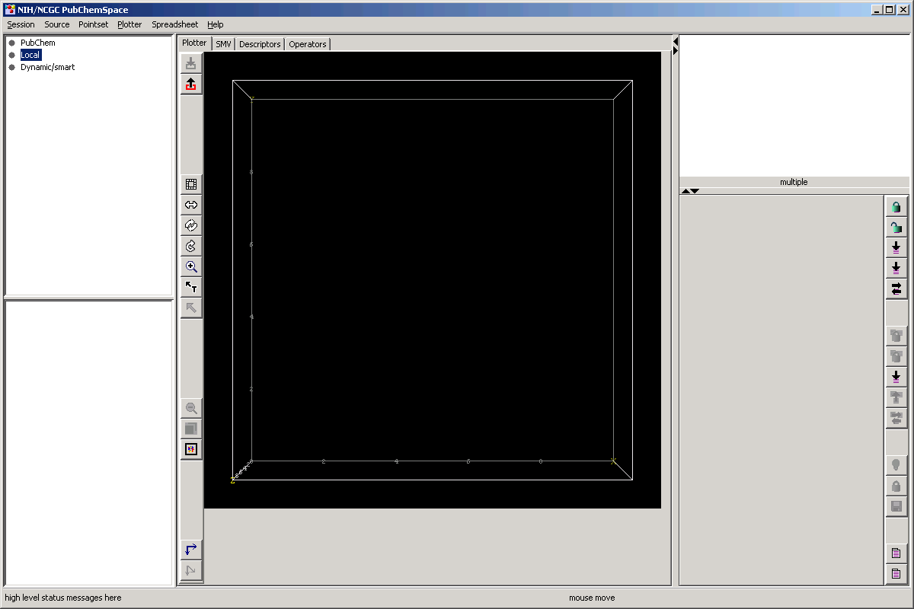

The total frame is split into 6 areas. Going from left to right, the left edge has the DATA SOURCE MANAGER at the top and the POINTSET MANAGER at the bottom. In the center is a VIEWERS tabbed pane which contains various viewers including the PLOTTER, SMV, DESCRIPTORS, and OPERATORS. The right edge has the PLOTTER MOLECULE VIEWER at the top and the pointset SPREADSHEET at the bottom.

The spatial layout reflects the workflow cycle which will start on the left, pass through the center, go to the right, pass through the center and start over at the left. Below, we visit each area in this cycle in turn.

DATA SOURCE MANAGER (upper left)

PCSpace is a data-intensive application and provides methods to relieve the user of some of the load of managing data. Central to this management is the notion of a DATA SOURCE. A DataSource is any collection of MOLECULES, values of DESCRIPTORS, and ACTIVITIES.

One type of DataSource uses the LOCAL file system as the I/O interface. This allows any application or user to place a file from any web site, script, or other application. All formats are CSV.

To specify a Local DataSource, the user chooses any number of folders/directories like the following:

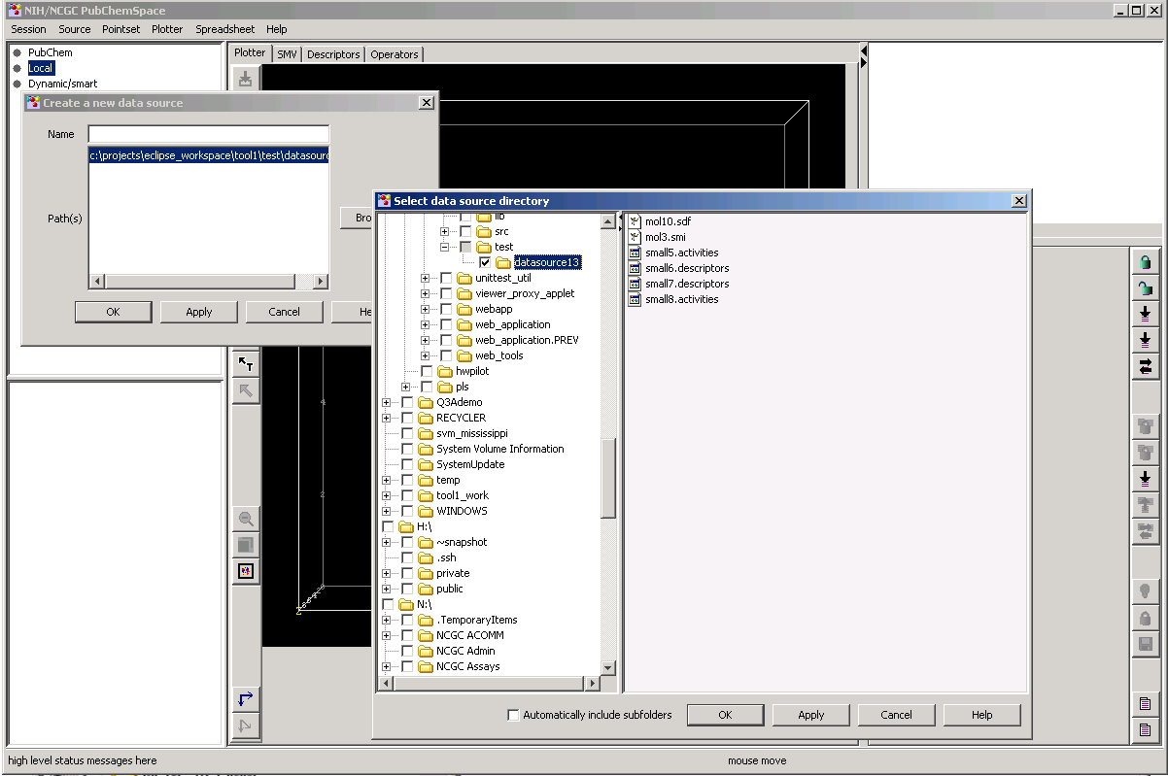

Once specified, the DataSourceManager locates all molecule containing files (*.sdf, *.smi, etc) in all specified directories, and joins any descriptor and activity information that can be found in files in the same specified directories to their respective molecule. The DataSourceManager “listens” for changes in the contents of the directories and keeps the DataSource synchronized with the local file system. For example, if the user drops more files into the directories, the DataSourceManager will read it and merge it into the current DataSource. So you can think of PCSpace as a “view portal” of dynamic DataSources.

The above listening mechanism is also used to read the results of DESCRIPTOR generation as we shall see later. Each DataSource records which Descriptors should be calculated for its Molecules. In the background, an ENGINE calculates any descriptors that are missing, creating a file that will trigger the DataSourceManager to merge it.

Other types of DataSources can be envisioned. One is a remote network socket that comes from a web service such as PubChem would provide. Such a service would provide a preplanned channel of DataSources which the user would simply observe. In other words, PubChem would decide what the user would see in a centralized manner, and ship it out to be visually perceived by masses of users in it participating network of volunteers.

Another type of DataSource would essentially be a search query that would appear to be “Smart” and find appropriate molecules, perhaps even based on the results the user just uncovered. We can also envision a hierarchy of nested DataSources.

POINTSET MANAGER (lower left)

Simply put, the purpose of the DataSource is to provide 2 or 3 numbers for each molecule (DESCRIPTORS) which will be the values of the coordinate POINT in PC space and to provide optional ACTIVITIES. The resulting collection of points is called a POINTSET.

Pointsets can be compared on the same plot if they have they have the same Descriptor BASIS which forms a mathematical space. The user can plot 2D or 3D subspaces by selecting 2 or 3 descriptors, respectively. The order of the descriptors is not important.

To create a Pointset, the user selects a DataSource from the DataSourceManager and subsequently selects which Descriptors and Activities to include like the following:
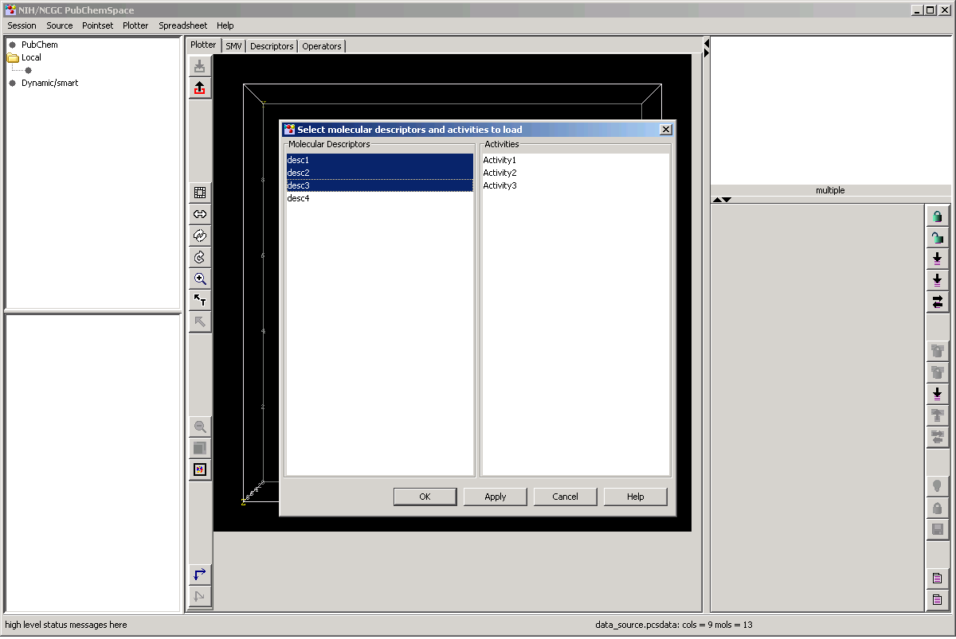

The selection of descriptors forms a Basis. Pointsets with the same basis are grouped together by a first level node in the Pointset tree.

Once loaded, the Pointset is plotted in the PLOTTER for the user to view, like the following:

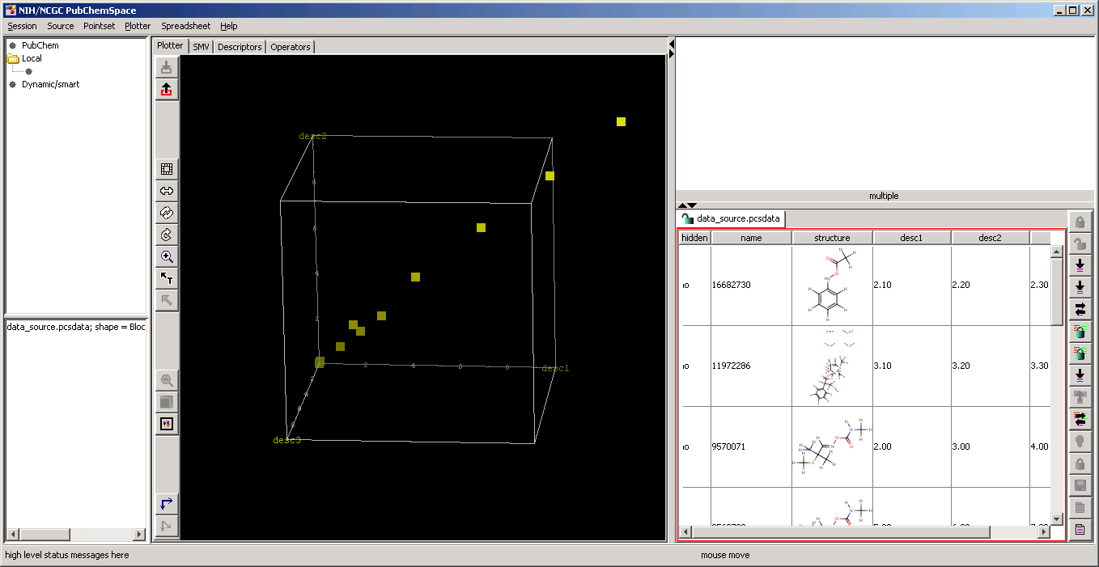

PLOTTER (center)

The Plotter draws the Pointset in the PChemspace. It’s two main purposes are to allow the user to perceive patterns like clustering and similarity and to allow selection of the compounds through hovering or clicking the drawn points.

For example, hovering the mouse over one point will cause the molecule to be drawn in the PLOTTER MOLECULE VIEWER (PMV, upper right) as follows (cursor not visible):

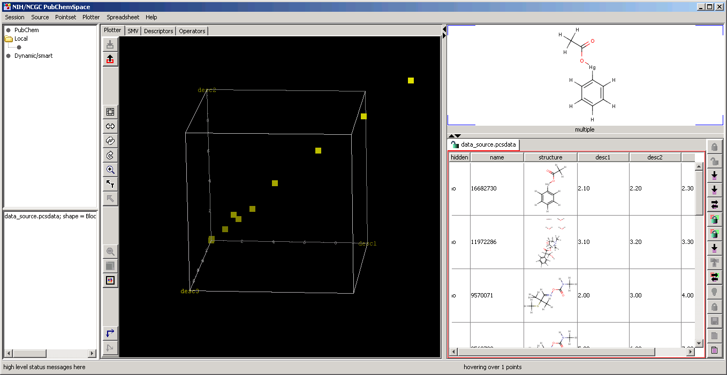

If there are more that one point, such as in the case where one point hiding behind another, the Plotter Molecule Viewer will show all in rapid succession. Hovering will allow the user to browse through Pchemspace. If the user clicks while hovering, the corresponding row in the SPREADSHEET is selected. When many points are desired to be selected and viewed, the user might employ a rubberband box selector which selects many of the rows in the Spreadsheet. Furthermore, the sense of the clicks may be change to deselection if desired. After a period of selection and deselection, the user has built up a collection of selected rows in the Spreadsheet.

In addition to synchronizing the selection process between the Plotter and Spreadsheet, the Plotter contains many other graphically-oriented tools that support easy viewing and selecting, such as stereoscopic viewing, view control, zoom, expandable canvas, etc.

SPREADSHEET (lower right)

The Spreadsheet provides a numerical view of all the Pointsets in the form of a table for each Pointset. As described in the Plotter section, the user may select rows through the Plotter, but also may select or deselect rows directly in the Spreadsheet. Since there is a bit of work deciding what to select, there is a user action which locks the selections in the table to prevent them from being changed. If structures are supplied with the molecules, they may be shown in the rows along with the selections, like the following:

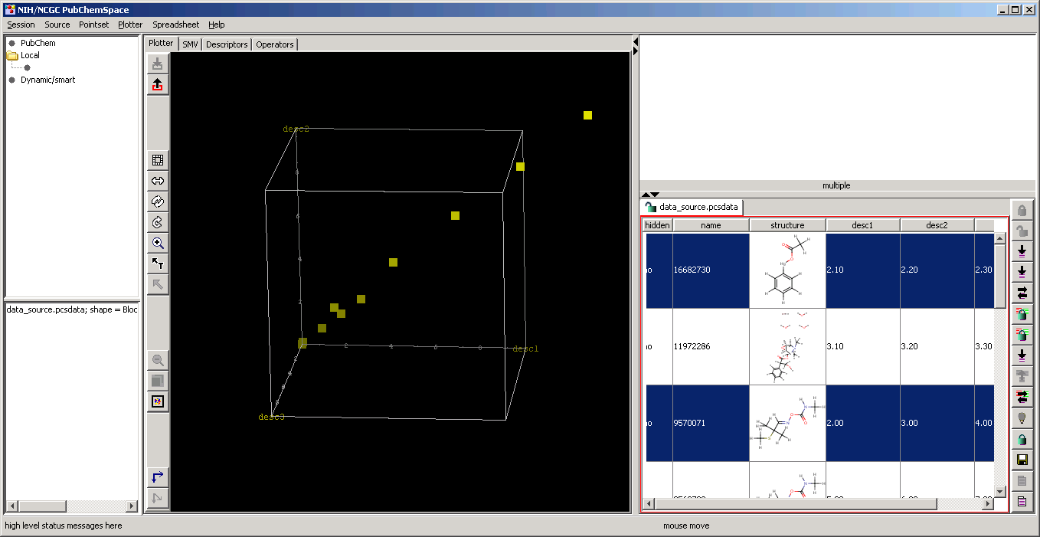

SPREADSHEET MOLECULE VIEWER (SMV, center)
Once the user selects rows from the Spreadsheet, they will want to view them all at once. This can be done by clicking a button in the SMV, which will show all the molecules in one large table. A synchronization between the SMV cells and the rows in the Spreadsheet may be very useful. Listeners between the two may be be used to keep the synchronization current, or a button may be used to update the synchronization manually. Furthermore, there may be more than one SMV in a tabbed pane format (not shown).

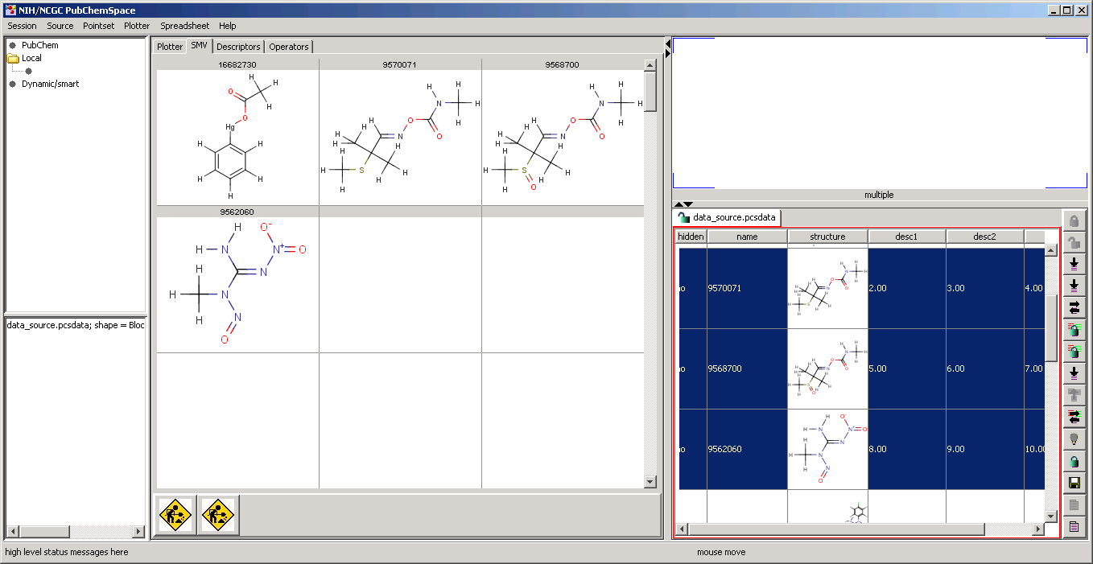

Once the user has finished selecting, the SMV can form a new DataSource from the displayed molecules and then the new DataSource will appear up in the DataSourceManager (upper left). The new DataSource will automatically be persisted across sessions of PCSpace until intentionally deleted.

ANNOTATIONS
The DataSource and perhaps other entities formed by the user should have the ability to be annotated. This will allow the user to take notes about the context in which a DataSource was created.

DESCRIPTOR MANAGER (center)
Descriptors are “the better half” of the PCSpace union. A Descriptor produce exactly one floating point number for each molecule.

The DescriptorManager will know all the Descriptors that are available. This will be done by accessing a directory which contains an XML file which contains all the information required to apply the Descriptor to the molecules in the DataSource. The information basically includes the name of the program/plugin, and the parameters to run it. This loose-coupling XML approach allows new Descriptors to be added by the user directly.

The Descriptor will be presented through a “viewlet” which is an XML Editor, like the following for BCUTs:

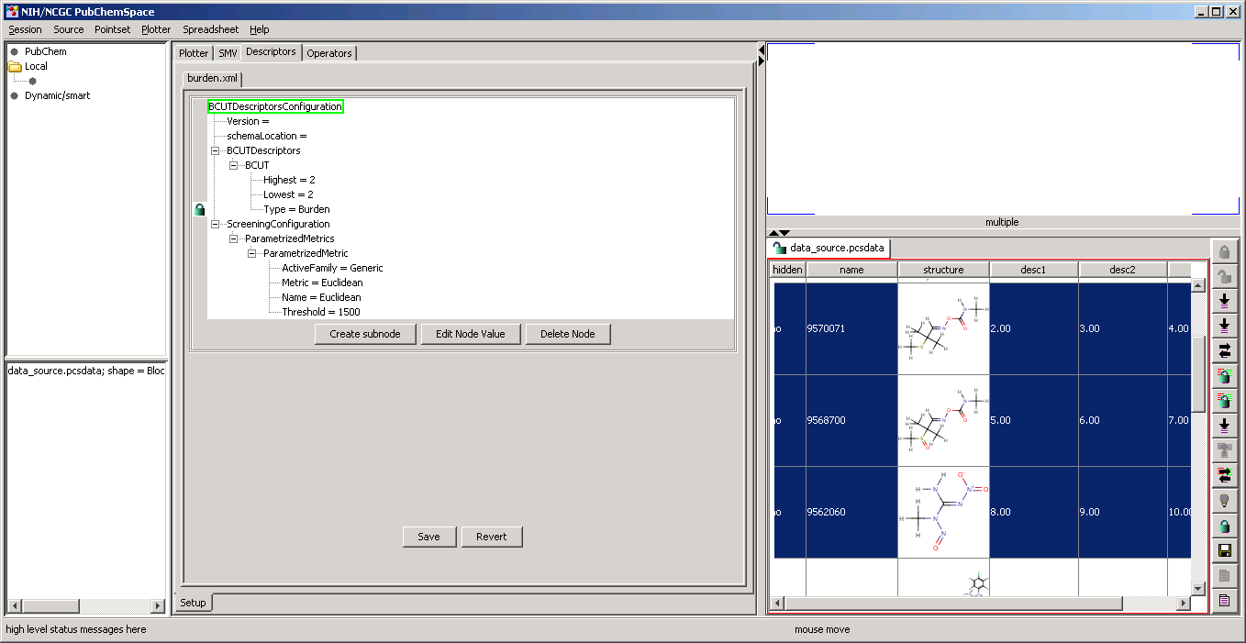

The XML files are installed in a known directory, and the DescriptorManager will be listening to this directory. In turn, the DataSourceManager will listen to the DescriptorManager, and if a Descriptor is removed or saved, the DataSourceManager will update the DataSources such that the DataSource can update their descriptor values if the user has selected that Descriptor.

A dialog to assist the mapping of new Descriptors and DataSources will allow provide a Descriptor-centric management.

Descriptors values are always calculated by an ENGINE that is running in the background. This will generate a descriptor value file that will be autoassembled by the DataSource as described in the DataSource section.

OPERATOR MANAGER (center)
In contrast to descriptors, an Operator applies a mathematical operation to a Pointset and returns another Pointset.

TEST CASES
New Datasource

New Pointset

CONCLUSION
The above provides a complete description of the first verion of PCSpace, with no missing pieces that are significantly important. In other words, these requirements are stable. Thus, implementators will not find themselves undoing their work as requirement change.

The primary purpose of PCSpace is to navigate spaces for purposes of assessing the diversity or focus of libraries, and to find clustering or other trends in the data.

Secondarily, it is hoped that the integrated environment that PCSpace provides will encourage descriptor development and novel application processes.

