Here is a demonstration that shows the DataSource -> Pointset creation pathway, this code exists but needs to be tested and debugged. The following was actually done with version 62 alpha.

When PCSpace starts it will ask for its root working directory:

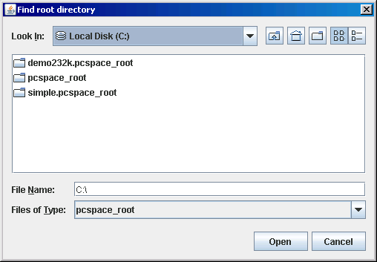

You will see that a DataSource is already loaded.

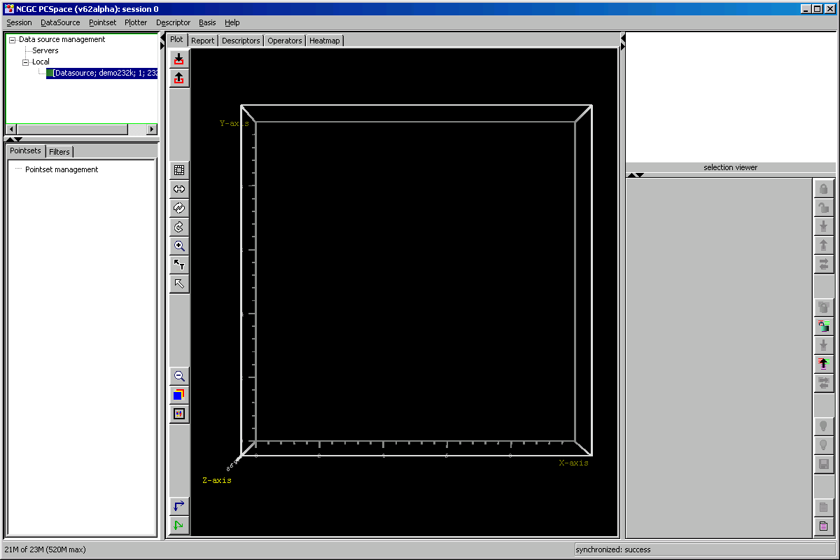

Right-click on the selected DataSource and select “Create Pointset”. You are asking PCSpace to read data from disk into memory as a Pointset which will consist (very essentially) of rows of molecules with columns as descriptors. You need to specify which columns you want and which rows you want because you can’t read the entire DataSource in, it is way too big.

You will see the following dialog. PCSpace needs a Basis to continue. A Basis is a collection of Descriptors (think “columns” for now). It give PCSpace the notion of a chemistry space. Once PCSpace learns of a Basis, it memorizes it and you can use it again, otherwise, you need to create it. Let’s create it, click the lower radio.

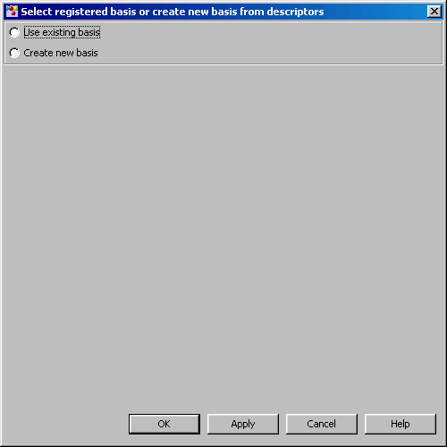
You will see the following. PCSpace knows about all these descriptors. Let’s create a Basis based on PCA. Note: This is not technically a basis, because the PCA axes are not technically descriptors, but this will be handled in a later version. Scroll down and multiply select PCA1, PCA2, PCA3, but also select a fourth descriptor that you want to use to colorize the data points with, any supplied number will do. (Strings will be handled later.)

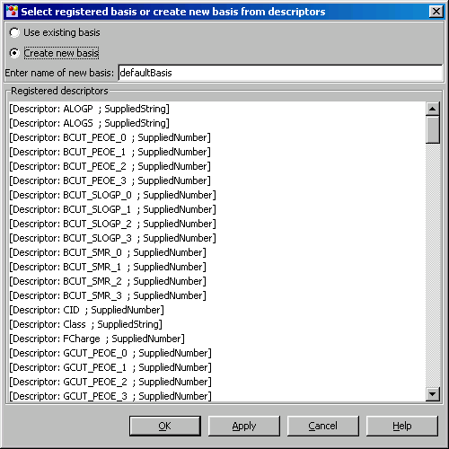

Don’t forget to name your new Basis:
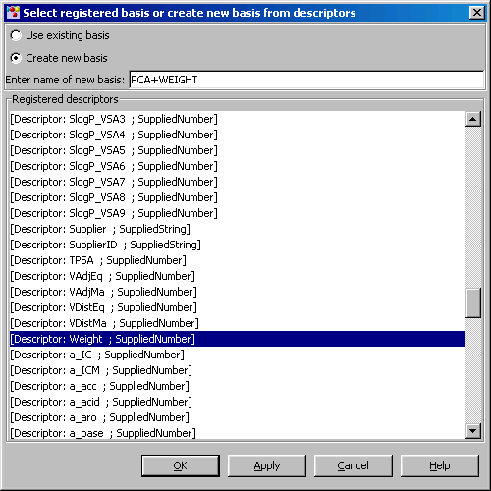

Click OK.Notice that the Basis becomes visible in the Main window:
Now you will see the following dialog. This is where you select the ROWS or molecules from the DataSource that will form the Pointset by creating a filter. If you want to pass all molecules and use no filer, just click OK. Otherwise, you need to build a filter. A filter is composed of a series of Matchers. A Matcher is simple: if the descriptor value is inside a range then the Matcher returns true, else false. A range can be specified by any two real number including infinity.

The Matchers for the various descriptors are assembled into an AND/OR tree. AND is horizontal depth-direction, and an OR is vertical breadth-direction. To determine whether a match occurs for a molecule, the tree is traversed in a depth first manner, and the first time it reaches a leaf, a match occurs and the Filter admits the molecule (row).

Let’s use the “Class” descriptor to create a Pointset. Select “Class” from the registered descriptors panel.

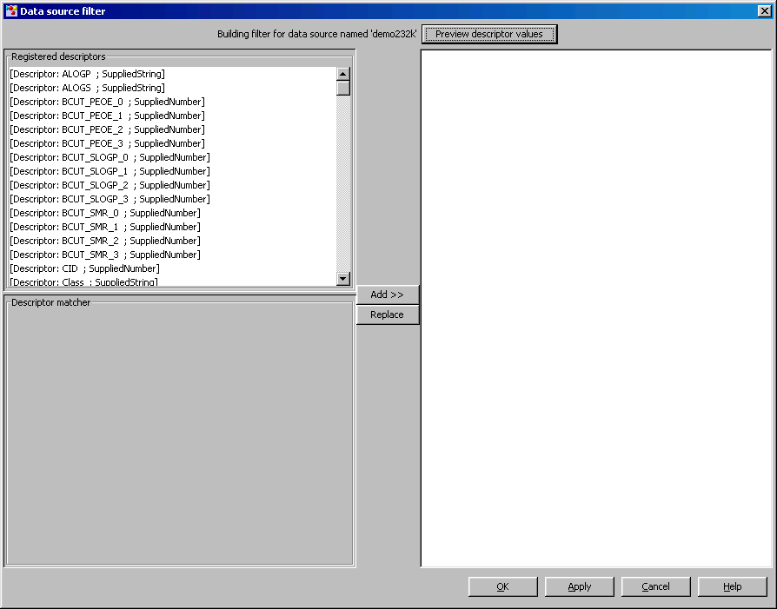

You will see the following dialog. Notice that the descriptor matcher panel is asking for actual values. But what do you put in there? You would need to know before hand what the DataSource contained. Instead, click the “Preview descriptor values” button and you will see a progress bar run as it scans the “Class” descriptor values to preview the possibilities that you can enter.

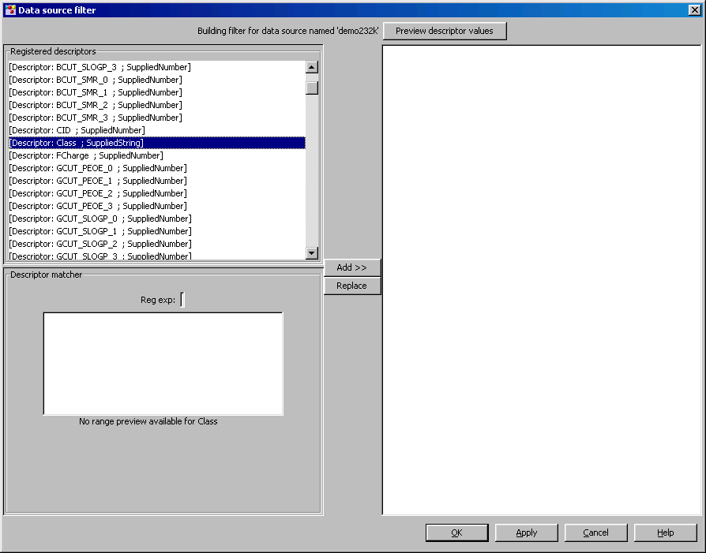

This is what the dialog looks like after previewing:
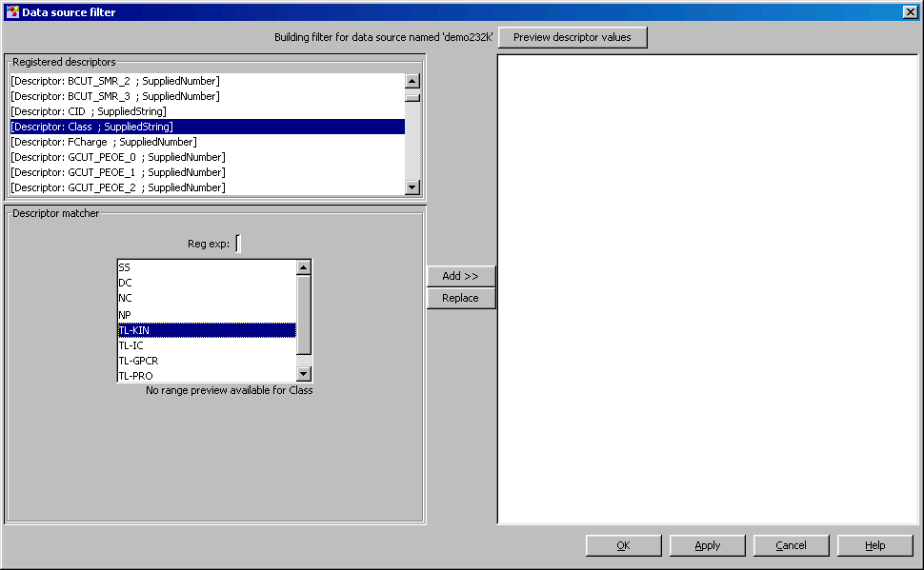

Select TL-KIN and Click the Add button to add the Matcher to the preview tree. Now all rows with the “Class” descriptor with value “TL-KIN” will pass the Filter:
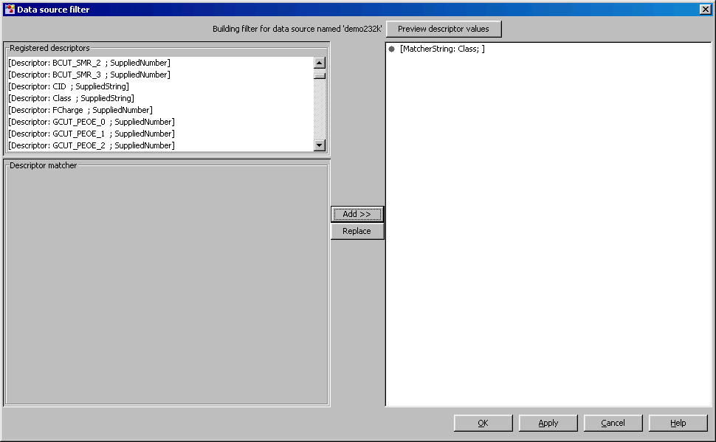

Then Click OK. You will see a progress bar appear in the Pointset Management tree that shows the matching and fetching of the molecules and data from the DataSource. When it is finished, your new Point set is almost done, and you need to specify its other properties. A dialog pops up and lets you do that:

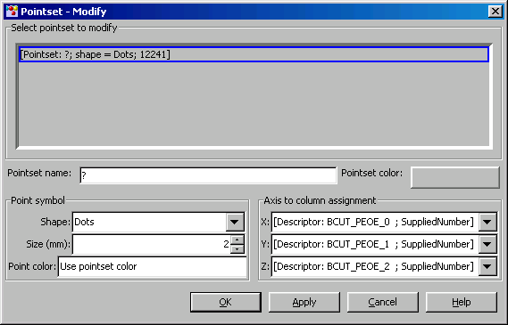

First, type in the name, such as “TL-KIN”.

Select the Axis to Column assignment. This selects which Descriptor to assign to which axis on the Plot. NOTE: these should read PCA1, PCA2,PCA3, but there was a parse error bug which needs to be fixed.

Select the color of the Pointset. This is used throughout PCSpace for visual indication. By default, it will be used to color the points as drawn on the Plot. However, we want to use another Descriptor to colorize the Points. Click the “Use pointset color box”:

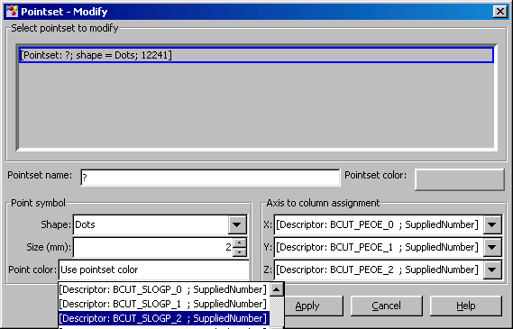

You will select the desired descriptor to colorize the points here. NOTE: the dropdown should read PCA1,PCA2,PCA3, MW but there is a parse bug again and I had to kludge a demo together. Select “MW”. You will see the dialog expand and expose the Colorizer:

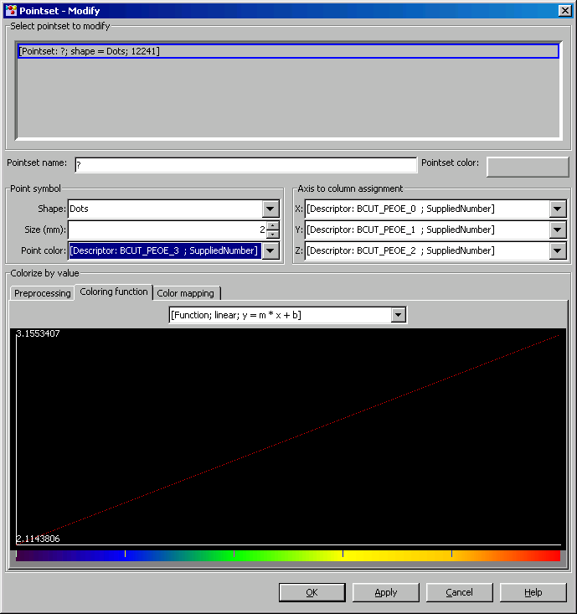

Focus on the Colorizer. It looks a little cryptic, but it is easy to understand once the theory is understood. The “Coloring function” transforms the range of descriptor value of “MW” to the range of 0.0 to 1.0. The range of the descriptor value is found on the Y axis. (2.1 to 3.2). The X-axis range is 0.0 to 1.0, but this is represented by a color bar. So what this tab is saying, is that we are mapping the descriptor values with a linear function. An graph of the actual function allows you to estimate color or value directly from the other, as you are exploring the Plot.

You can also change the linear function to another. A log10 function will spread out the upper range values so you can investigate more closely.

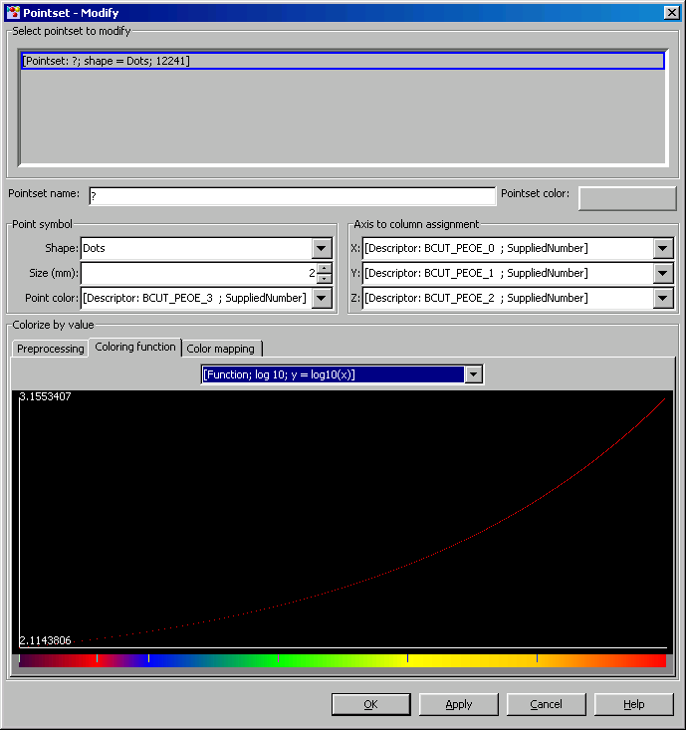

Click the Color mapping tab. You will see this:
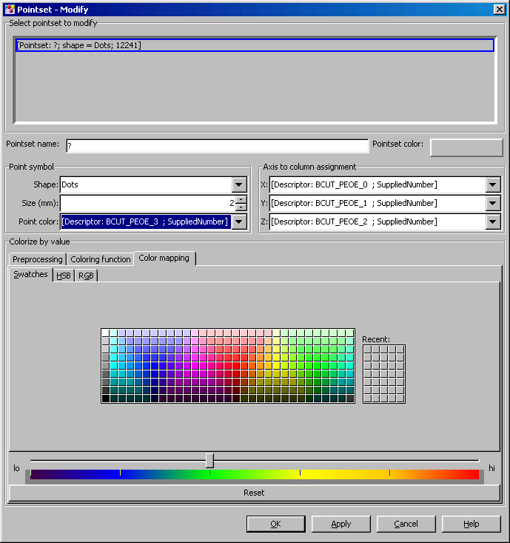

This where you assign a color to the 0 to 1 range. This is done through a list of “Waypoints” that are depicted as tics on the Color bar. Each Waypoint represents a color, and the colors are linearly interpolated between the Waypoints. Move the slider and click a color and you will see something like this:

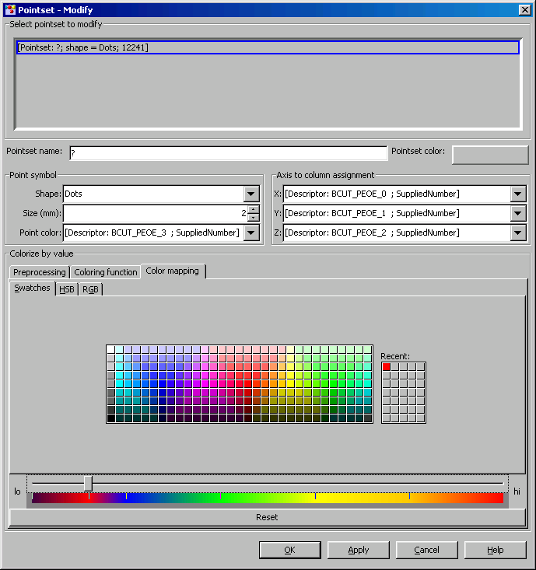

Notice the new red Waypoint at the left. If you go back to the second tab, you will see this:

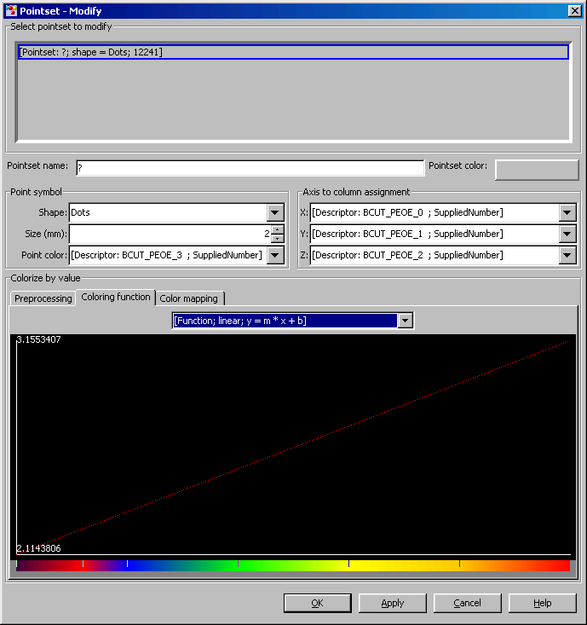

Now when you click Apply, the lower end of your data will be colored redder.

The above colorizes the descriptor values for “MW” itself. Suppose you need to find the outliers in your data away from the average. You need to colorize something different than the original data. You need to “preprocess” the data. Click the Preprocessing tab.

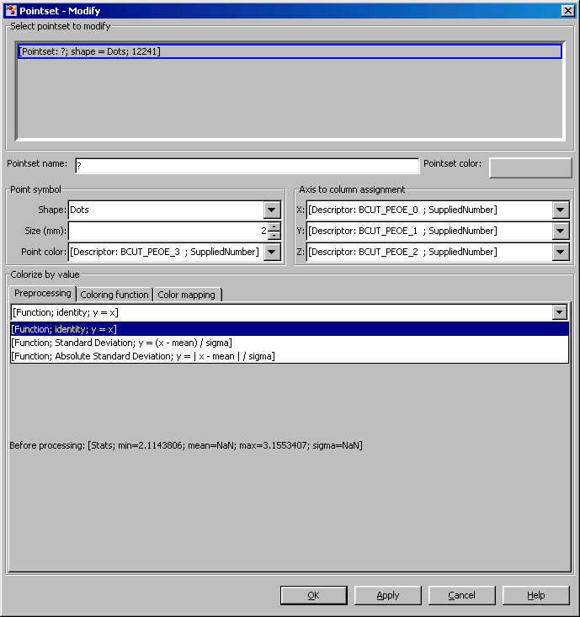

It’s not well developed but it provides three preprocessing options. NOTE: there is a bug with the mean and sigma, first time seen.

Now back to specifying the Pointset properties. Specify the Name and shape of points, and you are finished. Your new Pointset will be shown as follows:
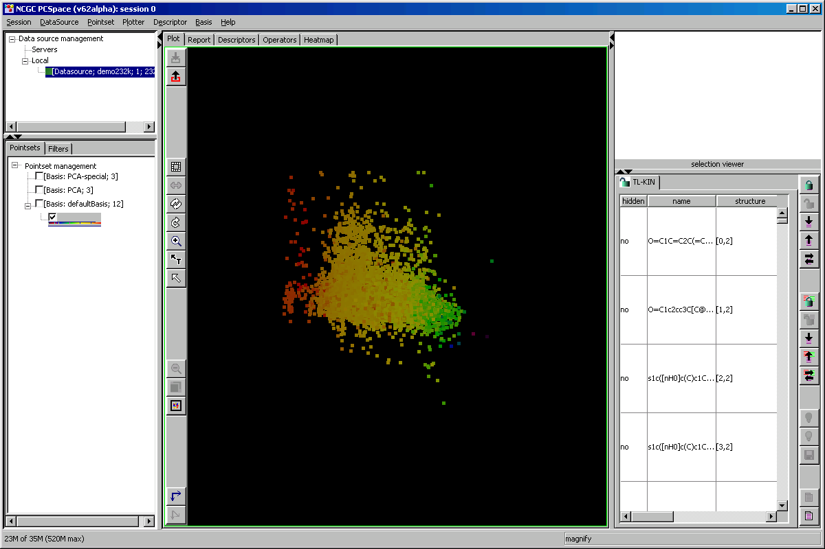

Notice that the Color bar is presented next to the name in the tree (NOTE: name missing, bug) to remind the user what the color means. The Spreadsheet has updated its table and the user is ready to explore the pointset.

