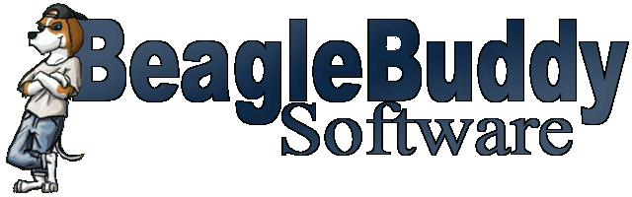

Non Compete Agreement

For good consideration and as an inducement for Beaglebuddy Software, located at 3072 N. 87th Street, Scottsdale, AZ 85251, to allow Sandy Jury, the undersigned, to become a member of the Beaglebuddy Tab Editor Project, hereby agrees not to directly or indirectly compete with the business of the Company and its successors and assigns during the period of the membership to the project and for a period of 1 year following termination and notwithstanding the cause or reason for termination.
The term "not compete" as used herein shall mean that the project member shall not own, manage, operate, consult be a member of, or be employed in a business substantially similar to, or competitive with, the present business of the Company or such other business activity in which the Company may substantially engage during the term of being a project member.
The project member acknowledges that the Company shall or may in reliance of this agreement provide the project member access to trade secrets, source code, implementation details, screen designs, customer lists and other confidential data and good will. The project member agrees to retain said information as confidential and not to use said information on his or her own behalf or disclose same to any third party.

__________________________________ ______________
project member date

__________________________________ ______________
beaglebuddy software representative date

