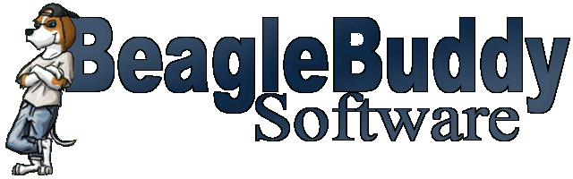

Non Disclosure Agreement

Sandy Jury agrees that any and all knowledge or information that may be obtained in the course of the being a member of the Beaglebuddy Tab Editor Project, with respect to the conduct and details of the business and with respect to the secret processes, formulas, source code, screen designs, etc. used by Beaglebuddy Software in creating its applications will be forever held inviolate and be concealed from any competitor and all other persons and that he or she will not engage as employer, employee, principal, agent, project member, or otherwise, directly or indirectly, at any time in a similar business or project, and that he or she will not impart the knowledge acquired to anybody and that should he or she at any time leave the Project, he or she agrees not to enter into the service or otherwise act in aid of the business of any rival company, concern, project, or individual engaged in the same or in similar lines of business. If he or she does so in violation, Beaglebuddy Software shall be entitled to an injunction by any competent court of equity enjoining and restraining him [her] and each and every other person concerned from continuance of employment, services or other acts in aid of the business of the rival company or concern. Nothing shall prevent him [her], upon the termination of the project, in engaging in any occupation in which the processes, formulas, and other secrets of the employer will not be directly or indirectly involved.
Sandy Jury agrees to use his best efforts to prevent and protect the Confidential Information, or any part thereof, from disclosure to any person other than the project members of the Beaglebuddy Tab Editor Project having a need for disclosure in connection with authorized use of the Confidential Information.
Sandy Jury agrees to take all steps reasonably necessary to protect the secrecy of the Confidential Information, and to prevent the Confidential Information from falling into the public domain or into the possession of unauthorized persons.

________________________ ___________________________
project member date

________________________ __________________________
beaglebuddy software rep. date

