Problem 1: “hello.cpp”

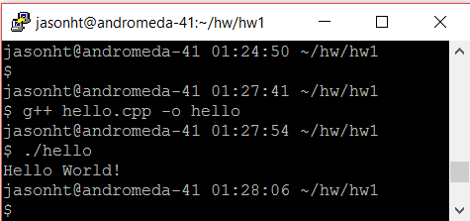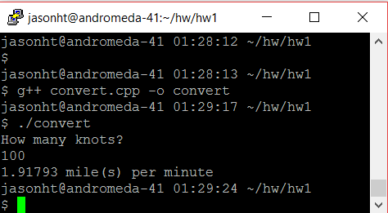

Problem 2: “convert.cpp”

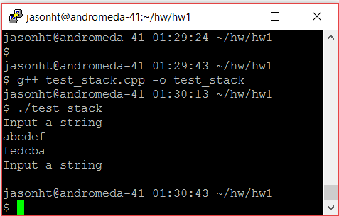

Problem 3: “test_stack.cpp”