# Bridge Inspection Robot

ECE4011 Senior Design Project

Section L01, Bridge Inspection Robot Team Project Advisor, Dr. Patricio Vela

Sean Csukas, [sean.csukas@gatech.edu](mailto:sean.csukas@gatech.edu) Kristen Fernandez, [kfernandez7@gatech.edu](mailto:kfernandez7@gatech.edu) Erikzzon Latoja, [elatoja@gatech.edu](mailto:elatoja@gatech.edu)

Justin Tamayo, [jtamayo6@gatech.edu](mailto:jtamayo6@gatech.edu) Sanmeshkumar Udhayakumar, [sudhayakumar3@gatech.edu](mailto:sudhayakumar3@gatech.edu)

Submitted

January 23, 2017

# Table of Contents

Executive Summary (5 pts) iii

1. Introduction (5 pts) 1
   1. Objective 1
   2. Motivation 2
   3. Background 2
2. Project Description and Goals (15 pts) 3
3. Technical Specification (20 pts) 3
4. Design Approach and Details (20 pts)
   1. Design Approach 4
   2. Codes and Standards 24
   3. Constraints, Alternatives, and Tradeoffs 24
5. Schedule, Tasks, and Milestones (10 pts) 26
6. Project Demonstration (5 pts) 26
7. Marketing and Cost Analysis (5 pts) 30
   1. Marketing Analysis 30
   2. Cost Analysis 30
8. Current Status (10 pts) 32
9. References (5 pts) 33

Appendix A 35

Appendix B 36

Appendix C 37

Appendix D 39

Appendix E 40

**Executive Summary**

The maintenance of civil infrastructure systems is a constant challenge faced by today’s engineers. Structural health monitoring is critical for identifying sections of civil infrastructure in need of repair, but traditional methods for doing so are time-consuming and costly. As an alternate solution, a network of wirelessly sensing robots can be developed to overcome these obstacles.

The main objective of the team is to design a wireless sensing robot that can be used for structural health monitoring of civil structures, particularly bridges. The Bridge Inspection Robot will consist of a computing core, various sensors, a wireless transceiver, and a custom movement mechanism that will permit the robot to autonomously scale bridges. The old wheeled design of the robot was limited in its ability to move along paths that were not a straight line. The team proposes several new designs that will allow the robot to turn corners and take non-linear paths more efficiently than the original design. New electrical and mechanical components will also be worked into the design to ensure that the robot has the most up-to-date parts.

On a larger scale, this Bridge Inspection Robot would be part of a network of wireless sensing robots. This project will focus on just prototyping a single robot as a proof of concept that the larger network of robots is feasible. The total cost of one Bridge Inspection Robot is estimated to be roughly$598.

# Bridge Inspection Robot

1. **Introduction**

The Bridge Inspection Robot team will design a wireless sensing robot that can autonomously maneuver a steel structure and take measurements of the frequency response with an attached accelerometer. The team will take the old wheeled-based design of the robot and upgrade it with a newer design with several mechanical and electronic improvements. The team proposes several legged and wheeled designs to accomplish this, however the team is currently favoring a three-wheeled design as the most effective solution. The team is requesting $598 to fund the prototype of the new robot.

* 1. Objective

The main objective of the team is to design a wireless sensing robot that can be used for structural health monitoring of civil structures, particularly bridges. This Bridge Inspection Robot will be capable of scaling structures and wirelessly sending accelerometer data to an external server for processing. The robot will be constructed to be as lightweight as possible to allow it to be carried by a quadcopter for placement onto a bridge. The current design of the robot will be reworked from the ground-up to create a prototype that has increased maneuverability and improved mechanical and electrical components. Figure 1 shows the old wheeled prototype of the robot that was created in 2011. This design, although functional, was limited in its ability to move along paths that were not a straight line. The team proposes several new designs that will allow the robot to turn corners and take non-linear paths more efficiently than the original design. New electrical and mechanical components will also be worked into the design to ensure that the robot has the most up-to-date parts.

On a larger scale, this Bridge Inspection Robot would be part of a network of wireless sensing robots. These robots would take measurements in one small neighborhood and then move on to the next part of the bridge, until the whole structure is scanned. However, this project will focus on just prototyping a single robot as a proof of concept that the larger network of robots is feasible.

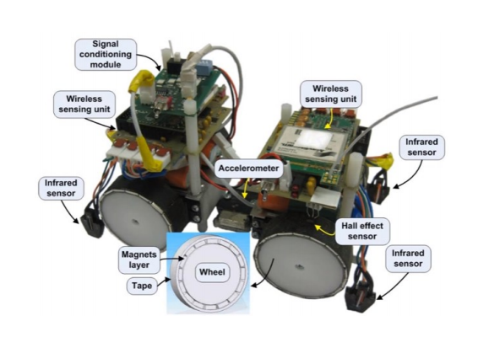

**Figure 1.** Wheeled prototype of the robot created in 2011

## Motivation

The repair and maintenance of civil infrastructure systems is a constant challenge faced by today’s engineers. Visual inspections of bridges have been shown to be highly subjective, as different inspectors can give drastically different condition ratings for the same bridge. Conducting a visual inspection also only shows damage that is visible at the surface, leaving damage that is below the surface undetected [1]. As an alternative solution, structural health monitoring (SHM) systems are widely used to assess the conditions of civil structures. In a SHM system, accelerometers and other types of sensors collect data and monitor structural behavior [2]. Traditionally, cables and wires connect sensors to a central server, but these systems are typically high cost and time-consuming to install [3]. The development of a network of wirelessly sensing robots for SHM overcomes these difficulties [4]. The team aspires to create a new design of the Bridge Inspection Robot that is not only functional, but will perform its functions with improved maneuverability.

## Background

There has been an increase in research for developing small-scale agile robots for inspecting engineered structures. These robots are typically used individually, and not in a mobile sensing network to provide measurements at multiple locations [4]. These robots also employ multiple methods to navigate different kinds of surfaces. For example, a robot with two magnetic wheels in a motorbike arrangement was developed to inspect the inner casing of complex-shaped metal pipes [5]. One kind of wall-climbing robot was developed using elastomer dry adhesion [6]; another robot uses claw-gripping to climb walls [7].

Recently, a model helicopter was developed to serve as a mobile host for charging and communicating with wireless sensors [8]. However, there are currently no products on the market that can dynamically move about a structure for the purposes of structural health monitoring.

# Project Description and Goals

The team will design and build a prototype robot that can navigate bridges and record structural vibration data, which can then be used to monitor the structural health of these bridges over time. Components include a 32-bit microcontroller, a high-resolution accelerometer, IR sensors, a gyroscope sensor, a GPS sensor, and a wireless transceiver. The robot’s movement will be implemented through a permanent-magnet three-wheeled design, which will allow the robot to safely move along steel bridges in two dimensions. A PC will wirelessly connect to the robot in order to send commands and store received sensor data. Features for the robot include:

* Ability to horizontally and vertically traverse steel bridges
* Measure bridge vibrations at low frequencies
* Wirelessly transmit vibration data to a PC
* Can be deployed and retrieved by a drone (quadcopter)
* Cost around $598

# Technical Specifications

**Table I**

Technical Specifications of the Bridge Inspection Robot

|  |  |
| --- | --- |
| **Characteristic** | **Specification** |
| Magnet Holding Force | Shall hold ≥ 2 kg of mass static for 2 minutes |
| Operational Lifetime | Shall have active operation time ≥ 1 hour  Shall have passive operation time > 1 hour |
| Accelerometer Range and Accuracy | 0-50 Hz ± 0.5 Hz |
| Robot Size | 0.25 m Width by 0.25 m Height |
| Weight | Total Robot Mass ≤ 1 kg |
| Wireless Communication Distance | Able to send data ≥ 800 m |
| Avoiding Falls | Shall not fall off bridge in “sunny day” conditions |

# Design Approach and Details

## Design Approach

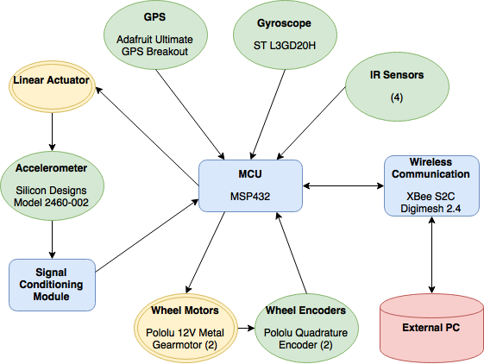The Bridge Inspection Robot will utilize a permanent-magnet three-wheeled design that will permit the robot to scale bridges. Other critical components include a microcontroller, various sensors, and a wireless transceiver.

**Figure 2.** Block Diagram of Robot Operation

## Robot Mobility

*4.1.1.1 Legged Designs*

The team proposes two legged designs for the robot to traverse the bridge. The first design is shown on the left of Figure 3; it features two legs attached by joints to a single rigid body. The robot will have strong electromagnets on the “foot” of each leg to attach it to the surface and servos will control the joints to move the legs. The right image of Figure 3 shows how this robot will move in a waddling fashion. The electromagnet in one leg will be engaged, allowing the robot to hold that foot in place. The magnet in the other leg will be off, and the servos in this leg will drive the leg and the body to swing forward. This magnet will turn on, the other magnet will turn off, and the process continues. This method requires a magnetic surface such as steel; it will not work effectively on concrete or wood. Future iterations may consider uses of "microspine" material, which would allow a powerful grip onto porous surfaces such as concrete [7].

By controlling how much the robot swings its body forward, it can turn almost any angle which was a feature that the older design was unable to perform. However, there are several problems associated with a legged design. As this design currently is, there is no mechanism to allow the robot to left up its legs vertically. Therefore, it could not traverse up inclines or go around corners, such as from a vertical surface to a horizontal surface. The robot would also scrape its legs against the floor as it moves, which could result in damage to the robot. Moving forward through the process of swinging its legs repeatedly also leads to complicated movement controls and mechanical complications as well.

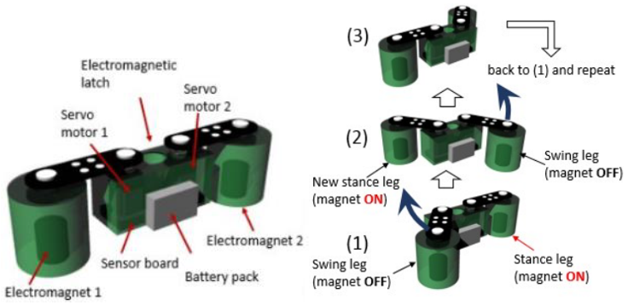

**Figure 3.** The design for a robot with legs attached by joints (left) and how this robot will move by waddling (right)

To avoid these mechanical complications, the team proposes a second legged design as shown in Figure 4. This robot has a single rigid body and the legs are attached to it without joints, and electromagnets would be located in the robot’s “feet” (similar to the other design). Servos are attached in the legs of the robot. Movement would occur in a similar way to the joint-legged robot. This design solves the mechanical complications that arise when using a joint-legged design; however, this robot still has all of the other problems that come with that other design.

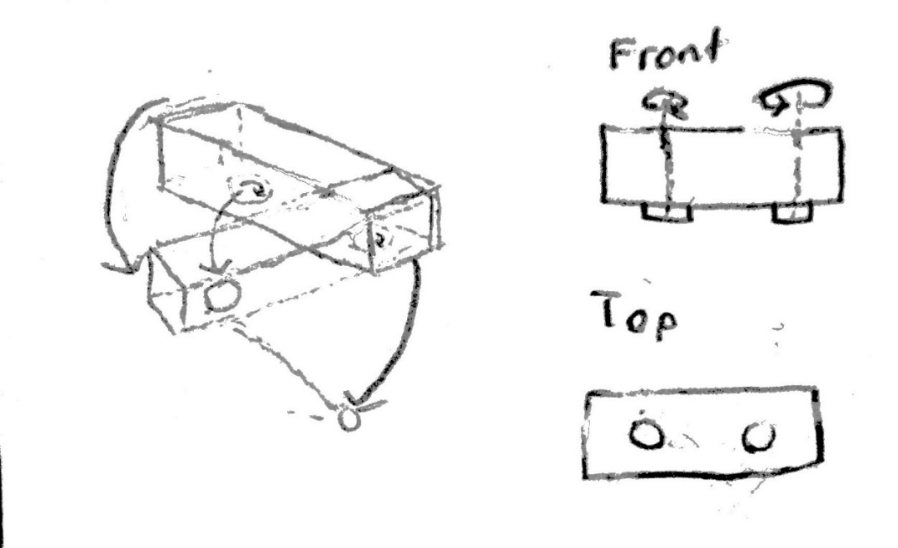

**Figure 4.** Design showing the front view of the legged robot without joints (top right), a top view of this design (bottom right), and a diagram showing how this robot would move (left)

*4.1.1.2 Two-Wheeled Design*

Another viable movement mechanism for the robot is to use a two-wheeled design with a single rigid body, as shown in Figure 5. The perimeters of the wheels would be surrounded with small permanent magnets that would provide enough attraction forces between the wheels and the surface, as shown in Figure 6.

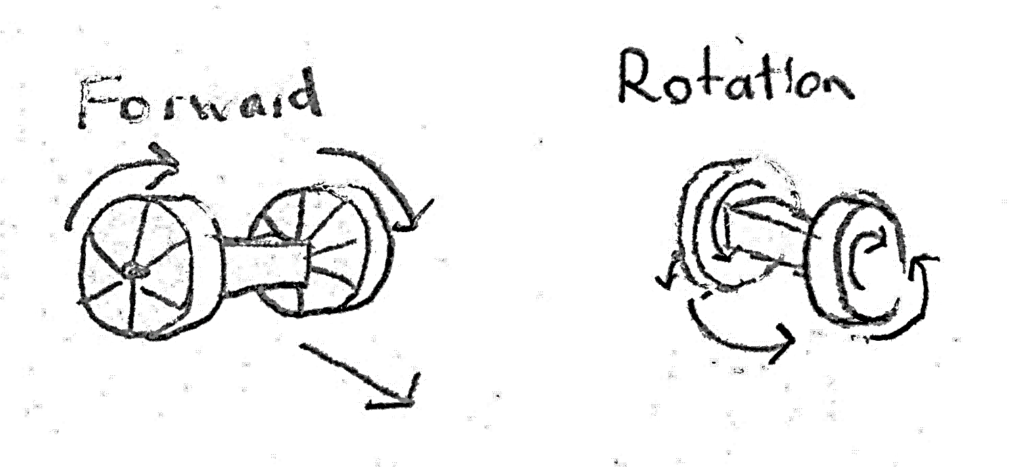

**Figure 5.** Diagram showing how the two-wheeled robot would move forward (left) and how the robot would rotate in place (right)

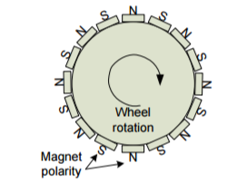

**Figure 6.** The placements of the permanent magnets on a wheel of the robot

A wheeled design offers many positives, such as simple movement controls, fast traversal of linear paths, less power consumption compared to a legged design, the ability to rotate in place, and traversal of inclines.

Yet there are some problems that arise with this design as well. When this robot traverses inclines, its body will not stay parallel to the surface it is on – instead, the body would stay horizontal. If the robot’s body is not parallel to the surface below it, then the accelerometer will not be flush against the surface. Therefore, an additional system would need to be designed to ensure that the accelerometer is deployed properly. However, the biggest problem this design poses would be the process of actually moving the robot forward. When the motors for the wheels are driven, the light weight of the body compared to the weight of the wheels plus the attractive forces of the magnets would result in the body rotating in place instead of the wheels rotating. One way to overcome this problem would be to make the body heavier, but this would needlessly add weight to the robot, which opposes the team’s design considerations.

*4.1.1.3 Three-Wheeled Design*

Another solution to the movement problem posed by the previous design is to simply add another wheel. This design as shown in Figure 7 features a single rigid body with two motorized wheels at the front and a either a caster wheel or ball bearing at the back. Permanent magnets would surround the two motorized wheels. Permanent magnets will also surround the caster wheel if it used, and if the ball bearing is used then a strong permanent magnet would be placed above the ball bearing and the magnetic forces would essentially pierce through it.

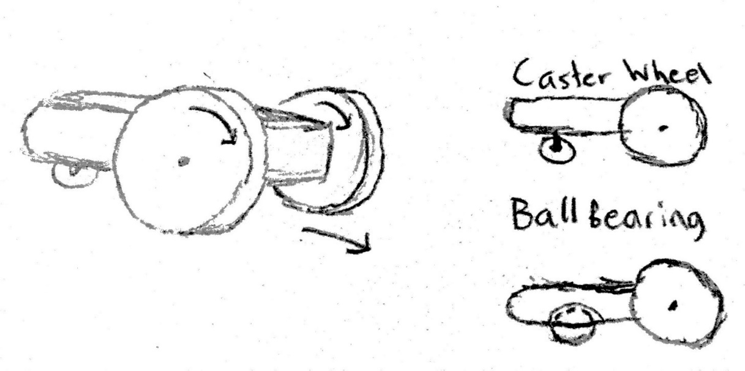

**Figure 7.** The design for a three-wheeled robot, with either a caster wheel or ball bearing in the back

By having a longer body and a magnetized wheel in the back, when the motors are driven there is no longer enough torque for the whole body to flip over, and the wheels will rotate instead. This design would also retain all the positive characteristics of the two-wheeled design as well. However, implementing a caster wheel or ball bearing into the design would be mechanically complicated, and nobody on the team has the experience to implement that aspect of this design. The team would require the help of a Mechanical Engineer for this part of the project.

To ensure that this design could traverse corners, the team would also need carefully design the robot so that the rigid body is raised around the two front wheels, so that it will not hit or scrape the surface while it is rounding a corner.

*4.1.1.4 Four-Wheeled Design*

The team also considered a design with four motorized wheels and a rigid body shown in Figure 8. This design would also involve surrounding each wheel with permanent magnets.

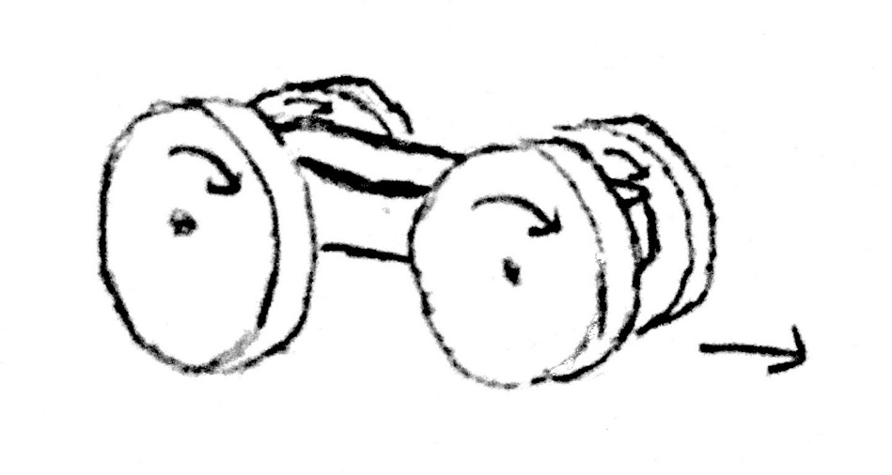

**Figure 8.** A four-wheeled robot with a rigid body

This robot would also have simple movement controls, traverse paths quickly, and climb inclines. Compared to the original flexure-based four-wheeled robot, this design would have thinner wheels, resulting in it having a smaller form factor. This robot would also be more stable compared to the two- and three-wheeled designs. However, this design may encounter the same problem as the old four-wheeled design in that it may have trouble turning. The magnetic forces keeping the robot attached along with a wide wheel width may not allow enough slippage for the robot to turn. The team would need to find the correct balance to allow for mobility while ensuring that the robot would stay attached to the surface. The extra motors needed to drive this robot would also add more weight and power consumption compared to the other wheeled designs.

*4.1.1.5 Mobility Choice*

The team has decided upon the three-wheeled design as the choice for the robot’s mobility. Not only does this robot overcome the forward movements that the two-wheeled robot encountered, but it retains all the pros of that design as well. Also, this design trumps the four-wheeled robot in terms of its mobility and lower weight and power consumption.

## Motor Selection

In the chosen three-wheeled design, one motor will drive each of the front two wheels. The third is passive. The motors have no inherent size constraint, but should have minimal weight. Additionally, there are no given speed requirements for the robot, but given a maximum bridge length of 100m, and an expected runtime of 1 hour, the robot would have to travel at least 0.028m/s. The torque requirements can be seen in Eq. 1. This is based on the maximum torque scenario of driving vertically upward. A weight of 1kg and wheel radius of 5 cm are given. A maximum acceleration of 5m/s is assumed.

(1)

Given two motors, 3.82 kg-cm per motor is the minimum torque for each motor. Both continuous servos and brushless DC motors were considered. Table 2 shows the various considerations.

**TABLE II**

Motor Considerations for Bridge Traversal

|  |  |  |  |  |  |  |  |
| --- | --- | --- | --- | --- | --- | --- | --- |
| Motor Name | Motor  Type | Operating  Voltage | Current Draw | Torque | Speed | Interface | Weight |
| Dynamixel  Ax-12 | Servo | 9V-12V | 50mA/900mA | 15.3kg-cm | 59 RPM | Async  Serial | 55g |
| Futaba S3003 | Servo | 4.8V-6V | 8mA/400mA | 4.2kg-cm | 52 RPM | Analog | 44.2g |
| Tower Pro  MG995R | Servo | 4.8V-6V | 30mA/400mA | 10kg-cm | 62 RPM | Pulse | 55g |
| Micro Gear  Box Motor | BDC | 12V | 110mA/800mA | 4kg-cm | 100RPM | PWM | 193g |
| Pololu 37D metal gearmotor | BDC | 6V  12V | 250mA/2.5A  300mA/5A | 9kg-cm  18kg-cm | 80RPM  40RPM | PWM | 205g |
| Pololu 25D metal gearmotor  w/ encoder | BDC | 12V | 100mA/1.1A | 6kg-cm  8kg-cm  … | 71RPM  55RPM  … | PWM | 104g |

The Pololu low power 12V metal gearmotor with 99:1 gear reduction, as shown in Figure 9, provides an approximate maximum torque of 8.2 kg-cm at 55rpm, which is sufficient to provide the required torque without reaching the recommended continuous limit of the motor, which is 25% less than the maximum. Using the accompanying 90mm x 10mm wheels also provided by Pololu, at max RPM, the robot would travel at 0.1m/s, which is well above the desired speed. The motor also includes an encoder, which will be used in motion control and tracking.

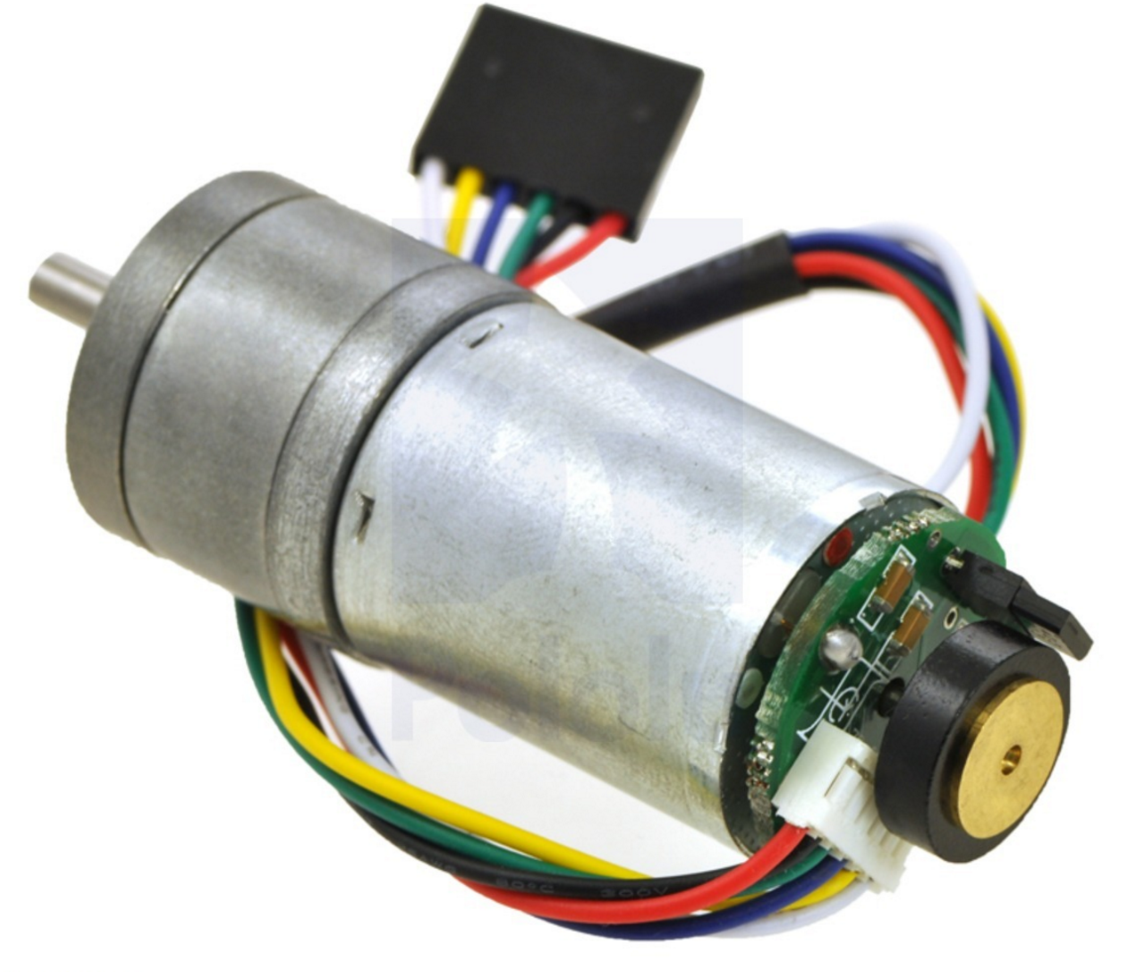

**Figure 9.** Pololu low power 12V metal gearmotor with 99:1 gear reduction and encoder

## Motion Control and Tracking

For the scope of the project in the time available for the initial design, two assumptions will be made. First, it will be assumed the initial orientation of the robot will be known, and thus, localization will not be incorporated in this design. In a practical application, one can imagine the Bridge Inspection Robot being deployed on a bridge by a quadcopter, which could take care of the localization. Secondly, it will be assumed that only straight path traversal will be required for the most part, with turning used only for path correction.

There are three requirements of movement that will be designed around:

1. The robot will need to be able to go in a roughly straight path, so that the robot can traverse quickly without continuously making sharp turns to correct its straight path
2. The robot will need to be able to detect edges so it won’t fall off the bridge
3. The robot will need to be able to identify fairly accurately the locations that structural health measurements on the bridge are taken at to about 2-4 m resolution as was done in the experiment done with the previous version of the robot [4].

### *Requirement 1: Straight path traversal*

In order to help the robot traverse roughly a straight path, path correction can be implemented through multiple sensors that can directly/indirectly measure yaw and accordingly correct the robot motion. Their pros and cons can be viewed in Table 3.

**TABLE III**

SENSORS THAT CAN BE USED FOR STRAIGHT PATH TRAVERSAL

|  |  |  |
| --- | --- | --- |
| Name/Description | Pros | Cons |
| Gyroscope: Measures angular velocity | * Cheap * Simple data to process | * No absolute reference, just measured change of angle so accumulation of error |
| Magnetometer: Magnetic compass | * Cheap * Absolute reference of earth’s magnetic field | * Magnetometer readings will be skewed by permanent magnets on wheels |
| Encoders: Measures rotations of wheels | * Cheap * Simple data to process * Probably not much drift due to permanent magnets holding the wheels well the to the bridge * Can be used for accurate path correction by measuring how much one wheel should spin over the other | * Still potential for drift since there is not absolute reference |

The team proposes to implement solely encoders for the scope of this project as its only downside of drift is minimal. The team will also incorporate a gyroscope into the design and have the gyroscope’s data accessible, but the actual incorporation of the data into path correction will be a stretch goal.

* + - 1. *Requirement 2: Edge Detection*

The sensors that can be incorporated into edge detection so the robot won’t fall off a bridge are listed in Table 4 below along with their pros and cons.

**TABLE IV**

SENSORS THAT CAN BE USED FOR EDGE DETECTION

|  |  |  |
| --- | --- | --- |
| Name | Pros | Cons |
| IR Sensors | * Have been implemented before * Simple data to process * cheap | * Color of bridge could affect edge detection (may need to adjust thresholds for an edge “hit” from bridge to bridge) |
| Ultrasonic Sensors | * Color no longer an issue | * Generally, more expensive * Sound-absorbent materials may blind the sensor |

The team proposes to use IR sensors in the configuration shown in Figure 10. As shown in this figure, the IR sensor will be before the front-most edge of a wheel so it won’t hit into inclines, but it will be past the floor-touching part of the wheel to ensure the IR sensor detects edges before the robot falls off.

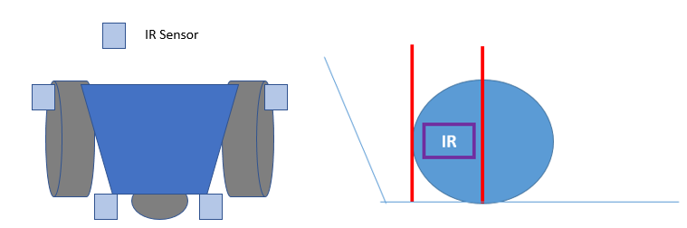

**Figure 10.** Diagram showing roughly the IR sensor placements on the robot, which is not drawn to scale (left). Diagram showing the placement of the IR sensor in a wheel (right)

* + - 1. *Requirement 3: Motion Tracking*

To accurately take structural health measurements, the robot design must be able to fairly and accurately assess the location where accelerometer measurements are taken. Sensors that help with this task and their pros and cons are listed in Table 5 below.

**TABLE V**

Sensors that can be used for motion tracking

|  |  |  |
| --- | --- | --- |
| Name | Pros | Cons |
| Solely Encoders | * Already on robot design for previous motion control and tracking requirements so can serve dual purpose * Probably not much drift due to permanent magnets holding the wheels well the to the bridge | * Still potential for drift since there is not absolute reference |
| GPS | * Absolute reference of position * Relatively Accurate (2m resolution) | * Won’t work in regions with poor GPS reception such as under the bridge |
| Separately bought IMU | * Very accurate for small movements * Can potentially be used for localize * All filtering and sensor data-fusion usually already done | * Not accurate over large distances * Can be expensive |
| Use existing accelerometer in conjunction with encoders and gyroscope | * Accelerometer/Gyroscope very accurate for small movements and encoders used for longer movements * Save money and weight by using parts we already need for other design requirements | * Need to implement filtering * Need to implement sensor data fusion and movement interpolation, which can be complex |

The team proposes to implement motion tracking through encoders and GPS, with encoder measurements recalibrating around every 2 m resolution of the GPS since the GPS is an absolute reference. The advantages of this design include that this design removes drift of an encoder, helps get a better resolution than 2m of the GPS, and allows the robot to track movement when under a bridge when GPS doesn’t work but encoders do. The disadvantage of this is extra cost, but the cost isn’t too much. In the future as a stretch goal, the GPS will be removed and movement tracking will be done using the existing accelerometer in conjunction with encoders and gyroscope for the reasons listed in Table 5.

* + - 1. *GPS Selection*

For GPS selection, the team is looking for low cost, an accuracy of about 2-4 m, a high update accuracy, low power consumption, and a data interface that works with the robot design’s microcontroller. The different GPS options evaluated are in Table 6 below with the selected option bolded.

**TABLE VI**

Different GPS Options Evaluated With The Selected Option Bolded

|  |  |  |  |  |  |  |  |
| --- | --- | --- | --- | --- | --- | --- | --- |
| Name | Price | Accuracy | Update Frequency | Sensitivity | Power | Interface | Other |
| **Adafruit Ultimate GPS Breakout - 66 Channel MTK3339** | **$39.95** | **1.8 m** | **10 Hz** | **165 dBm** | **100 mW** | **Serial** | **Comes with breakout board. Has in-built data-logging. SMA connector to connect external antenna.** |
| GPS Bee with Mini Embedded Antenna | $16.00 | 2.5 m | 4 Hz | 160 dBm | 200 mW | UART, USB, DDC, and SPI | SMA connector to connect external antenna. |
| Venus GPS with SMA Connector | $49.95 | 2.5 m | 20 Hz | 165 dBm | 297 mW | UART, SPI | Internal flash for optional 75K point data logging. SMA connector to connect external antenna. |

* + - 1. *Gyroscope Selection*

For gyroscope selection, the team is looking for low cost, a velocity range less than +-2000°/s, reasonable accuracy, low power draw, and a data interface that works with the robot design’s microcontroller. The different Gyroscope options evaluated are in Table 7 below with the selected option bolded.

**TABLE VII**

Evaluation Of Different Gyroscope Options With The Selected One Bolded

|  |  |  |  |  |  |  |
| --- | --- | --- | --- | --- | --- | --- |
| Name | Price | Range/Resolution | Accuracy | Power Draw | Interface | Other |
| SparkFun Triple-Axis Digital-Output Gyro Breakout -  ITG-3200 | $24.95 | ± (2000°/sec) / (2^16) =  ± .0305°/sec | Zero Bias: ± 40°/s | 23.4 mW | I2C | user-selectable internal low-pass filter bandwidth. Fast-Mode I2C (400kHz). Temp sensor. Optional external clock inputs of 32.768kHz or 19.2MHz to synchronize with system clock |
| **ST L3GD20H** | **$3.42** | **±245/±500/±2000°/s with 16 bits** | **Zero Bias: ±25°/s** | **15 mW** | **I2C/SPI** | **User enabled integrated low-pass and high-pass filters. Temp sensor.** |
| SparkFun Tri-Axis Gyro Breakout - L3G4200D | $49.95 | ±250/±500/±2000°/s with 16 bits | Zero Bias: ±245/±500/±2000°/s | 21.96 mW | I2C/SPI | Integrated low- and high-pass filters with user-selectable bandwidth. |

## Magnets

The selected three-wheel design will incorporate permanent neodymium magnets that wrap around the treads of the two front wheels, as shown in Figure 6. The team has identified K&J Magnetics B641 as a suitable magnet for this design. Each B641 magnet is 3/8” long by 1/4” wide by 1/16” thick, magnetized through the dimension of thickness, and has a pull force of 0.87 kg. Since the two front wheels will be “magnetized”, the combined pull force for the magnets will be 1.74 kg, which exceeds the weight specification of the robot.

## Microcontroller

The microcontroller of the Bridge Inspection robot will be responsible for receiving input from sensors, sending data to the wireless transceiver, and controlling the robot's servos and motors. The team has selected the TI MSP432P401R (MSP432) for the robot's microcontroller. The MSP432 contains a 48 MHz ARM 32-bit CPU, 256 KB of flash memory, 64 KB of SRAM, and a 14-bit analog-to-digital convertor (ADC) [9]. The MSP432 Launchpad, shown in Figure 11, is a development board with a built-in USB debugger and breakout pins, which allows for rapid prototyping. Early in development, the team will test the functionality of other components such as the accelerometer and electromagnets using the MSP432 Launchpad. The final version of the Bridge Inspection Robot will feature a printed circuit board with a surface-mounted MSP432.

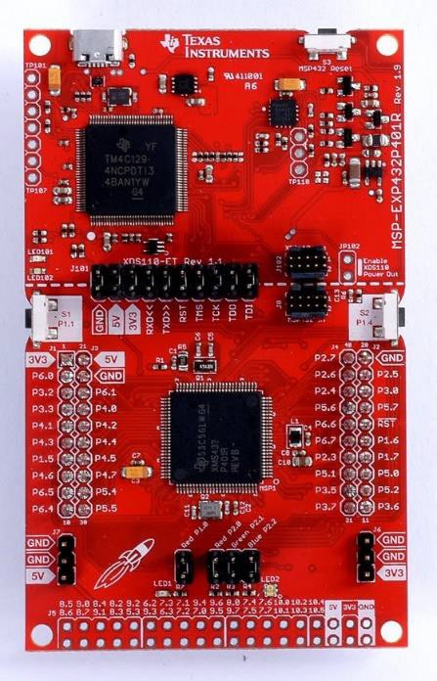

**Figure 11.** MSP432P401R Launchpad Development Kit

## Bridge Structural Health Measurement

* + - 1. *Accelerometer*

The accelerometer is the primary measurement tool of the Bridge Inspection Robot. At various locations along a bridge, the robot will lower its accelerometer to make contact with the support structures. The recorded structural vibrations will show the overall frequency response and any changes in the bridge’s natural frequency, which can then be factored into a decision for bridge repairs or other corrective actions [10]. Because the accelerometer is crucial to the project's goals, the team considers it a critical path item, and the accelerometer will be one of the first components that the team purchases and tests.

The frequency response of bridges considered for inspection require a bandwidth of 0 – 30 Hz. Anything outside of this range is considered noise and not useful. The initial wheeled prototype version of the Bridge Inspection Robot used a Silicon Designs Low Power Single Axis Accelerometer Model 2012-002, which could read 0 – 300 Hz with a differential sensitivity of 2000 mV/g [11]. The updated Bridge Inspection Robot will use a Silicon Designs Model 2460-002, an updated three-axis accelerometer differing from the Model 2012-002 only in size and axes of measurement [12]. The previous project advisor recommended a three-axis model due to significant lateral vibrations seen alongside measured vertical translations.

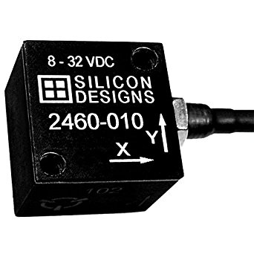

**Figure 12.** Silicon Designs Model 2460-002

As the accelerometer must be lowered onto the bridge, various methods of deployment were examined. The first method explored was a rack and pinion as shown in Figure 13. A servo would rotate the pinion and lower the accelerometer attached to the rack towards the bridge surface. This is a low-torque, low-power solution that does not require a high-end servo to actuate. The issue, however, is that the rack and pinion would have to be designed and machined. Servos considered are listed in Table 8.

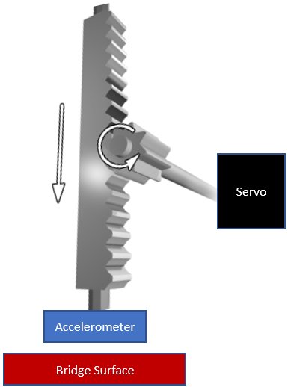

**Figure 13.** A rack and pinion system for accelerometer deployment

**Table VIII**

Servo Options for Rack and Pinion System

|  |  |  |  |  |  |  |
| --- | --- | --- | --- | --- | --- | --- |
| Servo | Torque | Input Voltage | Current Draw | Mass | Encoder? | Interface |
| Hitec HS-422 | 4.1 kg-cm | 4.8 V to 6.0 V | 8 mA / 150 mA | 45.5 g | No | Pulse |
| Futaba S3003 | 4.2 kg-cm | 4.8 V to 6.0 V | 8 mA / 400 mA | 44.2 g | No | Analog |
| Goteck GS-9025MG | 2.5 kg-cm | 4.8 V to 6.0 V | 250 mA / 1000 mA | 14.7 g | No | FET drive |

The second and third methods of deployment involve pre-packaged solutions. The accelerometer could be lowered by either a linear actuator or solenoid as pictured in Figure 14. The solenoid option would allow for rapid deployment as it simply launches the accelerometer out and pulls it back in on actuation. This also gives a very distinct start and stop in the accelerometer data as the actuation of the solenoid would be high-acceleration events. This solution falls short, however, as there would be no holding force applied to keep the accelerometer on the bridge. The team decided it was not worthwhile to examine this solution further.

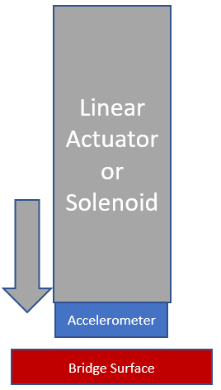

**Figure 14.** Either a solenoid or linear actuator used for accelerometer deployment

Finally, a linear actuator would allow for vertical movement of the accelerometer onto and off the bridge surface. A potentiometer built into said linear actuator would serve as a source for feedback control of the system, allowing for the control of pressure applied to the accelerometer onto the bridge. The downfall of this solution is the price as linear actuators run much more expensive than servos. Explored linear actuator options are outlined in Table 9.

**Table IX**

Linear Actuator Options

|  |  |  |  |  |  |  |  |
| --- | --- | --- | --- | --- | --- | --- | --- |
| Actuator | Stroke | Accuracy | Input Voltage | Current Draw | Mass | Potentiometer? | Interface |
| PQ12 20mm | 20 mm | ± 0.1 mm | 6 V  12 V | 550 mA (Stall) 210 mA (Stall) | 15 g | Yes | Analog |
| L12 30mm | 30 mm | ± 0.2 mm | 6 V  12 V | 7.2 mA / 460 mA 3.3 mA / 185 mA | 34 g | Yes | Analog |
| L12 100mm | 100 mm | ± 0.3 mm | 6 V  12 V | 7.2 mA / 460 mA 3.3 mA / 185 mA | 56 g | Yes | Analog |

Given these options, the team went with the L12 30mm linear actuator. With a 30 mm stroke the robot has a decent amount of vertical range for the accelerometer to be deployed. Furthermore, this saves time and excess weight as a rack and pinion design would take longer time than simply ordering another part and be heavier. Finally, a potentiometer is already included in this package, already giving a solution for applying a holding force onto the accelerometer.

* + - 1. *Signal Conditioning Module*

Previous structural health measurements were read to be as low as 0.001 m/s2, yielding only 0.125 mV measured by the previous accelerometer. As this low a reading is very susceptible to circuitry noise and is difficult to convert to digital data, a custom signal conditioning module was used. This custom module amplified and filtered the accelerometer signal prior to A/D conversion [18]. For the proposed Bridge Inspection Robot, the old signal conditioning module shown in Figure 15 will be updated to interface with the newly chosen three-axis accelerometer so that the readings can be amplified before digitized by the A/D converter. This will ensure measurements will turn into useful data that can be processed.

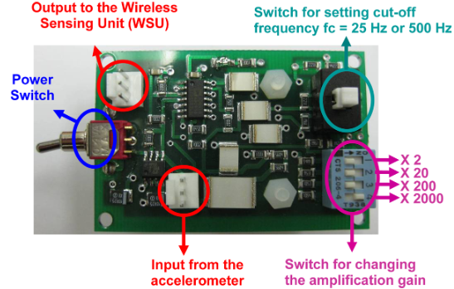

**Figure 15.** Custom low-noise, high-gain signal conditioning module

## Wireless Communication

During operation, the robot will communicate wireless with a PC through a dedicated module. T team desired a wireless communication module that would meet the following specifications: a maximum range of (at least) 800 m, a throughput greater than 10 Kbps, current consumption of less than 50 mA, and ability to interface via Serial Peripheral Interface Bus (SPI). The team has identified the XBee S2C DigiMesh 2.4 module, pictured in Figures the best wireless transceiver for the Bridge Inspection Robot [13]. The XBee S2C DigiMesh 2.4 offers a maximum outdoor range of 1200 m, a throughput of up to 250 Kbps, current draw of around 30 mA, and the ability to interface with a microcontroller through SPI. To complete the link, a second module will be connected to a PC through USB.

It may be necessary to incorporate an external Random Access Memory (RAM) module, such as the Adafruit SPI FRAM Breakout (64 Kbit), into the robot in order to provide adequate buffer space for data queued up for transmission. Without a sufficient memory buffer, if the wireless link were disrupted by interference, then the collected accelerometer data may be lost, which would be problematic in cases where a network of robots were deployed simultaneously.

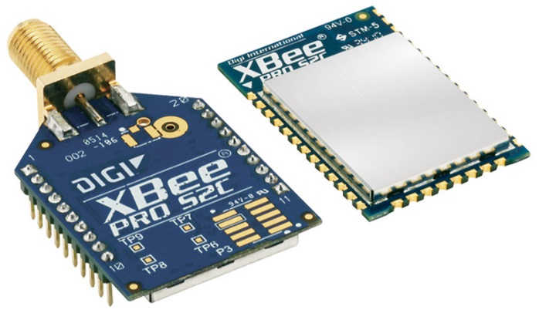

**Figure 16.** XBee S2C DigiMesh 2.4 Module, Through-Hole (left) and Surface-Mount (right) Versions

## Batteries and Power

The robot is expected to run actively for at least one hour, traversing the bridge while making measurements, and an additional hour passively, staying in place while transmitting data. The battery chosen must provide a suitable capacity to power the major components of the robot. These components include the motors, linear actuator, MCU, data acquisition, data transfer, and various supporting electronic circuitry. Of these, the highest minimum voltage needed is roughly 12V, for the motors, linear actuator, and accelerometer.

Each motor has a stall current of 1.1A and free run current of 100mA. Because of the light weight of the robot, the motors will run far below the stall current. The highest expected nominal draw, when traversing vertically, is 800mA each. The linear actuator will only be used for short movements of a small mass and thus will have low consumption. In conjunction with the accelerometer, expected current draw is only 35mA. The MCU and wireless module each require an input voltage of 3.3V. The accelerometer. The wireless module, MCU, GPS, and gyroscope are expected to collectively consume 300mW at 3.3V. With a power conversion efficiency of 80%, this would draw roughly 32mA from the battery. The remaining circuitry will have negligible power consumption. The final sum of power consumption with some additional margin of error is 1700 mA with maximum power consumption while active movement, and only 100 mA while passive. Therefore, a battery capacity of at least 1800mAh is required to power the robot for one hour actively and one hour passively. Several battery compositions have been considered for this purpose.

**Table X**

Battery Type and Sizing Considerations

|  |  |  |  |  |  |
| --- | --- | --- | --- | --- | --- |
| Battery Type | Voltage Rating | Capacity | Recharge? | Weight | Vendor |
| Alkaline AA | 1.5V | 1000mAh | No | 23g | Duracell |
| Alkaline 9V | 9V | 500mAh | No | 45g | Duracell |
| Ni-Mh AA | 1.2V | 2600mAh | Yes | 26.5g | Tenergy |
| Ni-Mh AAA | 1.2V | 1000mAh | Yes | 13g | Tenergy |
| Ni-Mh 9V | 9V | 250mAh | Yes | 86g | Tenergy |
| NiCd AA | 1.2V | 1000mAh | Yes | 27g | Tenergy |
| Li-Ion | 3.7V | 3000mAh | Yes | 45g | EBL |
| Li-Ion | 9V | 600mAh | Yes | 30g | EBL |
| Lipo 3S | 11.1V | 2200mAh | Yes | 170g | Turnigy |
| Lipo 3S | 11.1V | 5000mAh | Yes | 489g | Turnigy |

A three-cell LiPo battery was chosen to be used to power the robot. This battery will provide 2200mAh at 11.1V, satisfying the design constraints but also offering rechargeability and high current output for instantaneous torque from motors, all within a package that is lightweight compared to its output.

## External Server (PC)

A PC connected to an XBee S2C DigiMesh 2.4 module through a USB dongle will serve as the "master" for the Bridge Inspection Robot. The PC will send commands that direct the robot to advance along the bridge, make turns, and collect accelerometer data. The PC will also save the accelerometer data that it receives to a hard drive.

## Codes and Standards

One of the most significant standards for this project is Serial Peripheral Interface Bus (SPI). This is a synchronous bus interface protocol used to send data between device components [14]. It will be needed to interface the MSP432 with the XBee S2C DigiMesh 2.4 module for sending out data from the Bridge Inspection Robot to the external server. SPI is a straightforward protocol, requiring only four wires to implement. Furthermore, the intricacies of implementing SPI is abstracted away by open- source MSP432 code. However, understanding the constraints of SPI communication is critical for addressing the robot's design needs. For example, SPI is a single-master protocol, meaning that only one device on the SPI network can send commands to other devices. For the Bridge Inspection Robot, the MSP432 will serve as the SPI master.

DigiMesh is a proprietary wireless mesh networking protocol developed by Digi International. As an alternative to the popular ZigBee protocol, DigiMesh offers simpler network setup by treating all nodes in the network equally (no parent-child relationships). DigiMesh can also achieve a higher data throughput due to its larger max payload per frame (up to 256 bytes vs. 80 bytes for Zigbee). DigiMesh can operate at the 900 MHz and 2.4 GHz frequencies [15].

The MSP432 will be programmed in C, a low-level programming language that is most popular for small-scale embedded systems programming.

## Constraints, Alternatives, and Tradeoffs

The current design of the robot can traverse vertically and upside-down only on steel bridges since it uses magnets for these kinds of traversals. It must be small enough to stay on and traverse the support structures. Furthermore, the total weight of the robot is limited by the holding weight of the magnets, the servos, and the quadcopter used for delivery.

For data measurement, the accelerometer choice is dictated by the frequency of the vibrations expected, which are all below 30 Hz. The robot must also be able to take multiple measurements within a single run, meaning the battery and magnet designs must support the expected operation time of three to four hours before recharge. Finally, as the robot will be sending measurement data wirelessly, the choices concerning wireless communications are dictated by an expected maximum operation distance of 800 m away from an external computer.

An alternative to a mobile network is a static network of wireless sensors along the bridge. However, the accelerometers that are needed for accurate measurements typically cost several hundred dollars, making it unaffordable to densely equip bridges with a large number of sensors. Using a small number of sensors on the other hand results in poor spatial resolution that does not provide high enough accuracy for damage detection. A mobile network allows the robots to deploy in a tight configuration that allows for high resolution during data collecting, and then dynamically reconfigure to another part of the bridge to repeat this process.

Balancing performance and power consumption is the most significant tradeoff for the Bridge Inspection Robot. Several design decisions were made that compromise the robot's speed in favor of extending the robot's battery life. For example, a microprocessor would provide faster computing performance than a microcontroller, and it would allow the robot to extend its functionality with more computationally- intensive components, such as a camera. However, the higher power requirements of a microprocessor and a camera would significantly reduce the battery life.

# Schedule, Tasks, and Milestones

Appendix A shows the team's full Pert chart, which displays the major components of the project along with their associated start date, end date, duration, and critical path in red. Appendix B shows just the critical elements of the pert chart for better visual clarity. The full Gantt chart in Appendix C shows the tasks that the team must complete. For each specific task this chart outlines major milestones, start dates, end dates, durations, and start and finish slack. This chart also visually shows the timeline for these tasks. Sanmesh and Sean are responsible for the board designs, Kristen and Erikzzon are responsible for the Bridge Structural Health Measurements tasks, Kristen, Sanmesh, and Justin are responsible for the Sensing Environment tasks, Sanmesh, Erikzzon and Sean are responsible for the Mechanical Design tasks, and Justin and Kristen are responsible for the Wireless Communication tasks. A summarized pert chart is on Appendix D and a summarized Gantt chart is on Appendix E.

# Project Demonstration

## Inspection of Robot Properties

Verification of the weight and size shall be done by inspection. The overall weight in kilograms of the robot will be measured with a scale. Each dimension of the robot will be measured with a tape measure in meters. All values measured by inspection shall be recorded in an engineering notebook.

## Holding Force of Components

The holding force of the electromagnets and motors shall be verified by measuring the amount of time either component can maintain its position in a combination of configurations. Each configuration will be a pairing of component orientation and mass position as described in Figure 17.

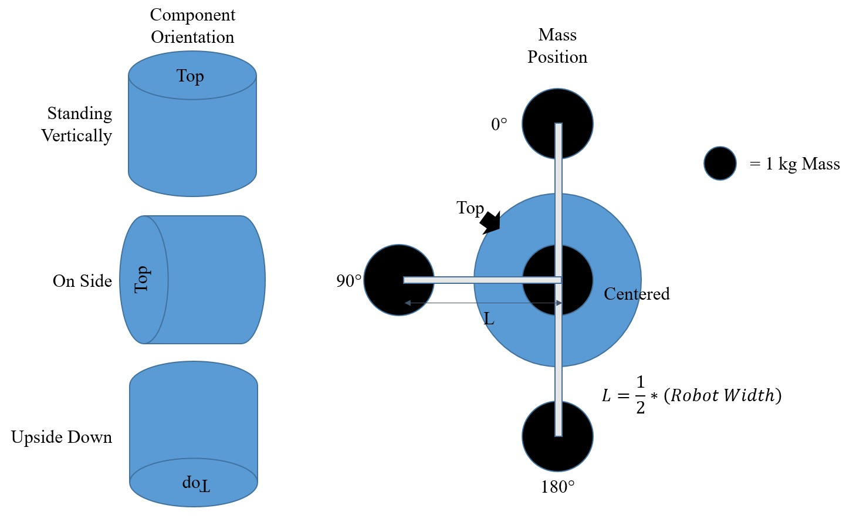

**Figure 17.** Configurations of the component and mass to be tested

This requirement is verified if the robot can maintain their position with a 1 kg mass attached at the varying locations for greater than two minutes. Times will be recorded in a copy of Table 11.

**Table XI**

Results Sheet from Holding Force Testing

|  |  |  |  |  |  |
| --- | --- | --- | --- | --- | --- |
| Electromagnet or Motor | | Mass Position | | | |
| Component Orientation |  | Centered | 0° | 90° | 180° |
| Standing Vertically |  |  |  |  |
| On Side |  |  |  |  |
| Upside Down |  |  |  |  |

## Accelerometer Data Accuracy

Verification of the accelerometer data accuracy will require a shaker table. A vibration profile will be measured using the shaker table. This profile will be measured by mounting both a statically mounted accelerometer and the robot with its installed accelerometer on to the table. A root-mean-squared analysis will be applied on the data to verify that the error between the raw accelerometer measurements and the robot measurements falls below the ± 0.5 Hz tolerance.

## Battery Life

Battery life analysis will be divided into traversal lifetime and holding lifetime. Verification of holding lifetime will be measured by having the robot collect ambient vibration data until the battery runs out. Verification of traversal lifetime will be measured by having the robot’s motors drive continuously in a circle on a metal surface as if it were traversing a bridge until the battery runs out. These test events will be timed and recorded.

## Path Following and Avoiding Falls

Verification of the Bridge Inspection Robot’s ability to stay on a bridge support element will require a lab setup with a 2 m long strip of sheet metal. The robot will be placed on the sheet metal and set to traverse the length of the strip. The starting angle of the robot with respect to the path shall be varied to ensure it can correct itself and still traverse.

## Wireless Communication Distance

Verification of the furthest distance the robot can communicate will be conducted in a large, open field. The robot shall send a known set of data at distances varying linearly from 500 m to 1000 m to a base computer. The robot meets its communication distance requirement if it sends accurate data at least 800 m away from the computer.

## Final Demonstration

Given that Sections 6.1 to 6.6 are verified, the robot shall be subjected to the same final verification test as the old wheeled design. The tests of the old wheeled design were performed on a group of four wheeled robots, but the team will perform these tests on just a singular legged prototype. Figure 18a shows four configurations for the robot, each consisting of four measurement locations. The south and north sides of the bridge are marked with the letters 'S' and 'N' respectively. A laptop server at one end of the

bridge will wirelessly control the robot (Figure 18b). The robot shall be placed on the upper support beam of the MRDC bridge, similar to Figure 18c, and be expected to traverse to one of the measurement locations in each configuration of the bridge without falling off. At each configuration, the robot will take measurements and record the vibrations of the bridge at each location in a way comparable to the robot in Figure 18d. The measurement accuracy will be further confirmed by having a test operator strike the bridge with a hammer, as shown in Figure 18e, which should then appear as a frequency spike in the data being recorded.

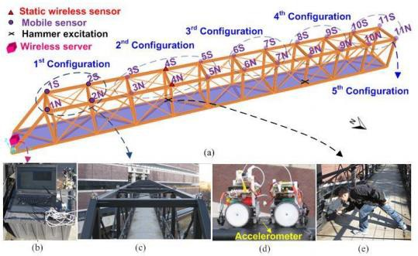

**Figure 18.** Experimental setup for final demonstration: (a) 3D illustration of the MRDC bridge showing the five configurations for the robot; (b) a laptop set up as the wireless server; (c) four robots set up in the 1st configuration; (d) the old wheeled robot attaching the accelerometer to the surface of the bridge; (e) a hammer impact being applied

# Marketing and Cost Analysis

## Marketing Analysis

There are a few wireless bridge structural health monitoring systems that are comparative to the Bridge Inspection Robot.

The SensSpot is a sensor that can be placed on bridges using its self-adhesive property [16]. It has a minimum expected life of 20 years, and for an average-sized highway bridge, would need about 500 sensors each $20 for a total of $10,000 [17]. The Bridge Inspection Robot's sensing nodes however would not need a mass deployment like the SensSpot because the mobile nature of the robot would allow a small number of sensing nodes to take measurements of the whole bridge over time. The team's robot also avoids the time and labor required in installing the SensSpot sensors. Lastly, the Bridge Robot would never run out of power during operation because it could always come back for charging during inactive times.

The robot described in the “Wireless Mobile Sensor Network for the System Identification of a Space Frame Bridge” by Dapeng Zhu et Al. is very similar to the Bridge Inspection Robot design, with the same mobile health measuring method at its base [10]. However, the key difference in the Bridge Robot’s design is that its motion mechanism allows it to move in multiple directions along the surface of a bridge while the robot described in [10] only allows for straight-line movement.

## Cost Analysis

The total cost of the Bridge Inspection Robot component is estimated to be roughly $600. Table 12 shows a breakdown of the material costs of the prototype. It will have several sensors and actuators which will need to be purchased. The supporting structure for the robot can be designed in CAD software and 3D printed at a very low cost, and provide a very low weight structure that could be rapidly prototyped. A handful of miscellaneous circuit components will be needed to support the main chips, including capacitors, resistors, and power convertors. These, in addition to assembly pieces such as screw, will be estimated in price. The completed circuit will be printed professionally by a board house. This cost is estimated at $25 for a two layer board.

**Table XII**

Total Component Costs for Prototype

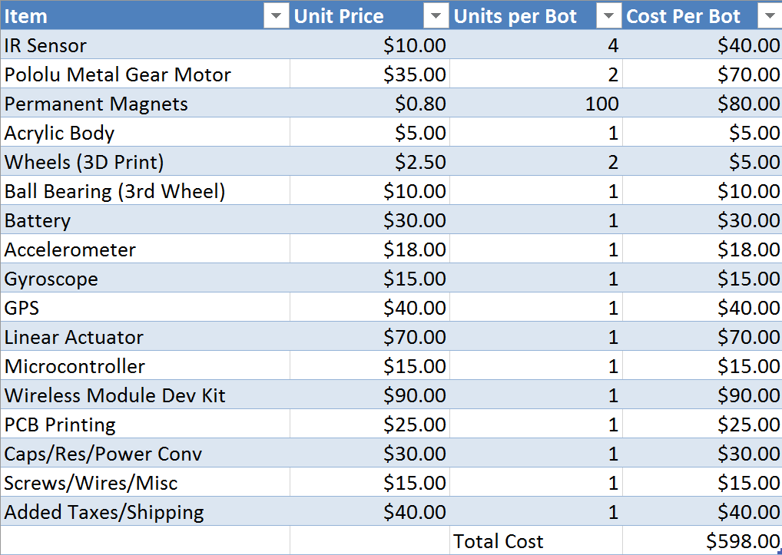

The labor costs are assumed to be at a rate of $20 per hour. At this rate, we find a total labor cost of

$13,600. The breakdown of the labor costs is shown in Table 13.

**Table XIII**

Total Labor Costs for Development

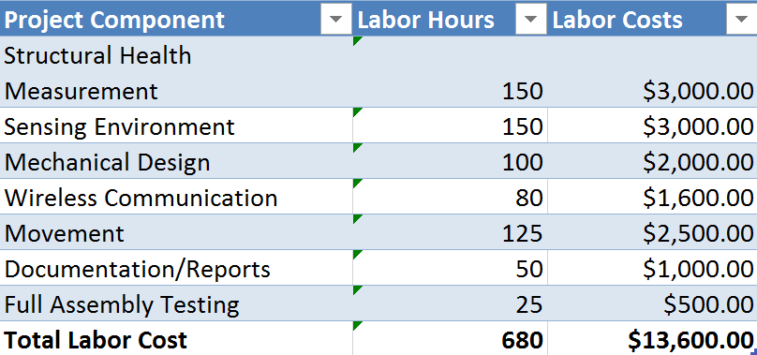

Using the fringe benefit as 30% of total labor and overhead as 120% of material and labor, the total development cost would be $40,212 The breakdown of these costs are shown in Table 14.

**Table XIV**

Total Development Costs

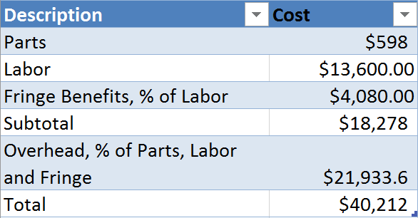

# Current Status

The Bridge Inspection Robot team has discussed all aspects of the robot's design and testing, and most components have already been selected after presenting to the team advisor and representatives from the schools Civil Engineering and Mechanical Engineering. Several team members have previous experience working with the MSP432, which should accelerate component prototyping. The team is prepared to begin ordering parts and start testing the design.

# References

1. M. Moore, B. Phares, B. Graybeal, D. Rolander, and G. Washer, "Reliability of Visual Inspection for Highway Bridges," Federal Highway Administration, McLean, VA Report No. FHWA-RD-01-020, 2001.
2. J. M. Ko and Y. Q. Ni, "Technology developments in structural health monitoring of large-scale bridges," Engineering Structures, vol. 27, pp. 1715-1725, 2005.
3. E. G. Straser and A. S. Kiremidjian, "A Modular, Wireless Damage Monitoring System for Structures," John A. Blume Earthquake Eng. Ctr., Stanford University, Stanford, CA Report No. 128, 1998.
4. Zhu, D., Guo, J., Cho, C., Wang, Y., and Lee, K.-M. (2012). "[Wireless mobile sensor network for the](http://wang.ce.gatech.edu/sites/default/files/docs/Wireless%20mobile%20sensor%20network%20for%20the%20system%20identification%20of%20a%20space%20frame%20bridge.pdf) [system identification of a space frame bridge,](http://wang.ce.gatech.edu/sites/default/files/docs/Wireless%20mobile%20sensor%20network%20for%20the%20system%20identification%20of%20a%20space%20frame%20bridge.pdf)" [Mechatronics, IEEE/ASME Transactions on](http://doi.org/10.1109/TMECH.2012.2187915), 17(3): 499- 507.
5. F. Tache, W. Fischer, G. Caprari, R. Siegwart, R. Moser, and F. Mondada, "Magnebike: a magnetic wheeled robot with high mobility for inspecting complex-shaped structures," Journal of Field Robotics, vol. 26, pp. 453-476, May 2009.
6. M. P. Murphy and M. Sitti, "Waalbot: an agile small-scale wall-climbing robot utilizing dry elastomer adhesives," Mechatronics, IEEE/ASME Transactions on, vol. 12, pp. 330-338, 2007.
7. W. R. Provancher, S. I. Jensen-Segal, and M. A. Fehlberg, "ROCR: an energyefficient dynamic wall- climbing robot," Ieee-Asme Transactions on Mechatronics, vol. 16, pp. 897-906, Oct 2011.
8. M. Todd, D. Mascarenas, E. Flynn, T. Rosing, B. Lee, D. Musiani, et al., "A different approach to sensor networking for SHM: remote powering and interrogation with unmanned aerial vehicles," in Proceedings of the 6th International Workshop on Structural Health Monitoring, Stanford, CA, 2007.
9. Texas Instruments, “MSP432P401R, MSP432P401M Mixed-Signal Microcontrollers”, Datasheet, March 2015. [Revised May 2016]. [Online]. Available: [http://www.ti.com/lit/ds/symlink/msp432p401r.pdf.](http://www.ti.com/lit/ds/symlink/msp432p401r.pdf) Accessed Nov. 20, 2016.
10. D. Zhu, J. Guo, C. Cho, Y. Wang and K. M. Lee, "Wireless Mobile Sensor Network for the System Identification of a Space Frame Bridge," in *IEEE/ASME Transactions on Mechatronics*, vol. 17, no. 3, pp. 499-507, June 2012. DOI: 10.1109/TMECH.2012.2187915
11. Silicon Designs, “Low Power Single Axis Accelerometer Module, Model 2012”, Datasheet, October 2013. [Online]. Available: [http://www.krone.co.jp/pdf/2012.pdf.](http://www.krone.co.jp/pdf/2012.pdf) Accessed Nov. 21, 2016.
12. Silicon Designs, “Low Cost & High Performance Triaxial DC Accelerometer Modules”, Datasheet, 29 April 2016. [Online]. Available https://drive.google.com/open?id=0B4eVto02URUhQlNCMGxTUW85eXc.

Accessed Jan. 23, 2017.

1. "XBee DigiMesh 2.4", Digi International, Minnetonka, MN, 2016. [Online]. Available: <https://www.digi.com/products/xbee-rf-solutions/modules/xbee-digimesh-2-4>*.* Accessed Nov. 20, 2016.
2. Byte Paradigm, "Introduction to I²C and SPI protocols – Byte Paradigm – Speed up embedded system verification", *Byteparadigm.com*, 2016. [Online]. Available: [http://www.byteparadigm.com/applications/introduction-to-i2c-and-spi-protocols/.](http://www.byteparadigm.com/applications/introduction-to-i2c-and-spi-protocols/) Accessed: Nov. 21,

2016.

1. "Wireless Mesh Networking: Zigbee vs. Digimesh" Digi International, Minnetonka, MN, 2015. [Online] Available: https:/[/www.digi.com/pdf/wp_zigbe](http://www.digi.com/pdf/wp_zigbeevsdigimesh.pdf)e[vsdigimesh.pdf.](http://www.digi.com/pdf/wp_zigbeevsdigimesh.pdf) [Accessed Nov. 20, 2016].
2. Resensys, "SenSpot," *Resensys*, 2011. [Online]. Available: [http://www.resensys.com/product1.html.](http://www.resensys.com/product1.html) Accessed: Nov. 20, 2016.
3. D. Quick, "Wireless sensor to monitor structural integrity of bridges," *New Atlas*, 2011. [Online]. Availa[ble: http://newatlas.com/wireless-bridge-sensor/19380/.](http://newatlas.com/wireless-bridge-sensor/19380/) Accessed: Nov. 20, 2016.
4. Y.Q. Ni, B. Li, K.H. Lam, D.P. Zhu, Y. Wang, J.P. Lynch, and K.H. Law, “In-construction

vibration monitoring of a super tall structure using a long-range wireless sensing system,” in *Smart Structures and Systems*, vol.. 7, no. 2, pp 83-102, September 2010. [Online]. Available: http://www-personal.umich.edu/~jerlynch/papers/GTVTowerStudy.pdf. Accessed: Jan. 23, 2017.

# *Appendix A – Project Complete PERT Chart*



# *Appendix B – Project Complete PERT Chart Critical Tasks*

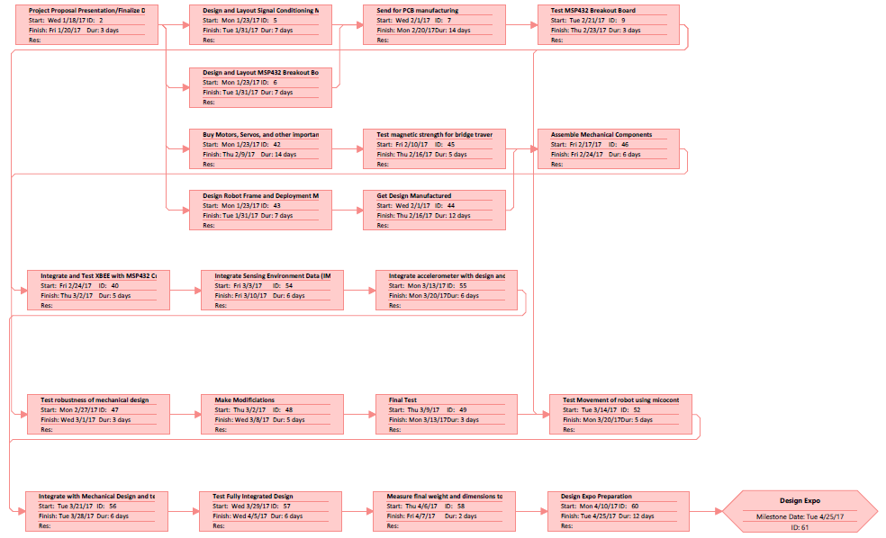

# *Appendix C – Project Complete GANTT Chart*



# *Appendix C – Project Complete GANTT Chart cont.*

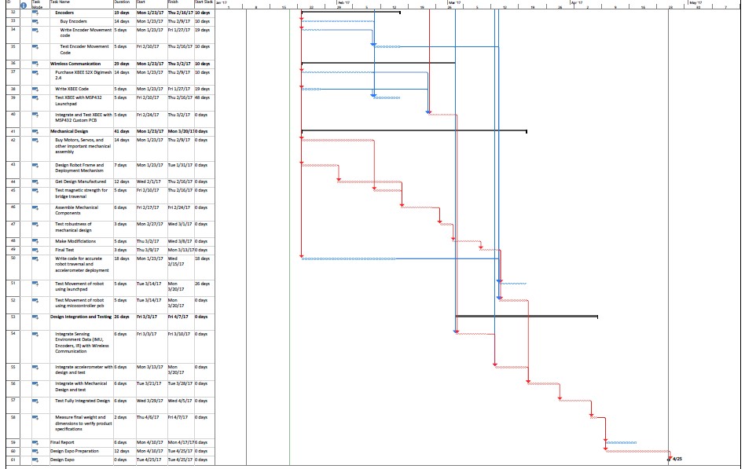

# *Appendix D – Project Summary PERT Chart*

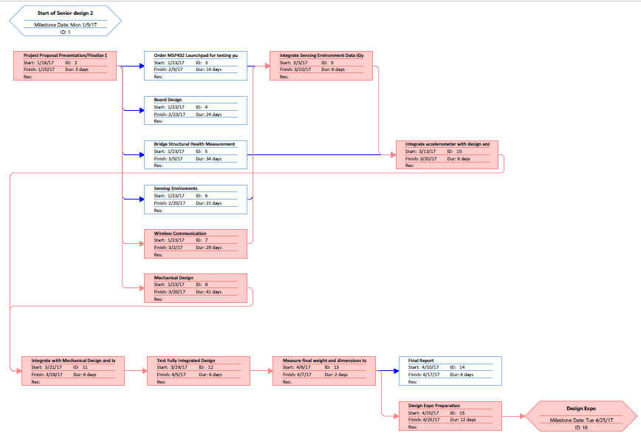

# *Appendix E – Project Summary GANTT Chart*

