LMI Increased Rebate Customer Profiles

# Introduction

We used CVRP application and survey data from 1,157 low-to-moderate income (LMI) increased rebate consumers to identify “consumer groups” that contain individuals with similar characteristics for the purpose of targeted marketing. We identified four consumer groups­―across all LMI rebate consumers in California―using a cluster analysis type approach (see Methods). We also performed regional analyses for four air districts with significant sample sizes: Bay Area, South Coast, San Diego and San Joaquin Valley Unified. Specifically, we show how LMI rebate consumers are distributed across the four consumer groups identified for California.

It should be noted that the data used in this analysis represents only the fraction of all LMI rebates consumers that completed a survey. However, for simplicity, we refer to the 1,157 consumers that responded to the survey as “all” LMI rebate consumers in this document.

## Recommendation

The clustering approach provides a good overview of current LMI rebate consumers, but its interpretation is complicated by the variable demographics of each population. For example, this analysis showed that only 9% of Latino LMI rebate consumers have graduate degrees (much lower relative to other groups) which may suggest that Latinos with graduate degrees are not a fertile marketing target. However, background demographic information indicates only 3% of Latinos in California have graduate degrees (California Senate Office of Research 2017). In other words, Latinos with graduate degrees are consuming 300% more rebates than would be expected based on their population size alone, which suggests that this demographic would be a viable target market. As such, the value of this analysis would be significantly increased by comparing it to general population demographic data.

# LMI Consumer Groups

Below we summarize all LMI rebate consumers followed by a description of the consumers in each consumer group. The Figures: California section contains the plots that are the basis for the consumer group summaries below.

## All LMI Rebate Consumers

Most CVRP LMI respondents are between 30 and 70 years of age (Figure 1). They are typically in households with at least one individual with a college degree (or better; Figure 2) and income around $25-50k per year (Figure 3). A significant percentage of LMI rebates are consumed by household with four or more members (~40%; Figure 4). The LMI rebate consumers are primarily White (~50%), but there are also significant numbers of Latino (15%), East Asian (~11%) and South Asian (~7%) consumers (Figure 5). The primary motivation of consumers for purchasing an EV was to save money (Figure 7). They primarily live in detached homes (~65%; Figure 8). Approximately 30% of respondents used the rebate to replace a vehicle that used an alternative fuel (e.g., electric, hydrogen, etc.; Figure 9).

## Group 1: Younger/Lower Education/Latino

*13% of LMI rebate consumers*

This is the youngest group with ~75% of LMI rebate consumers younger than 50 years. This group also has the lowest education levels with ~45% of households without a college degree. Household income is slightly above average (relative to all LMI rebate consumers) with ~70% earning $25-75k. Household size is slightly larger than normal. This group is 100% Latino.

## Group 2: High Income/Large Households/Primarily White/Married

*31% of LMI rebate consumers*

This group is generally aged 30-60 with relatively moderate household education levels. This is the highest income group with ~40% of households earning more than $50k. This consumer group also has the largest household sizes with 100% with three or more individuals. A majority of consumers in this group are White (~70%) with increased levels of marriage.

## Group 3: Older/Lower Income/Small Households/Primarily White

*36% of LMI rebate consumers*

This group is the oldest group with ~60% of recipients 50 years or older. Household education levels in this consumer group is moderate compared to all LMI rebate respondents. This is the lowest income group with ~80% earning less than $50k. This group also has the smallest household sizes with 100% with 1 or 2 people. Environmental impacts tend to be of increased importance in the decision to purchase/lease PEV. A majority of consumers in this group are White (~80%).

## Group 4: Younger/High Education/Large Households/Primarily Asian

*19% of LMI rebate consumers*

This group is young with ~70% of respondents younger than 50 years of age. This is the most highly educated group with ~70% of households having a member with at least a bachelor’s degree. The income in this group is moderate compared to other groups and the households tend to be larger with ~70% with 3 or more people. The consumers in this group are almost entirely of South or East Asian descent.

## Figures: California

The following figures describe the LMI consumers in each of the four consumer groups identified in the cluster analysis. For instance, in the first figure we show the age structure of each group and across “all” LMI rebate consumers. The figure shows that across all LMI rebate consumers that ~13% are between 21-29 years of age. It also shows that ~22% of consumers in Group 1 are in the 21-29 age group. The “NA” category indicates the percentage of individuals in each group that did not respond.

### Age

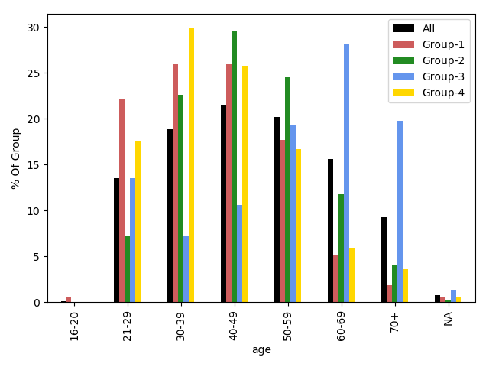

Figure 1: Age by group

### Education

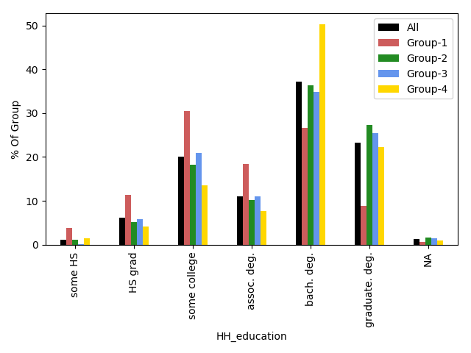

Figure 2: Education by group.

### Income

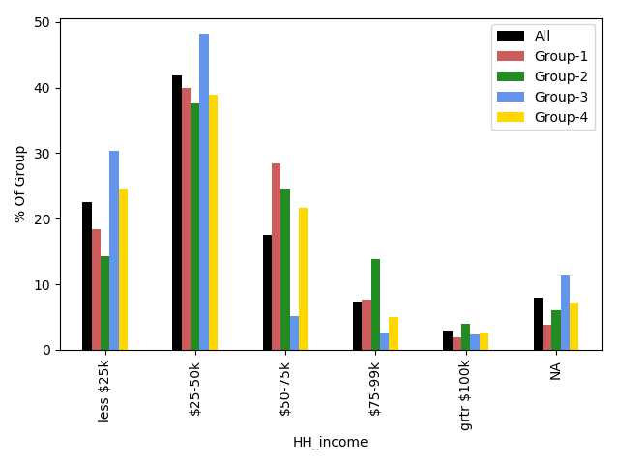

Figure 3: Income by group.

### Household Size

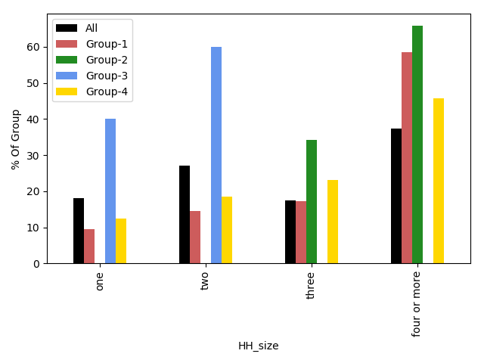

Figure 4: Household size by group.

### Race/Ethnicity

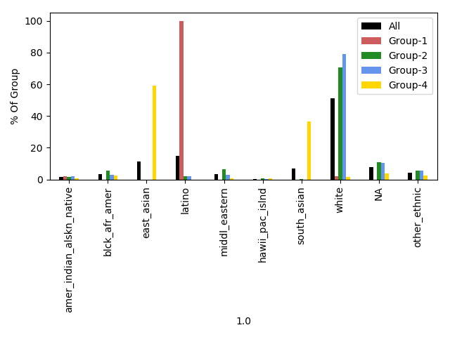

Figure 5: Race/ethnicity by group.

### Tax Filing Status

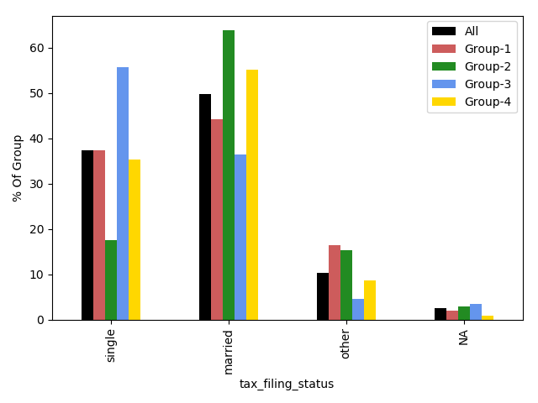

Figure 6: Tax filing status by group.

### Reason for Purchasing a PEV

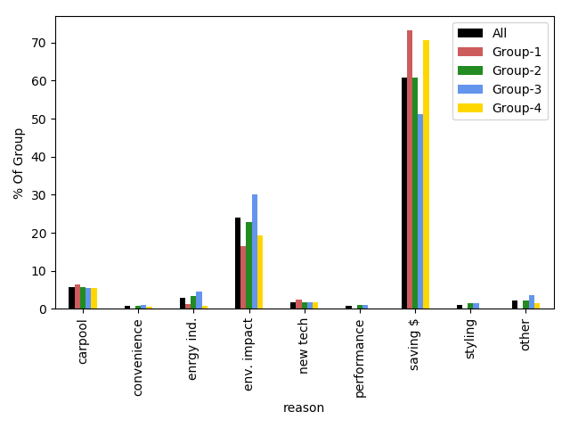

Figure 7: Most important reason for purchasing an EV by group.

### Residence Type

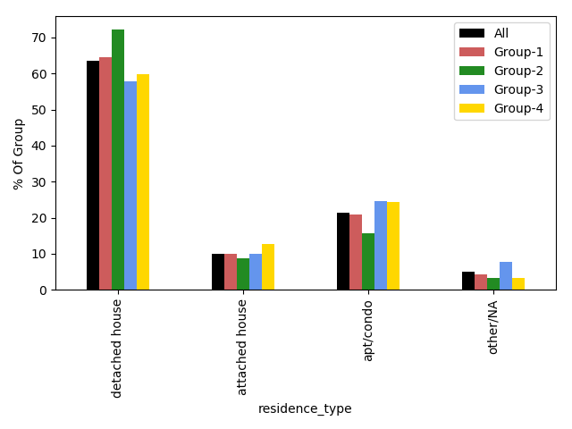

Figure 8: Residence type by group.

### Previous Tech Type

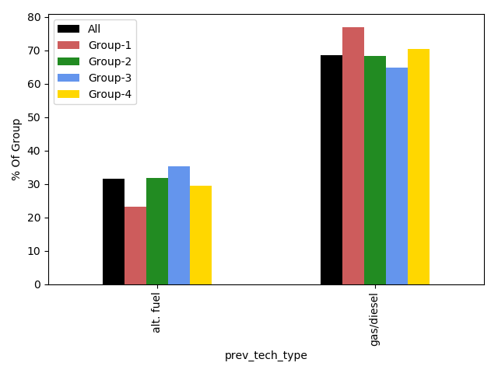

Figure 9: Previous vehicle technology type by group.

### Solar Panels

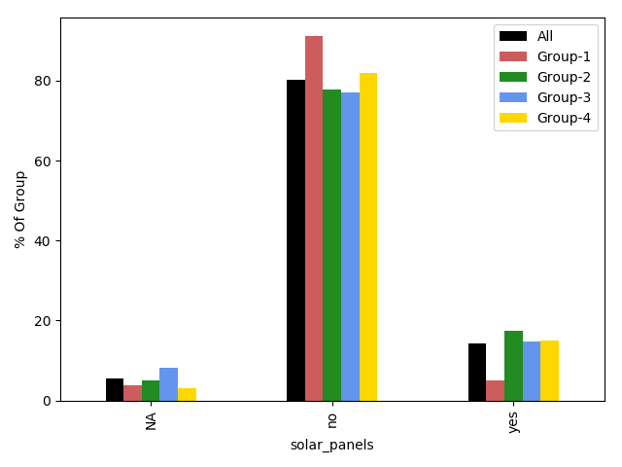

Figure 10: Active solar system generation capacity at residence by group.

### Vehicle Model

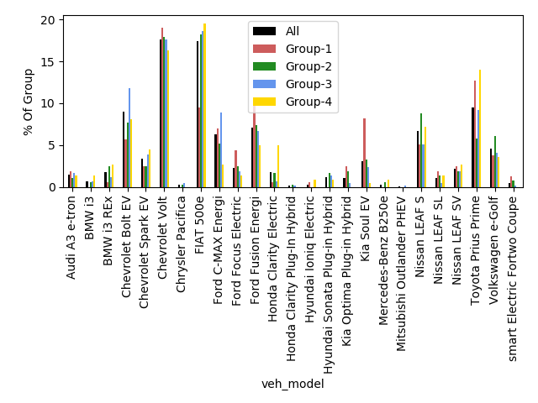

Figure 11: Vehicle model purchased by group.

# Regional LMI Consumer Group Prevalence

We performed regional analyses on air districts with >75 LMI rebate consumers: Bay Area, San Diego, South Coast and San Joaquin Valley Unified (Table 1‑1). The LMI rebate consumers in these regions comprised nearly 90% of all LMI rebate consumers. The analysis shows the prevalence of each consumer group varies by region.

|  |  |  |
| --- | --- | --- |
| **Air District** | **Total LMI Rebate Consumers** | **% of Total** |
| South Coast | 629 | 62% |
| Bay Area | 197 | 19% |
| San Diego | 110 | 11% |
| San Joaquin Valley Unified | 83 | 8% |

Table 1‑1: Number of LMI rebate consumers by air district.

Although the prevalence of consumer groups vary across regions, the general group structure is relatively consistent (Figure 12). In particular, Groups 2 (High Income/Large Households/Primarily White/Married) and 3 (Older/Lower Income/Small Households/Primarily White) are the most prominent consumer groups, ranging between 60-75% of LMI rebate consumers for each region. Groups 1 (Younger/Lower Education/Latino) and 4 (Younger/High Education/Large Households/Primarily Asian) are less prevalent with ~15% and ~20% of consumers on average, respectively. That said, in the Bay Area the prevalence of Group 1 is below average, and Group 4 is above average. In San Diego, there is a decrease in the prevalence of Group 4 consumers. In the San Joaquin Valley there is a slight increase in Group 1 consumers. The South Coast has slight increases in the prevalence of Group 1 and 4 consumers.

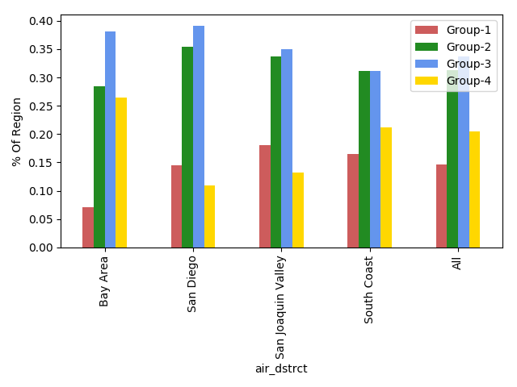

Figure 12: Prevalence of consumer groups by region.

# Methods

## Data

We used fields from CVRP application and survey (2016-2017 and 2017-2018) data. Only records corresponding to LMI rebates were included in the analysis. Rebates used to purchase vehicles greater than $50,000 were dropped to reduce the prevalence of high-wealth/low-income individuals in the data. Records with more than three missing values were dropped.

## Analysis

We used latent class analysis (LCA) which is a clustering technique that incorporates statistical methods to guide the selection of clusters. We clustered on 8 variables and reported each cluster’s association with several additional variables (Table 1). We used BIC to measure the fit of the LCA model and identify the optimal number of clusters to define.

|  |  |  |  |  |
| --- | --- | --- | --- | --- |
| **Variable Name** | **Used in cluster analysis** | **Description** | **Dataset** |  |
| age | Yes | Age category | Survey |  |
| air_dstrct | No | Local air district | Application |  |
| gender | No | Gender category | Survey |  |
| HH_education | Yes | Highest education in household | Survey |  |
| HH_income | Yes | Household income | Survey |  |
| HH_size | Yes | Household size | Survey |  |
| Latino | Yes | Race/Ethnicity | Survey |  |
| num_cars_HH | No | Number of cars in household | Survey |  |
| num_lic_drvr_HH | No | Number of licensed drivers in household | Survey |  |
| other_ethnic | Yes | Race/Ethnicity | Survey |  |
| prev_tech_type | No | Previous vehicle tech type (e.g., gas) | Survey |  |
| reason | No | Most important reason for purchasing an EV | Survey |  |
| residence_type | No | Type of residence (e.g., detached house) | Survey |  |
| s_e_Asian | Yes | Race/Ethnicity | Survey |  |
| solar_panels | No | Solar installed on property (yes/no) | Survey |  |
| tax_filing_status | No | tax filing status (e.g., single) | Survey |  |
| tech_type | No | Technology type of purchased vehicle (e.g., gas) | Application |  |
| tot_rebate | No | Total rebate received for purchase from CVRP | Application |  |
| Vehcile model | No | Rebated vehicle model | Survey |  |
| White | Yes | Race/Ethnicity | Survey |  |