Testing

* Testing attack to make sure after attack you take damage

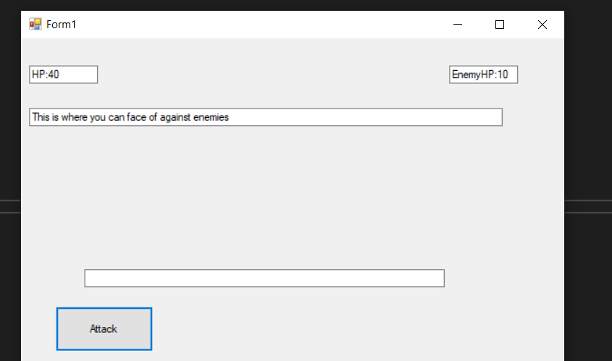

Realized need to change the hp value

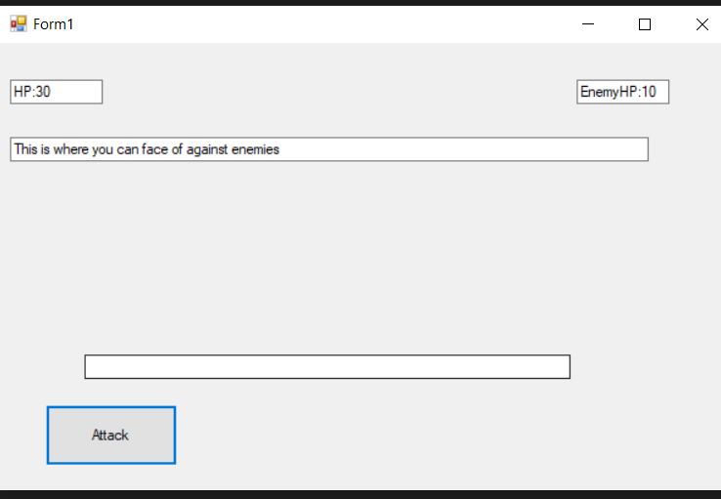

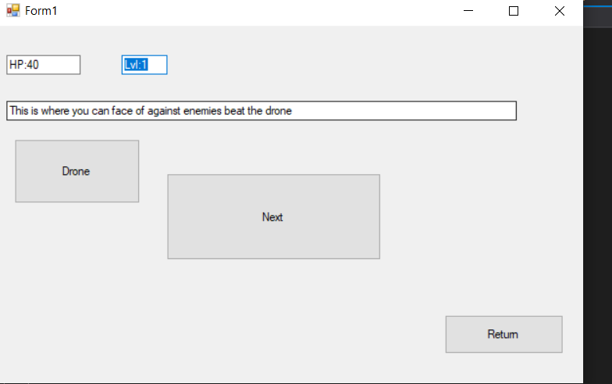

Removing the giant next because it is not necessary

Checking if leveling up works

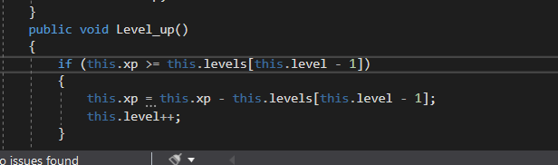

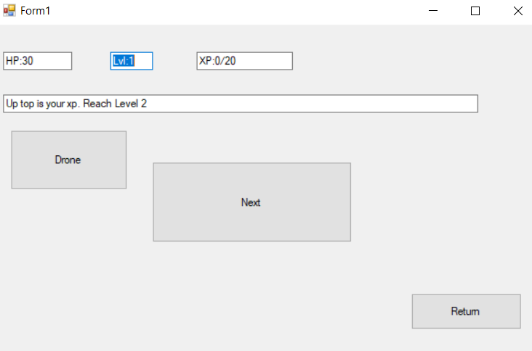

Realized the current level did not update in the code

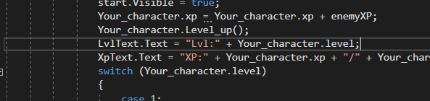

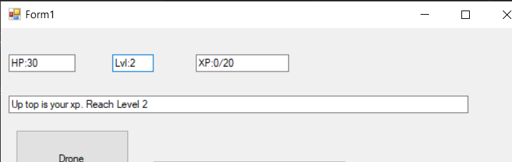

Testing enemy scaling

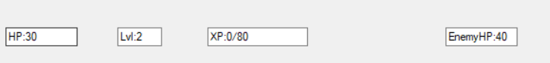

Testing amp damage should be a .05% increase to 10

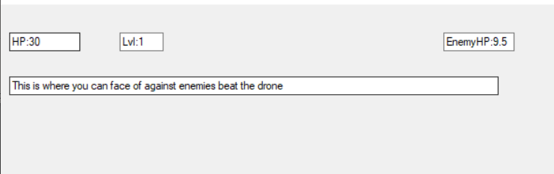

Realized I forgot to update the damage delt