Armalia

The Beginning

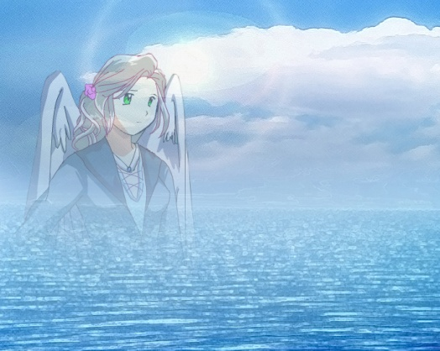In the beginning there existed an empty world with no land or life. A vast world covered in water for all its existence. This world was Armalia. Though it had no life, it wasn’t dead. It itself was alive. After eons of loneliness it wished to see the glorious adventure of what is life. It began its wish by creating giant mountains and vast plains, and then came the spewing growth of plantation filling the plains and mountains with green.

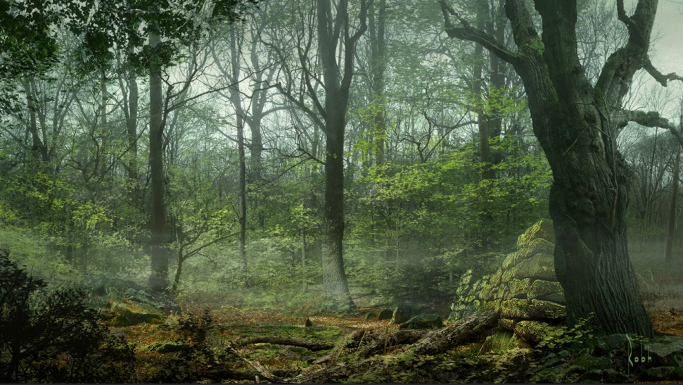

Next came, the wildlife that filled the world with noise and action. Lacking intelligence, Armalia sought to create an intelligent being, the human. Being pleased with its latest creation, it felt to award the intelligent being with the power of magic.



With the power of magic, the intelligent being was able to create a society that quickly turned into a civilization. This civilization was centered on Armalia’s gift of magic. The humans used magic to create massive cities that gave light to what would be world engulfed in darkness. For a while Armalia was satisfied with the turnout of its creation.

The Joining

Seeing its creation having fun and enjoying their gift of life and magic, Armalia wished to join them. It created itself a human body in form of a woman. With its new form, it then joined the civilization. As the years went by, Armalia enjoyed its form more and more. However, the form didn’t come without consequences. With the human form came emotions. Eventually, Armalia fell in love.

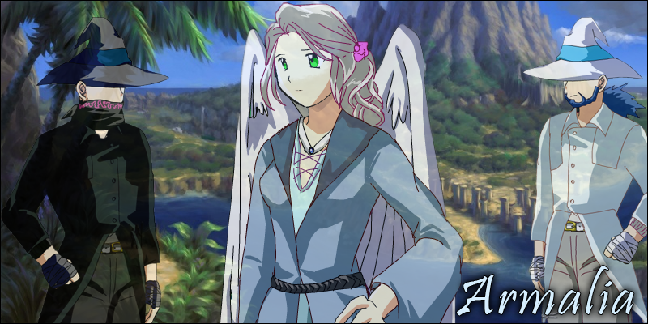

With love came marriage, and Armalia in deed got married. Who she married is unknown, but what came of it is legend. She gave birth to two twin boys. They were named Zane and Zoran.

They were both very unique in personality, and they both inherited their mother’s strength.

As the boys got older, their strength grew. This came with a consequence. Armalia’s power left her and went to her sons. Eventually, she was unable to hold her human form, and her soul returned to the planet. Not knowing their mother’s secret, the boys thought she had passed away. Grieving for his mother, Zane came to hate the magic that killed his mother.

The Prologue

Being demigods, the boys lived for 100s of years. Zane, hating magic, hid himself away in the shadows of the mountains never to be seen. Zoran on the other hand strived to use magic to for the better good. Through Zoran’s effort, magic became stronger and more beneficial to the humans. However, magic made its way into other uses, darker uses.