Game Design Document
Game Concept & Design Document Template

Document Contents

3 Design Document 7
3.1 Design Guidelines 7
3.2 Game Design Definitions 7
3.3 Game Matrix 7
3.4 Game Flow Chart 8
3.5 Player Elements 8
3.5.1 Player Definition 8
3.5.2 Player Properties 8
3.5.3 Player Rewards (Power-ups & Pick-ups) 9
3.5.4 User Interface (UI) 9
3.5.5 Heads up Display (HUD) 9
3.5.6 Player View 9
3.6 Antagonistic Elements 9
3.6.1 Antagonistic Definitions 10
3.6.2 Antagonistic Properties 10
3.6.3 Antagonistic List 10
3.6.4 Artificial Intelligence (AI) 10
3.7 Global Game Elements 10
3.8 The Story 10
3.8.1 The Story Copy 10
3.9 Concept Art 10
3.10 Level Design 11
3.10.1 Level Copy 11
3.11 Audio & Sound F/X 11
3.12 Game Architecture 11
3.12.1 Game Architecture Overview 12
3.12.2 Architecture Copy 12
3.12.3 How to play Copy 12

Design Document

This document describes how game objects behave, controlled and properties they have.

This documentation is primarily concerned with the game it’s self.

This part of the document is meant to be modular. Meaning you could have several Game Mechanic documents attached to the Concept Document.

Design Guidelines

This is an important statement about any creative restrictions that need to be regarded and a general over all goal of the design.

Game Design Definitions

This is a section where the definition of the game play is established.

Definitions should include how a player wins, loses, passes levels and the main focus of the game play.

Issues that should be addressed here are:
- Menu
- Synopsis
- Game Play
- Player Control
- Game Over (Winning & Losing)

Game Matrix

This is a spreadsheet containing the generic names of the player and antagonistic elements and their game properties.

This should allow an easy cross reference for an elements in the game that a value.

Consult with the programmer about the properties a game object.

See Appendix B

Game Flow Chart

This is where a visual of how the different game elements and their properties interact.

Game Flow chart should represent Objects, Properties and Actions that are present in the game.

Flow chart objects, properties and actions should have a number reference to where they exsist with in the game mechanics document.

See Appendix C

Player Elements

List all the elements that are directly related to or to the benefit of the player.

Devise two sets of names for player elements. One set is a generic name (or code) and the other is its game name.

Describe the terminology that you use to describe the player’s properties.

This is a good place to interact with a graphic designer to get graphics to match to game names.

Graphics that will be seen during game play should be exhibited here.

Multi-player issues should also be mentioned here.

Player Definition

Make quick descriptions that define the player.

What are the default settings for the player at the beginning of the game or level.

A suggested list of player definitions:
- Actions: What can the player do?
- Information (Status): What information about the game is available for the player?
- Default Properties: How does the player begin the game?
- Winning: How can the player win?
- Loosing: How does the player lose?

Player definition
- Belongs to a certain race or type
- Has powers and weaknesses of that race or type
- Can be named
- Has a banner (?)

Player actions
- Move
  - In game space on the ground
  - No means of aviation
  - Can swim (?)
  - Can ride weapons, vehicles, animals (?)
- Pick up objects (limit to the number that can be held?)
  - Weapons, armor, portions, etc.
- Choose objects in possession
  - Weapons, portions, etc.
- Communicate
  - Using predefined text dialogues
  - With NPCs, enemies, allies
- Attack
  - Attack enemies

Game Status
- Player health
- Player experience level
- Player magical ability level
- Possessions (weapons, armor, artifacts, etc.)
- No indication of enemy power
- Geographical location(?)
- Quests to be accomplished (?)

Default properties
- Basic weapon(s), armor (?) (Auto generated)
- Some currency
- Quest or purpose
- Few allies (?)
- Experience (?)

Winning condition
- Completion of storyline and defeat the boss

Loosing condition
- Losing a battle

Player Properties

Make a list that defines the properties that a player has.

Player properties can be affected by player’s action or interaction with other game elements.

Define the properties and how they affect the player’s current game.

A suggested list of player definitions:
- Health
- Weapons
- Actions
- Etc.
Each property should mention a feedback as a result of the property changing

Player Rewards (Power-ups & Pick-ups)

Make a list of all objects that affect the player in a positive way. (i.e. health replenished)
- (Temporarily affect) Player abilities
  - Mana accelerators (?)
  - Portion of negative and positive effects
    - Add to overall powerfulness (?)
    - Reduce health
  - Antidote
    - Health replenisher (rare element)
  - Magic enhancers (magical ability enhancers)(?)
- Player equipment
  - Weapons (Magical and non-magical)
  - Armor (Defense)
  - Maps
  - Magic scrolls (?) – one time use (?)
  - Currency (money) or tradable artifacts
  - Artifacts objects that can complete quest for NPCs
  - Runes

Define these objects by describing what affect they cause and how the player can use the object.

Player ability enhancers

Portion of negative and positive effects
A portion that gives power, at the cost of health of the user. Non- rare item can be traded, scavenged, or awarded. (Power given is magical or ?)

Antidote
Increases health of the user. Rare item. (Does health decline with time?)

Mana accelerators
Accelerates the user’s ability to cast spells or use magic. Can be scavenged, traded, or given.

Runes
Health runes that replenish health. (rare item).

Player equipment

Non- magical weapons
Weapons that doesn’t need magic. Rarity depended on the power of the weapon.

Magical weapons
Weapons that need magic in order to function. Rarity depended on the power of the weapon.

Non- magical armor
Defense that doesn’t need magic. Rarity depended on the power of the armor.

Magical armor
Defense that need magic in order to function. Rarity depended on the power of the armor.

Maps
Guides to the geography of the area, or points to certain buildings or places.

Magical scrolls
Can be used to enhance magical ability. Rare items(?)

Currency/Money
Can buy certain objects/ objects that are tradable.

Artifacts given by NPCs
Quest completion aids or reducers.

Runes
Can enhance the power of magical weapons or armor. Rare(?)

User Interface (UI)

This is where a description of the user’s control of the game can be placed.

It is also recommended to think about which buttons on a device would be best suited for the game.

Consider what the worst layout is, then ask you self if your UI is it still playable?

A visual representation can be added, where we relate the physical controls to the actions in the game.

When designing the UI, make use of the expertise of someone from quality control.

Heads up Display (HUD)

This is where a description of any graphics that will represent information during game play should be described.

A visual representation (mock-up screenshot) here would be useful.

This is a good place to interact with a graphic designer.

Player View

A screen shot is very necessary here.

A definition of how the camera moves for the player.

A mock-up of an overview of the level relative to the screen size will help create a perspective of a levels size compared to what is actually seen.

Antagonistic Elements

This is where a list of antagonistic (enemies, opponent) objects should be listed with graphics and written description.

Describe the terminology that you used to describe antagonistic properties.

Devise two sets of names for player elements. One set is a generic name (or code) and the other is its game name.

This is a good place to interact with a graphic designer to get graphics to match to game names.

Antagonistic Definitions

This where a description of what makes a antagonistic element.

Antagonistic Properties

This is a list of properties that antagonistic elements have in common.

Antagonistic List

This is where a list of all the antagonistic elements goes.

Artificial Intelligence (AI)

This is where visuals and written description(s) of the antagonistic element’s behaviors.

These should be labeled in such a way that they can be used in level design with out having to describe them again.

Devise generic names for repetitive behaviors.

This is how an AI action could be broken down:
- Normal State: What is the object doing if it has not come in contact with the player?
- Detection State: What does it take for this object to detect the player?
- Reaction State: What does the object do as an action after passing the reaction state?
- End State: What happens to the object after player has reacted correctly or incorrectly to object?

Global Game Elements

In this section it is important to describe the boundaries, neutral objects, camera views and scale of the world.

Neutral game world objects can be things like a static background, objects that do not interact with the player or antagonistic elements.

The Story

This is where the story can be described in detail.

A story board can be used to tie in graphics to the text.

This can later be used for splash screen concepts.

The Story Copy
A shorter version of the story (The in game version) should also be written here.

This is where the script for in game characters or story information during the cut scenes would be placed.

This category does not always pertain to the current Game Design.

Concept Art

Sketches that are used for the concept can go into this section as visual reference.

In the case of a brand, certain creative restrictions should be noted here.

This is a good place to interact with a graphic designer to get graphics to match to game names.

Level Design

This is where information pertaining to level design and visuals of the level design goes.

Level design can best be shown as a flow chart.

Use generic names to create level design.

Level Copy
This is where the script for in game characters or story information during the cut scenes would be placed.

Audio & Sound F/X

This is where game ambient and Sound F/X should be listed with generic names then described.

This section also includes deciding if you will use a device’s vibration ring mode.

Game Architecture

This is best done by a flow chart to represent the overall game.

Number each screen.

- Title Screen
- Option Screens
- Game Modes
- End Screens

See Appendix D

Game Architecture Overview

The splash screens or video clip need to be in accordance to game story and style.

If cut scenes use video then story boards should be created.

This will need to be created with the graphic designer.

Menu should be designed with the most important options easily accessible.

Be aware how many clicks it takes to accomplish a task.

It would be wise to get together with someone from quality control and a programmer.

The Game Instructions should be written so that the player understands how to play the game.

Mock-ups should be made so that the programmers get the correct layout of the menu.

Mention and describe high score screen here as well.

Architecture Copy

All text fro the game can be complied here.

Review Game Architecture Overview

How to play Copy

This will be game copy.

Information for the player, clearly describing how to play the game.

Appendix B
Object | Properties
Unit type | Hit Points | Damage | Bullet speed | Movement
Basic Enemies
Cannon -01 | 30 | 100 | Medium | NA
Cannon -02 | 60 | 150 | Slow | NA
Static rocket launcher | 70 | 700 | Medium | NA
Flock 1 | 15 | 500 | NA | Medium
Flock 2 | 15 | 35 | Slow | Medium
Medium 1 | 80 | 350 | Fast | Slow
Medium 2 | 90 | 400 | Medium | Slow
Rail | 120 | 600 | NA | Slow
Small 1 | 25 | 200 | Fast | Fast
Small 2 | 30 | 210 | Fast | Fast

Appendix C

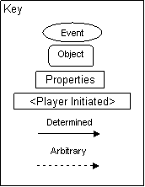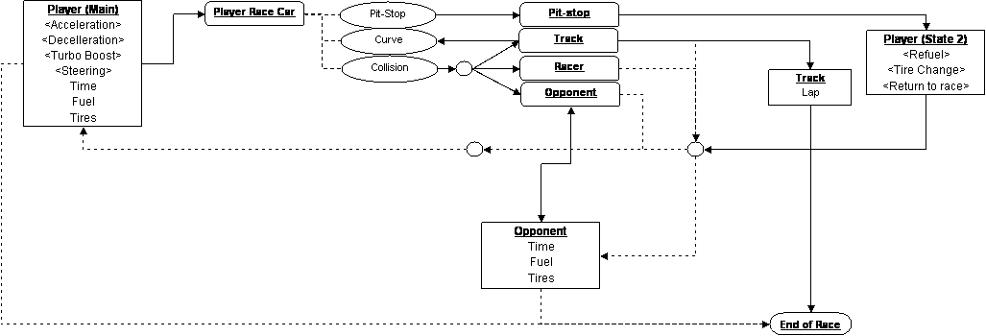

Appendix D
