Game Design Document

Version 1.0

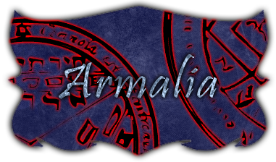

Armalia
“When war dies, revenge is born.”

Persei Games
Anderson, Justin
Calvillo, Anthony
DeSilva, Nilmini
Tan, Josh

Group Project Assignment 2
Section 1
March 1, 2013
Table of Contents

Design Document 3
1. Design Guidelines 3
2. Game Design Definitions 3
3. Game Matrix 3
4. Game Flow Chart 3
5. Player Elements 3
Player Definition 3
Player Properties 3
Player Rewards (Power-ups & Pick-ups) 3
User Interface (UI) 3
Heads-Up Display (HUD) 3
Player View 3
6. Antagonistic Elements 3
Antagonistic Definitions 3
Antagonistic Properties 3
Antagonistic List 3
Artificial Intelligence (AI) 3
7. Global Game Elements 3
8. The Story 3
The Story Copy 3
9. Concept Art 3
10. Level Design 3
Level Copy 4
11. Audio & Sound F/X 4
12. Game Architecture 4
Game Architecture Overview 4
Architecture Copy 4
How to Play Copy 4
Technical Document 4
1. System Requirements 4
2. Visual Content 4
3. Audio Content 4
4. Programming Content 4
5. Code Structure 4
6. Concerns and Alternatives 4
7. Resources 4
8. Technical Matrix 4
Appendix A 4
1. Taxonomy 4
2. Genre 4
3. Game Elements 4
4. Content 4
5. Theme 5
6. Style 5

Design Document

Design Guidelines

Game Design Definitions

Game Matrix

Game Flow Chart

Player Elements

Player Definition

Player Properties

Player Rewards (Power-ups & Pick-ups)

User Interface (UI)

Heads-Up Display (HUD)

Player View

Antagonistic Elements

Antagonistic Definitions

Antagonistic Properties

Antagonistic List

Artificial Intelligence (AI)

Global Game Elements

The Story

The Story Copy

Concept Art

Level Design

Level Copy

Audio & Sound F/X

Game Architecture

Game Architecture Overview

Architecture Copy

How to Play Copy

Technical Document

System Requirements

Visual Content

Audio Content

Programming Content

Code Structure

Concerns and Alternatives

Resources

Technical Matrix

Appendix A

Taxonomy

Genre

Game Elements

Content

Theme

Style

