统计IEQc8.1满足要求面积的方法

1. Export your data as txt.

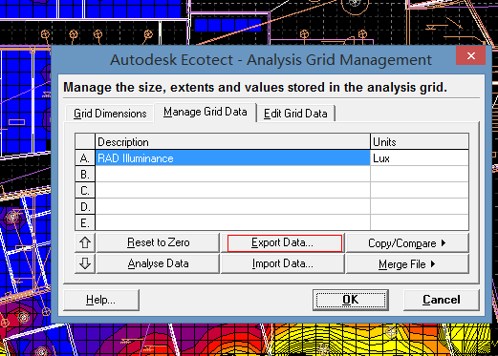

1. The exported file will be arranged in such way that the data on Ecotect analysis grid node will be written in a matrix. Each data be separated by comma. “0” in data means that node is not asked to be analyzed in Ecotect.

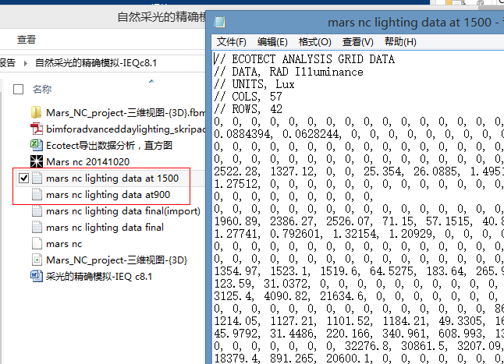

1. Paste content of exported .txt file into MS excel, treat the data by using command “分列”

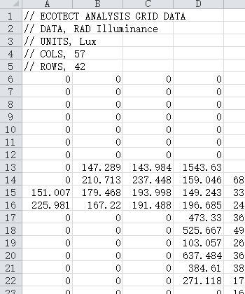

1. Write function as follows at any position in the chart.

=IF(A6=0,"NA",IF(A6<107,"dim at 900",IF(A6>5000,"bright at 900",IF(A54<107,"dim at 1500",IF(A54>5000,"bright at 1500","Pass area")))))

Where, “A6” refer to the 1st row 1st column node at 900 analysis grid, “A54” should be its counterpart at 1500.

The point showing “pass area” are those in accordance with LEED requirement.

1. Autofill other cells. Here comes the result matrix. You can then auto count the “passed node” or etc. Or even treat the data as your wish and then export as txt file, then import the data back to the Ecotect.

