After starting the program, this start window should be shown:

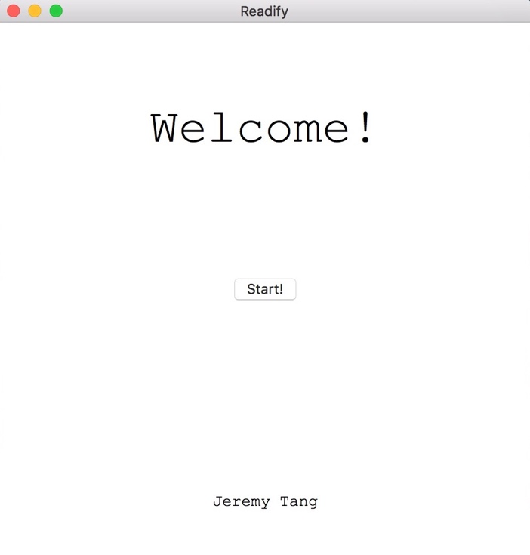

When you click on the start button, you will reach this window:

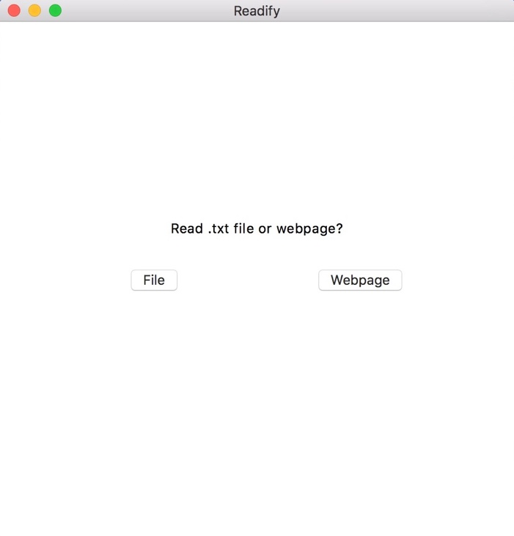

If you click on the “File” button, the following should be shown:

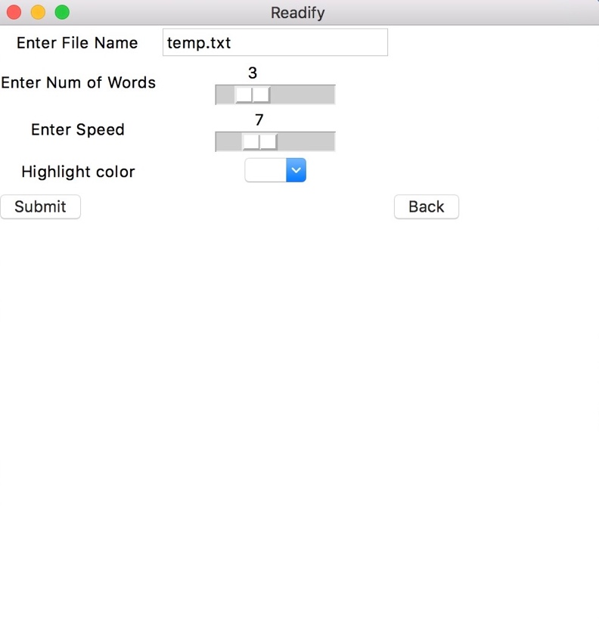

The sliders should be shown with default values.

If you click on the “Back” button, it will take you back to the main screen.

If the “Webpage” button is clicked, the following will be shown:

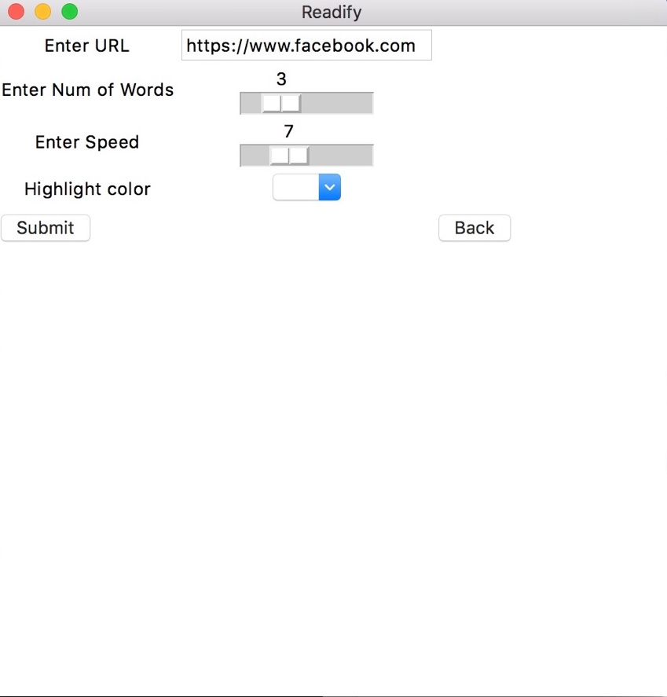

When you select a highlight color, the words will start to be print out as shown:

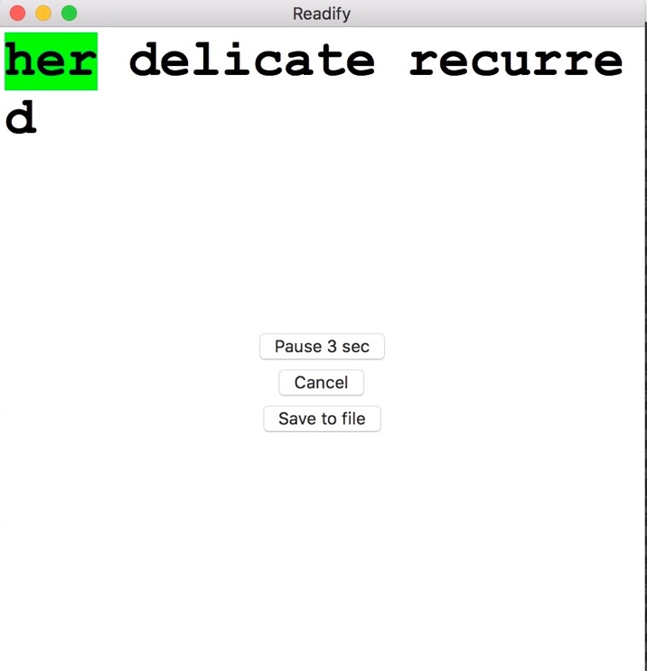

If no highlight color is selected, the words will not be highlighted one by one.

Pressing the Pause button will pause the application for 3 seconds. The word highlighted should not move.

Pressing the Cancel button will bring you back to the main page.

If you press “Save to file”, the words not printed out will be saved for resuming later.

Upon returning to the main screen, there should now be an option to “Resume”

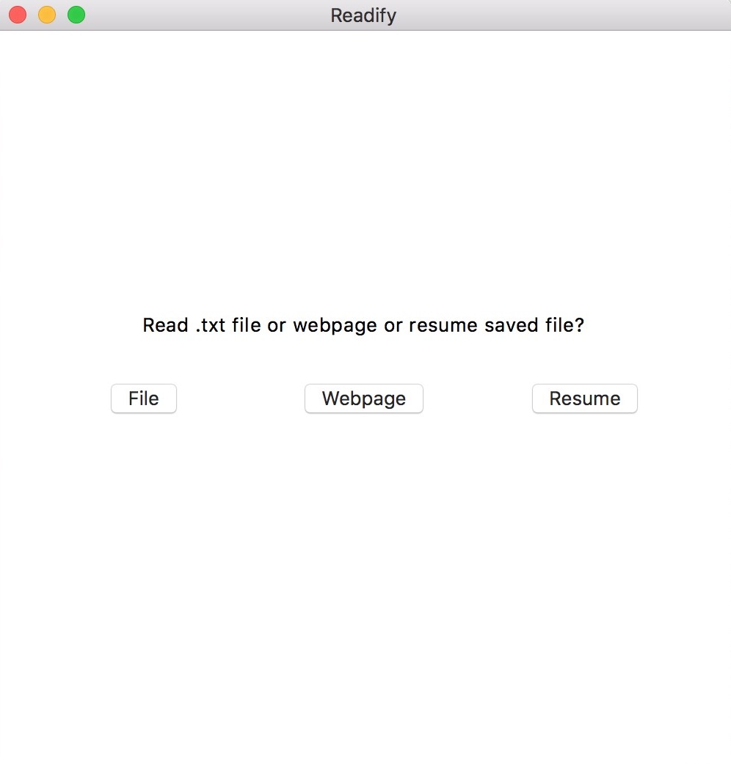

After pressing “Resume”, you will reach the page where it asks you for speed, numwords, etc. Once you start, the saved file will be deleted from the system.