SUNYAT v.0x0 Programming Guide
revised Nov. 8, 2009

Table of Contents
Documentation License 2
Overview 2
Architecture 2
Instructions 4
MOV - register to register 4
MOV – immediate to register 4
ADD – register to register 5
ADD – immediate to register 5
SUB – register to register 5
SUB – immediate to register 6
MUL – register to register 6
MUL – immediate to register 6
DIV – register to register 7
DIV – immediate to register 7
CMP – register to register 7
CMP – immediate to register 8
JMP 8
JEQ 8
JNE 9
JGR 9
JLS 10
CALL 10
RET 10
AND – register to register 11
AND – immediate to register 11
OR – register to register 11
OR – immediate to register 12
XOR – register to register 12
XOR – immediate to register 13
NEG 13
LOAD 13
LOADP 14
STOR 14
STORP 14
PUSH 15
POP 15

Documentation License
Copyright 2008, 2009 William "Amos" Confer
The Sunyat documentation by William "Amos" Confer (www.miniat.org) is licensed under the Creative Commons Attribution-Share Alike 3.0 United States License. To view a copy of this license, visit
http://creativecommons.org/licenses/by-sa/3.0/us/
or send a letter to Creative Commons, 171 Second Street, Suite 300, San Francisco, California, 94105, USA.

Overview
The SUNYAT v0x0 (pronounced “SUE-knee-at hex zero”) virtual machine (VM) simulates a simple computer with a character terminal for input and output. Everything about its design targets understandability rather than speed or performance. In this way it is appropriate for educational use when examining the basics of computer organization and assembly/machine language programming. The VM is also paired with a working assembler/linker application which provides an expressive programming syntax and promotes a comprehension of how the target binary is produced without requiring it. Further, the VM, assembler/linker, and example programs are distributed under the GNU Public License, Version 3.0, and may therefore be used, modified, and distributed relatively freely under its terms.

Architecture
The SUNYAT is a fully 8 bit architecture (all registers and buses are 8 bits wide.) There are 12 system registers (see Figure 1):
- Eight general purpose registers (R0—R7) are initialized to '0', '7', '2', '8', '2', '0', '0', '7' on system launch (the primary author's wedding date). Each of these registers are directly manipulable by user programs.
- The Program Counter (PC) contains the memory address of the next instruction to execute. This register can only be indirectly manipulated via the JMP, CALL, and RET instructions. PC is initially set to execute code at address 0x00.
- The high and low Instruction Registers (IRH and IRL respectively) hold the currently executing instruction. These are not accessible to user programs.
- The Stack Pointer (SP) contains the memory address of the top element in the system stack. SP initially points just beyond RAM indicating an empty stack.
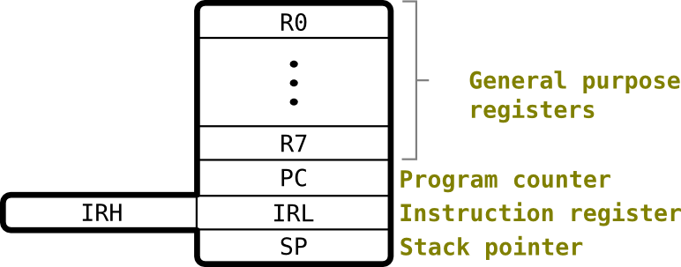
Figure 1: SUNYAT system registers
Considering the 8 bit nature of the SUNYAT, there are 2⁸ (256) addressable byte-sized words of memory (see Figure 2). The first 254 (addresses 0x00—0xFD) are RAM. 0xFE and 0xFF are the terminal input and output addresses, respectively. Writing to the terminal output address using the STOR or STORP instructions will cause the terminal to display the ASCII character associated with the byte written... this includes non-printable characters such as carriage returns and line feeds. Reading from the terminal input address using the LOAD or LOADP instructions will read the next character from the host computer's standard input. Since the standard input is buffered, a read from the terminal input may cause the SUNYAT application to wait until the buffer is ready... usually when the user hits the “Enter” key. If the buffer already contains characters, the read will complete without further interaction from the user.
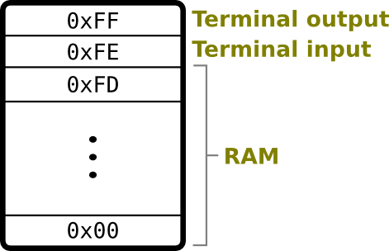
Figure 2: SUNYAT memory map
An interesting element of the SUNYAT design is its clock cycle. For the sake of simplicity (both in the implementation of the VM and user program analysis) every cycle of the VM conducts a complete fetch-decode-execute cycle, regardless of the complexity of an instruction, operands, or addressing mode. This results in a reliable one cycle time for all instructions. This includes terminal reads which might require user interaction... still only one clock cycle to the VM. This does not reflect the timing of real CPUs (particularly I/O communications) but it does provide a simple basis on which the beginning assembly programmer might predict the complete runtime of an application given known input.

Instructions
The following pages detail the SNUYAT's 32 assembly instructions and encodings. For each of these instruction definitions the following symbols are used for the sake of brevity:
Symbol | Meaning
opcode | The 5 bit machine code equivalent for the instruction. Each instruction description will detail this bit pattern
reg_A or reg_B | Identifies one of the eight general purpose registers (R0—R7). In the encoding, this is an unsigned 3 bit number (e.g., R6 = 110₂)
immediate | Signed 8 bit number.
address | Unsigned 8 bit memory address

MOV - register to register
General usage: | MOV reg_A reg_B
Description: | Copies the value in reg_B into reg_A
Example usage: | MOV R3 R1
Affected flags: | none
Opcode: | 00000₂
Encoding: | 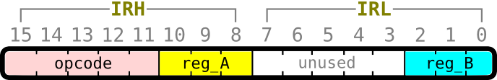

MOV – immediate to register
General usage: | MOV reg_A immediate
Description: | Loads the immediate value into reg_A
Example usage: | MOV R4 -15
Affected flags: | none
Opcode: | 00001₂
Encoding: | 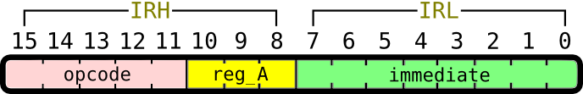

ADD – register to register
General usage: | MOV reg_A reg_B
Description: | Adds reg_B to reg_A, storing the result in reg_A
Example usage: | ADD R2 R7
Affected flags: | Zero and Sign
Opcode: | 00010₂
Encoding:

ADD – immediate to register
General usage: | ADD reg_A immediate
Description: | Adds immediate to reg_A, storing the result in reg_A
Example usage: | ADD R6 3
Affected flags: | Zero and Sign
Opcode: | 00011₂
Encoding:

SUB – register to register
General usage: | SUB reg_A reg_B
Description: | Subtracts reg_B from reg_A, storing the result in reg_A
Example usage: | SUB R1 R0
Affected flags: | Zero and Sign
Opcode: | 00100₂
Encoding:

SUB – immediate to register
General usage: | SUB reg_A immediate
Description: | Subtracts immediate from reg_A, storing the result in reg_A
Example usage: | SUB R5 64
Affected flags: | Zero and Sign
Opcode: | 00101₂
Encoding:

MUL – register to register
General usage: | MUL reg_A reg_B
Description: | Multiply reg_B and reg_A, storing the result in reg_A
Example usage: | MUL R2 R7
Affected flags: | Zero and Sign
Opcode: | 00110₂
Encoding:

MUL – immediate to register
General usage: | MUL reg_A immediate
Description: | Multiply immediate and reg_A, storing the result in reg_A
Example usage: | MUL R5 -4
Affected flags: | Zero and Sign
Opcode: | 00111₂
Encoding:

DIV – register to register
General usage: | DIV reg_A reg_B
Description: | Divides reg_A by reg_B, storing the result in reg_A
Example usage: | DIV R6 R4
Affected flags: | Zero and Sign
Opcode: | 01000₂
Encoding:

DIV – immediate to register
General usage: | DIV reg_A immediate
Description: | Divides reg_A by immediate, storing the result in reg_A
Example usage: | DIV R2 5
Affected flags: | Zero and Sign
Opcode: | 01001₂
Encoding:

CMP – register to register
General usage: | CMP reg_A reg_B
Description: | Compares the two register values via subtraction but does not store the result. However, the flags are set based on the result of the subtraction.
Example usage: | CMP R3 R7
Affected flags: | Zero and Sign
Opcode: | 01010₂
Encoding:

CMP – immediate to register
General usage: | CMP reg_A immediate
Description: | Compares the register value and immediate via subtraction but does not store the result. However, the flags are set based on the result of the subtraction.
Example usage: | CMP R0 2
Affected flags: | Zero and Sign
Opcode: | 01011₂
Encoding:

JMP
General usage: | JMP address
Description: | Jump (branch) unconditionally to the code beginning at address. Sets the PC to address. The address will typically be provided as a label, but can be written as an immediate, as well.
Example usage: | JMP !finished
Affected flags: | none
Opcode: | 01100₂
Encoding: | 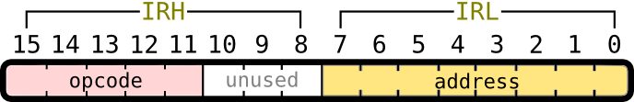

JEQ
General usage: | JEQ address
Description: | Jump (branch) to the code beginning at address if the previous CMP found an equality or if an ALU instruction's result was zero... in either case the Zero flag would be high. Sets the PC to address. The address will typically be provided as a label, but can be written as an immediate, as well.
Example usage: | JEQ !find_offset
Affected flags: | none
Opcode: | 01101₂
Encoding:

JNE
General usage: | JNE address
Description: | Jump (branch) to the code beginning at address if the previous CMP found an inequality or if an ALU instruction's result was not zero... in either case the Zero flag would be low. Sets the PC to address. The address will typically be provided as a label, but can be written as an immediate, as well.
Example usage: | JNE !distribute
Affected flags: | none
Opcode: | 01110₂
Encoding:

JGR
General usage: | JGR address
Description: | Jump (branch) to the code beginning at address if the previous CMP found the left operand to be greater than the right or if an ALU instruction's result was positive but not zero... in either case the Zero flag would be low and the Sign flag low. Sets the PC to address. The address will typically be provided as a label, but can be written as an immediate, as well.
Example usage: | JGR !no_trigger_found
Affected flags: | none
Opcode: | 01111₂
Encoding:

JLS
General usage: | JLS address
Description: | Jump (branch) to the code beginning at address if the previous CMP found the left operand to be less than the right or if an ALU instruction's result was negative... in either case the Sign flag would be high. Sets the PC to address. The address will typically be provided as a label, but can be written as an immediate, as well.
Example usage: | JLS !negate
Affected flags: | none
Opcode: | 10000₂
Encoding:

CALL
General usage: | CALL address
Description: | Call function beginning at address. This pushes the address after the CALLing line of code to the system stack, and then sets the PC to address. The address will typically be provided as a label, but can be written as an immediate, as well.
Example usage: | CALL !is_even
Affected flags: | none
Opcode: | 10001₂
Encoding:

RET
General usage: | RET
Description: | Returns from a function call. This pops the top of the system stack into the PC... presuming this was the address pushed to the stack by a previous CALL. RETurning when the stack is empty is the signal to halt the VM and print the total number of clock cycles executed by the application.
Example usage: | RET
Affected flags: | none
Opcode: | 10010₂
Encoding: | 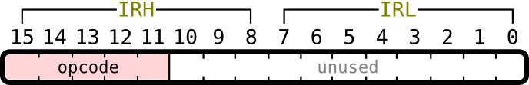

AND – register to register
General usage: | AND reg_A reg_B
Description: | Perform a bitwise AND on reg_A and reg_B, storing the result in reg_A
Example usage: | AND R0 R4
Affected flags: | Zero and Sign
Opcode: | 10011₂
Encoding:

AND – immediate to register
General usage: | AND reg_A immediate
Description: | Perform a bitwise AND on reg_A and immediate, storing the result in reg_A
Example usage: | AND R1 0b_0010_1001
Affected flags: | Zero and Sign
Opcode: | 10100₂
Encoding:

OR – register to register
General usage: | OR reg_A reg_B
Description: | Perform a bitwise OR on reg_A and reg_B, storing the result in reg_A
Example usage: | OR R4 R5
Affected flags: | Zero and Sign
Opcode: | 10101₂
Encoding:

OR – immediate to register
General usage: | OR reg_A immediate
Description: | Perform a bitwise OR on reg_A and immediate, storing the result in reg_A
Example usage: | OR R6 0b_0110_0011
Affected flags: | Zero and Sign
Opcode: | 10110₂
Encoding:

XOR – register to register
General usage: | XOR reg_A reg_B
Description: | Perform a bitwise EXCLUSIVE-OR on reg_A and reg_B, storing the result in reg_A
Example usage: | XOR R2 R3
Affected flags: | Zero and Sign
Opcode: | 10111₂
Encoding:

XOR – immediate to register
General usage: | XOR reg_A immediate
Description: | Perform a bitwise EXCLUSIVE-OR on reg_A and immediate, storing the result in reg_A
Example usage: | XOR R0 0b_0100_0100
Affected flags: | Zero and Sign
Opcode: | 11000₂
Encoding:

NEG
General usage: | NEG reg_A
Description: | Perform two's complement negation on reg_A, storing the result in reg_A
Example usage: | NEG R3
Affected flags: | Zero and Sign
Opcode: | 11001₂
Encoding: | 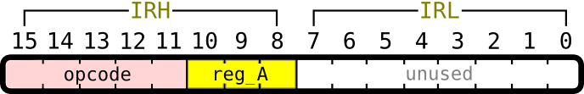

LOAD
General usage: | LOAD reg_A address
Description: | Loads (copies) a value from the given memory address into reg_A.
Example usage: | LOAD R7 width
Affected flags: | none
Opcode: | 11010₂
Encoding: | 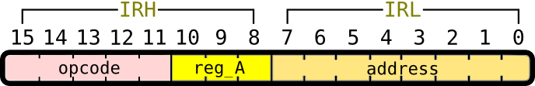

LOADP
General usage: | LOAD reg_A reg_B
Description: | Loads (copies) a value from the memory address in reg_B into a reg_A.
Example usage: | LOAD R3 R5
Affected flags: | none
Opcode: | 11011₂
Encoding:

STOR
General usage: | STOR address reg_A
Description: | Stores (copies) the value from reg_A to the given memory address.
Example usage: | LOAD count reg_A
Affected flags: | none
Opcode: | 11100₂
Encoding:

STORP
General usage: | STORP reg_A reg_B
Description: | Stores (copies) a value from reg_B into the memory address in reg_A.
Example usage: | STORP R1 R4
Affected flags: | none
Opcode: | 11101₂
Encoding:

PUSH
General usage: | PUSH reg_A
Description: | Pushes (copies) the value in reg_A to the top of the system stack. This is accomplished by first decrementing SP and then storing the at the new address in SP.
Example usage: | PUSH R3
Affected flags: | none
Opcode: | 11110₂
Encoding:

POP
General usage: | POP reg_A
Description: | Pops (copies) the value at the top of the system stack into reg_A. This is accomplished by first copying the value at the address in SP and then incrementing SP.
Example usage: | POP R0
Affected flags: | none
Opcode: | 11111₂
Encoding:

