Jasmine Tang

Operating Systems

Problem Set 1: Minicat

Sample Outputs

Program Compiling



Running until Ctrl+D is pressed with standard input and output

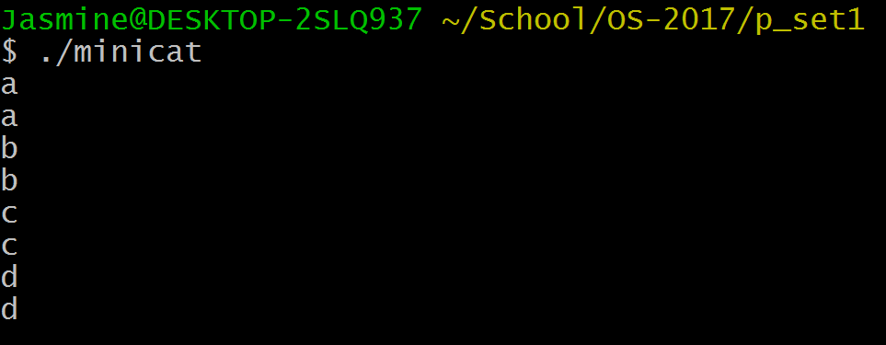

Running with buffer size specified as 1024 and using standard input and output.

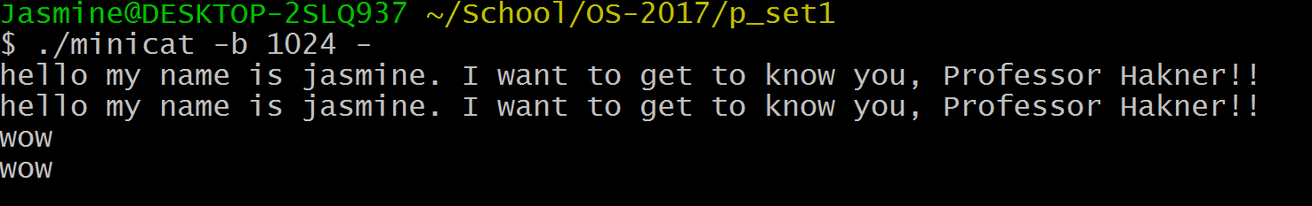

Running with output file specified. Buffer size is automatically set to 4096 and input is given in the standard input.

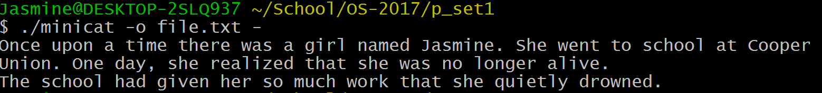

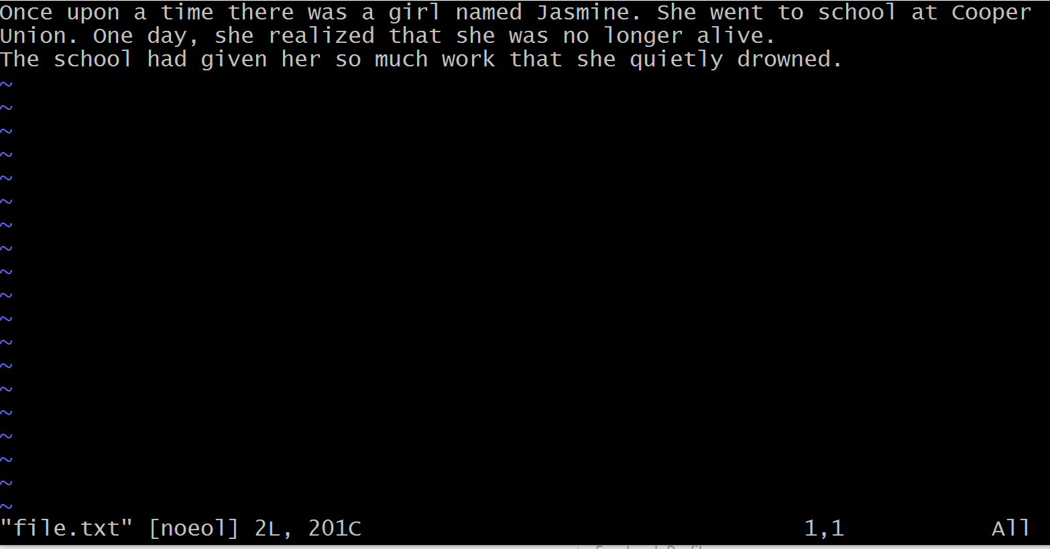

Running with input file specified. Buffer size is automatically set to 4096 and output is given in the standard output.

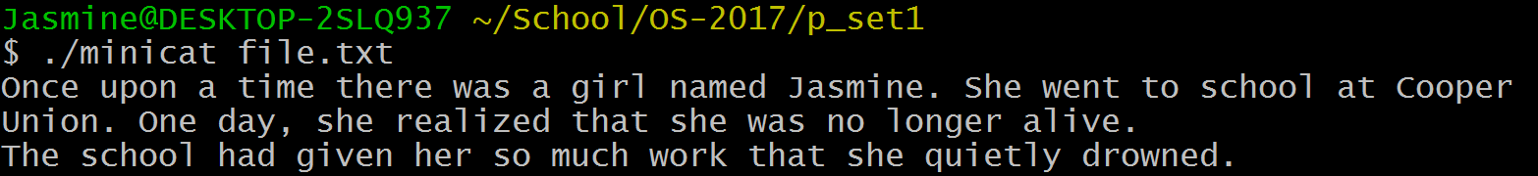

Running with output file and buffer size specified. Input is given in the standard input.



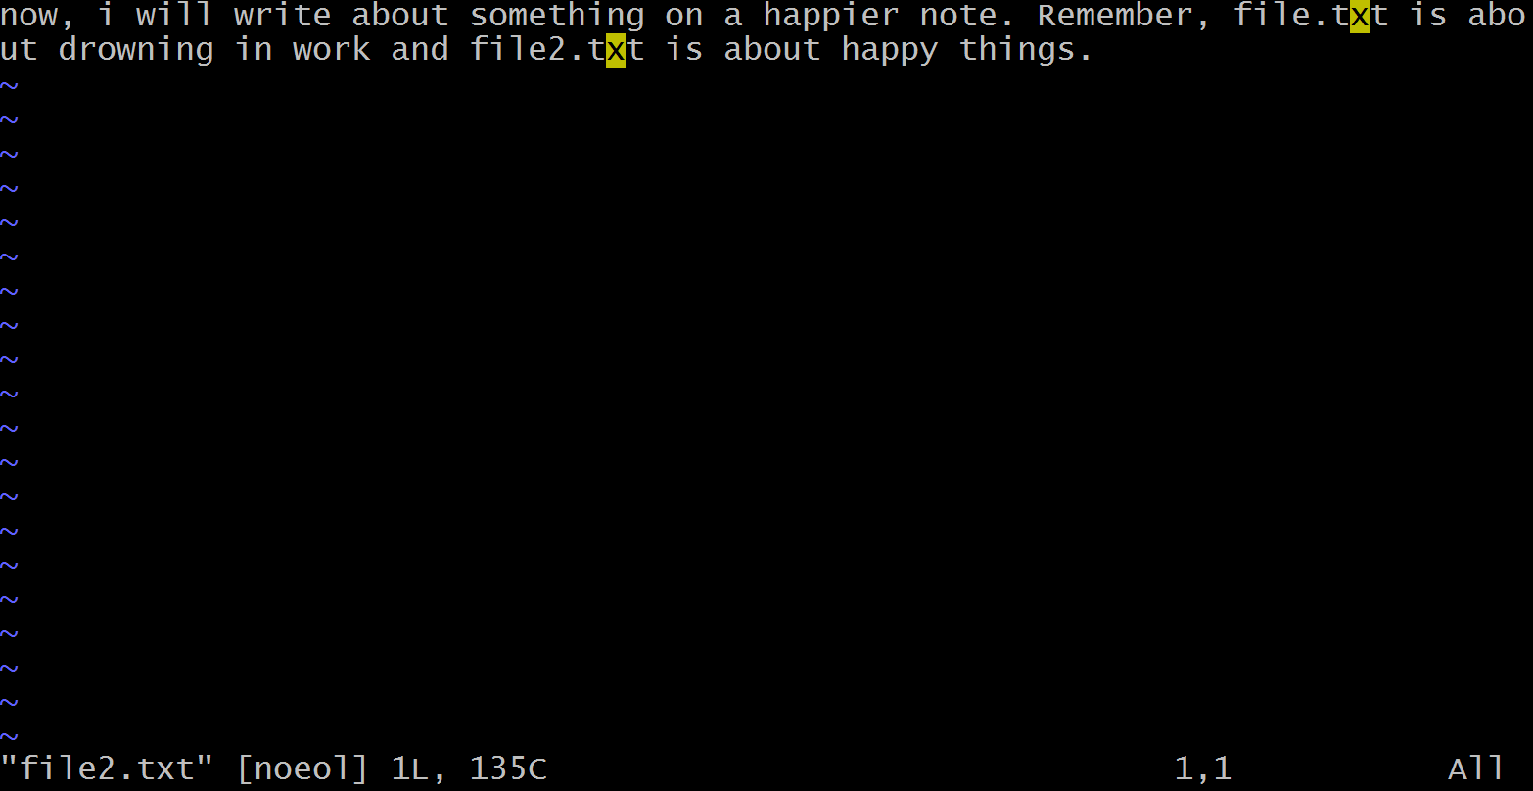

Running with input file and output file specified. Buffer size is automatically set to 4096.



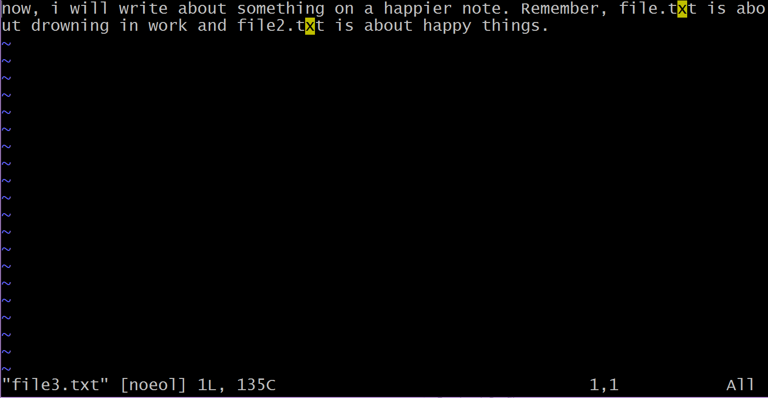

Running with input file and buffer size specified. Output is given in the standard output.



Running with input file, output file and buffer size specified.



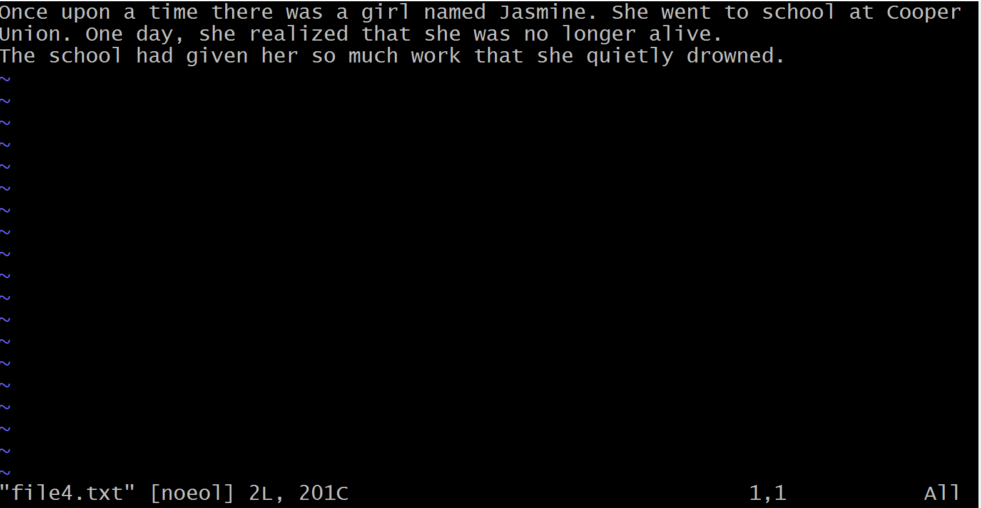

Error Checking

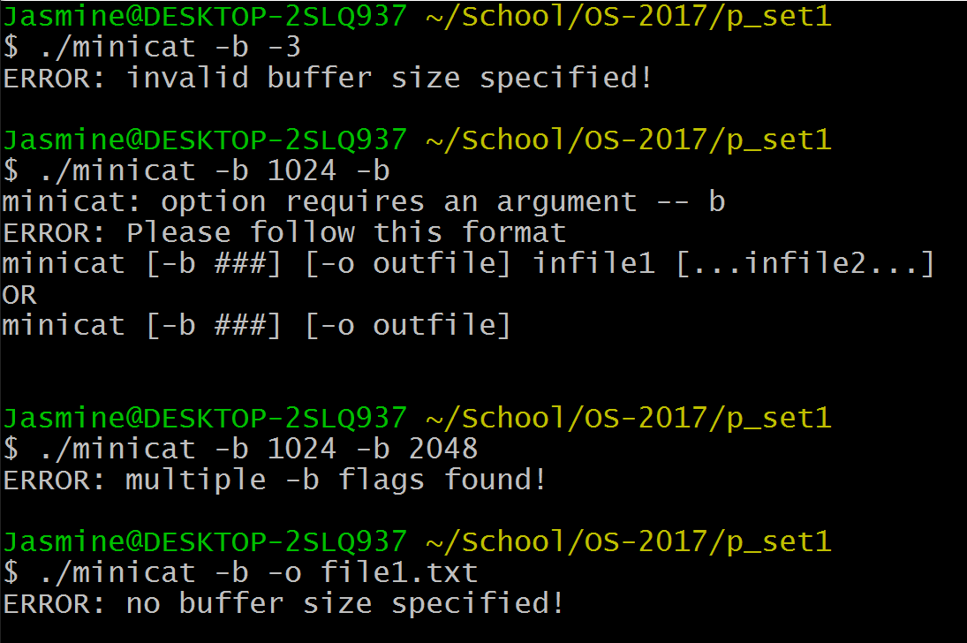

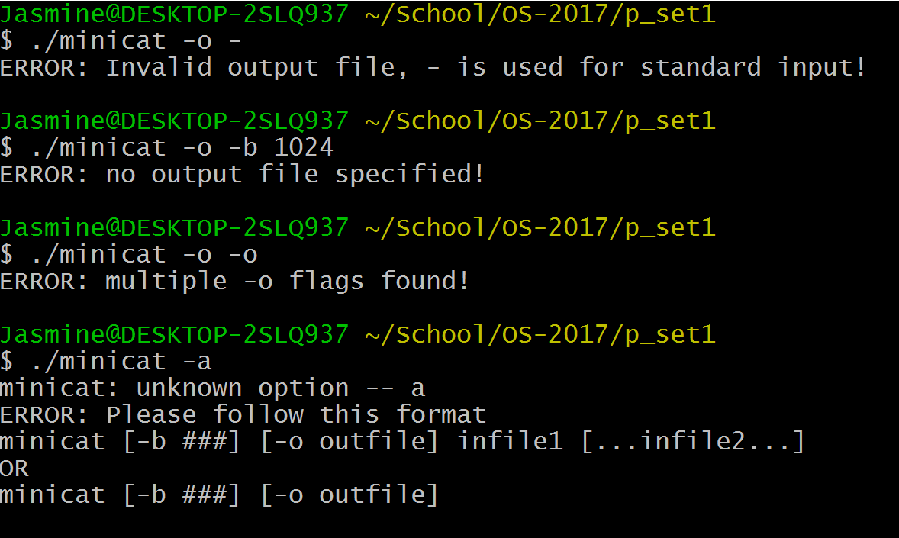

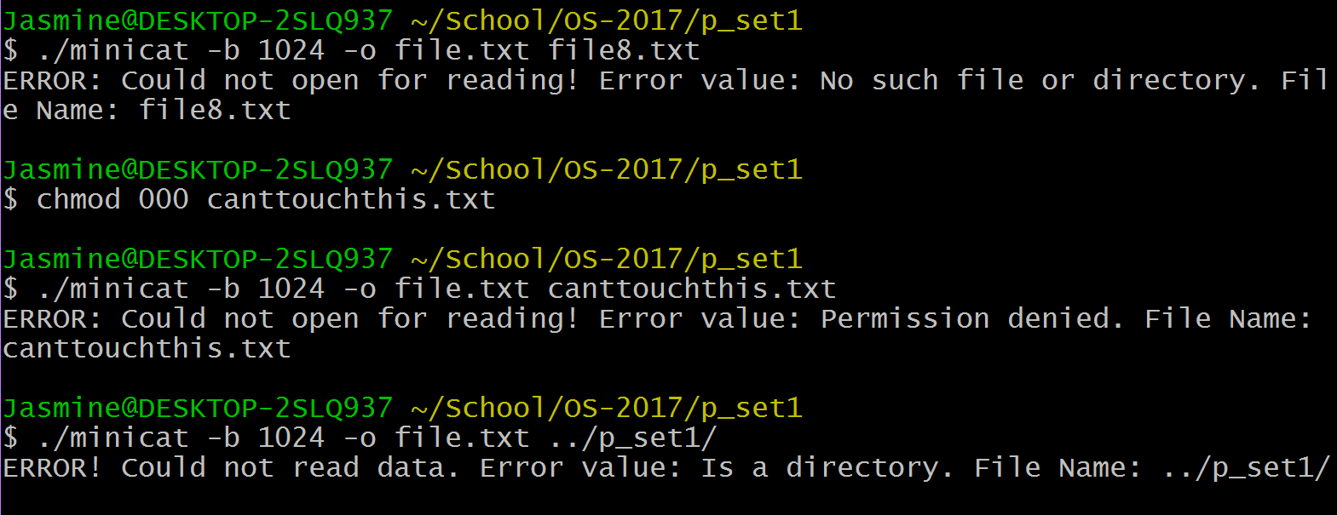

Performance Measure

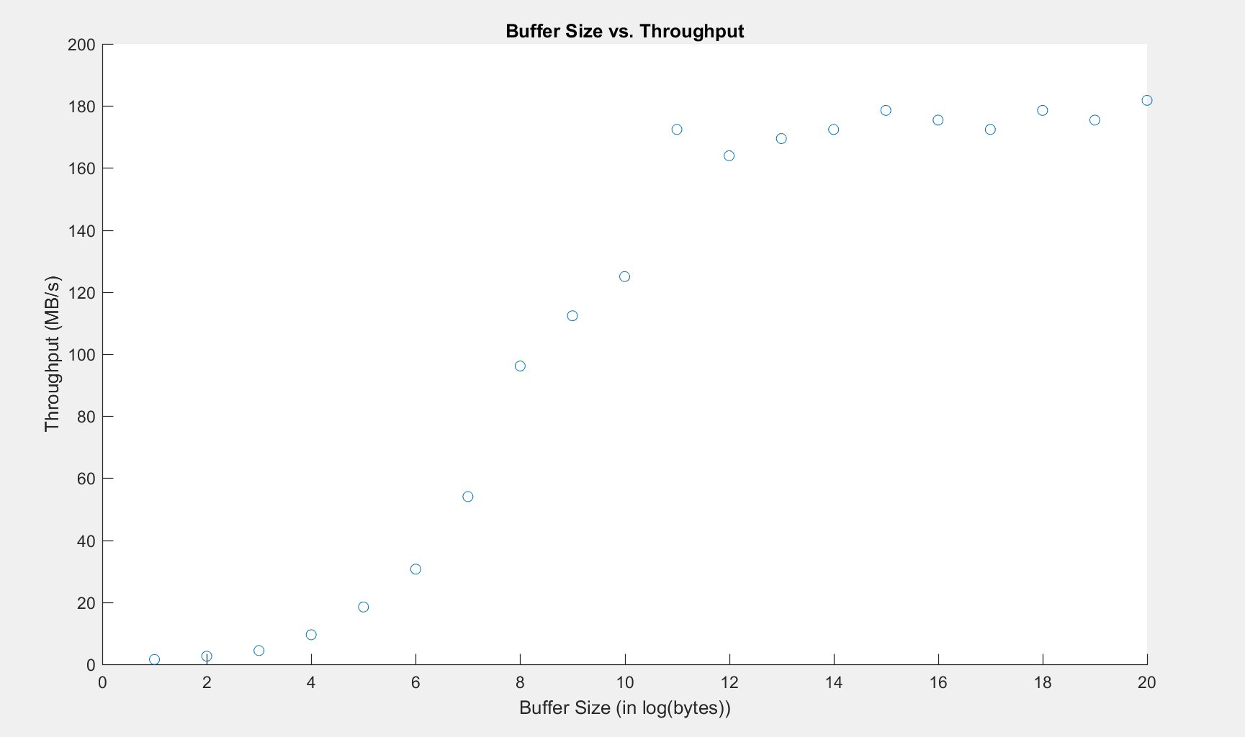

The general trend for the throughput is that it increases until a certain point. The increase in throughput is due to the fewer system calls that minicat is making. However, at the point where the throughput evens out, is the point where the number of syscalls is small enough so that it’s looking at how much each syscall is writing into the file. That is the bottleneck in comparison to when there are more syscalls and smaller buffer size.