MyLivingCity   
Project Status Report 2

Sprint (1)

|  |  |
| --- | --- |
| Period ending: | May 15 – May 22 |

|  |  |
| --- | --- |
| **Team Name: 10/10** | **Tasks In-Progress/Accomplished** |
| Phuong (Jennifer) Tang-Tran | * Finished editing the final version of the Project Charter * Development task “Update User” in progress   + Responsible for coding features that allow users to change their account information and reset their password |
| Joshua Sivertson | * Weekly status report written * Development task “Create User” in progress   + Responsible for coding features that will create a user account and assign roles such as Administrator, Associate, and Visitor |
| Changsin Park | * Project backlog uploaded to Jira and updated to include project scope * Development task “Delete User” in progress   + Responsible for coding features that will create a user account to be deleted and safely remove sensitive user information |
| Qin Liu | * Finished expected meeting schedule and communications document * Development task “User Agreement Acceptance” in progress   + Responsible for coding features that will display a standard user agreement and will record user acceptance |

|  |  |
| --- | --- |
| **Client:** | Nic LeBlanc |

**At the end of this week:**

|  |  |
| --- | --- |
| Number of units remaining in backlog | 236 |
| Number of units in progress | 34 |
| Number of units in review | 0 |
| Number of units completed this week | 0 |
| Number of new units identified (additional scope) | 0 |

**Describe any tasks that could not be completed and how these is being addressed:**

|  |  |
| --- | --- |
| **Task** | **How is this being addressed?** |
| ­All current tasks | We are redefining the goals of the current sprint |
|  |  |

**Descripted any tasks that could not be completed and the impact:**

|  |  |
| --- | --- |
| **Task** | **Impact** |
| All current tasks | Project progress will be delayed by approximately one week |
|  |  |

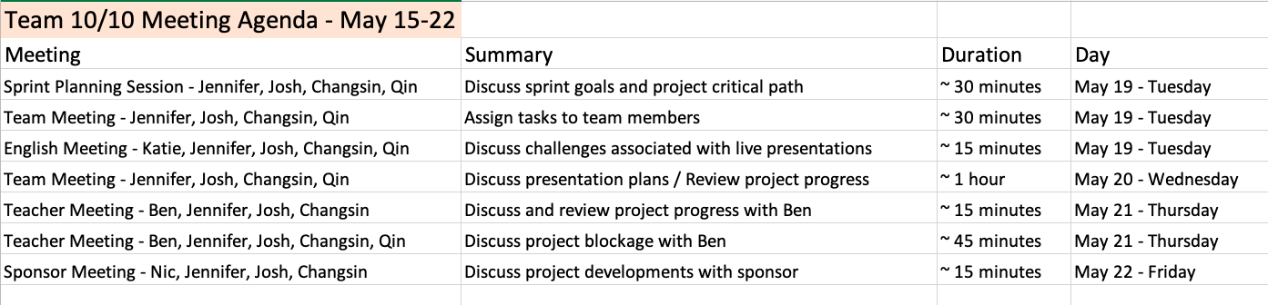**Provide a schedule of this week's meetings and a summary.  Include agenda, minutes.**

**At the end of each sprint (even numbered weeks), include everything above and the following:**

1. Project end date as estimated at the end of last sprint (based on burn-up chart)
2. Project end date as estimated at the end of this sprint (based on burn-up chart)
3. Estimated unit completion target for this sprint
4. Achieved unit completion target for this sprint.
5. Provide context for any loss or gain in productivity.
6. Estimated unit completion target for next sprint.  If different, please explain justification.
7. Attach a list of tasks addressed in the current sprint and their current state, assigned resource and estimate.
8. Attach a picture of your completed burn up chart.