Software Requirements Specification

For

Online Job Portal

**Prepared by:**

**Mrunali Salunke**

**Anuj Yadav**

**Anshal Khatri**

**(CDAC MUMBAI)**

**Abstract**

Job portal service was developed for creating an interactive job vacancy form for candidates. This web application manage updates both from the job seekers as well as the companies. It’s unique development methodology helps in acquiring the client and candidate information and separating them according to the job requirements and vacancies. The online access to it provides details of the job. An employer being registered in the web site has the facility to use the services. Being an authorized user he can publish vacancy details and can search no of Employees on portal and also he can search candidates on basis of the key skill which employee provides on registration.

Contents

Table of Contents 1

Revision History 2

.1. Introduction 3

1.1 Purpose 3

1.2 Document Conventions 3

1.3 Scope 3

1.4 Definition, Acronyms, and Abbreviations 3

1.5 References 3

2. Overall Description 2

2.1 Product Perspective 5

2.2 Product Functions 5

2.3 User Classes and Characteristics 5

2.4 Operating Environment 5

2.5 Design and Implementation Constraints 6

3. External Interface Requirements 8

3.1 Hardware Interfaces 8

3.2 Software Interfaces 8

4. System Features 9

4.1 System Feature 1 9

4.2 System Feature 2 (and so on) 9

5. Other Nonfunctional Requirements 13

5.1 Performance Requirements 13

5.2 Safety Requirements 13

5.3 Security Requirements 13

5.4 Software Quality Attributes 13

5.5 Business Rules 13

6. UML Diagrams 14

6.1 Use case diagram................................................................................................................

Appendix A: Glossary 5

Appendix B: Analysis Models 5

Appendix C: To Be Determined List 6

Revision History

|  |  |  |  |
| --- | --- | --- | --- |
| **Name** | **Date** | **Reason For Changes** | **Version** |
|  |  |  |  |
|  |  |  |  |

# Introduction

# Purpose

The purpose of designing the online job portal is to give the job seekers a platform for finding a right and a satisfactory job according to their qualification. It also connects the job seekers with the major agencies. Viewing available jobs, or applying for the job at the agency can be done for which job seekers has to go to the agency and check the available jobs at the agency. Job seekers check the list of jobs available and apply the job. Then the agency will show available jobs for the job seeker for his qualifications and then updates the jobs database.

.

## 1.2 Document Conventions

Heading:

Font Size: 14

Font Style: Bold Font: Times New Roman Subheading:

Font Size: 12

Font Style: Bold Font: Times New Roman Content:

Font Size: 12

Font: Times New Roman

## Scope

The scope of the online job portal includes:

The Online job Portal System that is to be developed provides the members with jobs information, online applying for jobs and many other facilities. The basic scope of the project is given as under.

Job Seekers Area

Recruiter’s Area

## 

## Definitions, Acronyms, and Abbreviations

HTML (Hyper Text Markup Language): It is used to create static web pages.

• JSP (Java Server Pages): It is used to create dynamic web content.

• J2EE (Java 2 Enterprise Edition): It is a programming platform, belonging to the Java platform, which is used for developing and running distributed java applications.

• DB2 (IBM Database 2): It is a database management system that provides a flexible and efficient database platform to raise a strong "on demand" business applications

• HTTP (Hyper Text Transfer Protocol): It is a transaction oriented client/ server protocol between a web browser and a web server.

## References

The documents and websites referred to, are as follows:

<https://naukari.com>/ ,

<http://www.w3schools.com/> ,

I had referred this website to get idea about the topics

**1.5 Technologies to be used**

J2EE: (Spring , Java Beans) Application architecture.

JAVA: Application architecture.

DB2: MYSQL Database.

# 2.Overall Description.

# 2.1 Product Perspective

The Online Job Portal System is a package to be used by agencies to improve the efficiency of business. The Online Job Portal System to be developed benefits greatly the members. The system provides jobs catalog and information to members and helps them decide on the jobs to apply. The Admin can keep the jobs catalog updated all the time so that the members (Job seekers and the agencies) get the updated information all the time.

The main users are users: Recruiters, Members who are the Job seekers and the agencies.

## Product Functions

The Online Job Portal System provides online real time information about the jobs available in the agencies and the user information.

The functions of the system include

-The member should be provided with the updated information about the jobs catalog.

-Provisions for the members to apply the job they want, if all the other required rules hold good.

-The member is given a provision to check his account information and change the account information

-any time in the given valid period.

-The members are provided with the jobs available roster and allowed to apply job, which they want.

-The admin can get the information about the members who have advertised jobs.

## 2.3 User Classes and Characteristics

The major user classes in the system would be:

1. **Job Seeker:**

- New employee needs to Sign Up or Register giving complete details.

-They can also login to apply for the job.

- They can also login to see their details.

1. **Recruiter:**

**-**Recruiter can login to see all applications.

-They can also login to see their details.

1. **Database:**

**-**It needs to update regarding any new additions .

-It will show the list of applications.

## Operating Environment

This web application can be deployed on window machine with Apache Server and MySQL server.

* Minimum RAM 512MB
* 20GB Storage Space.
* Intel Dual Core Processor
* Internet Connectivity with Ports configured

This application can be accessed by user through a machine having any web browser with html JavaScript support. The client devices must preferably have browsers like IE9 or above, Mozilla Firefox (version 3.5 or above) or Opera 10 or chrome (version 29 or above) or safari installed in their OS and must have enabled flash content to get videos output. Specified versions are preferred to get HTML 5 output. The portal can be accessed through a mobile or PDA with internet access and a web browser supporting html JavaScript output.

## Design and Implementation Constraints

Design Constraints:

The users access the Online Job Portal System from any computer that has Internet browsing capabilities and an Internet connection.

## User Documentation

User documentation components such as user manuals, online help, and tutorials will be delivered along with the software. Manual can be downloaded along the CMS package. Other tutorials and support form will be made available in case to report any bug or other support related issues. A simple how it works page will be included in package in html static page format.

## Assumptions and Dependencies

* We are assuming that the job seekers can apply for the jobs.
* Recruiter can see all applications.

# External Interface Requirements

## Software Interfaces:

The software interface uses a WAMP (Windows, Apache, MySQL) set-up.

Operating system: windows

Web Server: Apache 2.2.34

Database: MySQL 5.0

Scripting Language: Hypertext Preprocessor and JavaScript

Web Browser: Mozilla Firefox or Google Chrome

The product will host a local Apache web server where the user interface will be displayed via the Mozilla Firefox web browser. The scripting language html, CSS and JavaScript will define image placement, size and overall set-up. Html, CSS and JavaScript will also be used to create background colors, border colors and text display. JavaScript will be used to control client-side interactions (i.e. sound output when image is clicked). The MySQL database will store the images and sounds to be displayed at the output. All images are in jpeg format.

## Hardware Interfaces

The program will communicate with hard drive (the filesystem and database) via the appropriate spring, Spring-boot and Hibernate code. The user can communicate through browser using keyboard and a display through graphical interface displayed on user’s screen.

## Communications Interfaces

The requirements associated with any communications functions required by this product, web browser, network server communications protocols, and so on. Communication standards that will be used, such as HTTP. Communication security or encryption issues will handle by using java scripts.

# System Features

The major user classes in the system would be:

**1. User:**

- New jobseeker needs to Sign Up or Register giving complete details.

-They can also login to apply for the job.

- They can also login to see their details.

**2. Recruiter:**

**-** New Recruiter needs to Sign Up or Register giving complete details.

- They can also login to see all applications details.

- Recruiter is responsible for maintaining and updating the whole system.

**USE CASE DIAGRAM:**

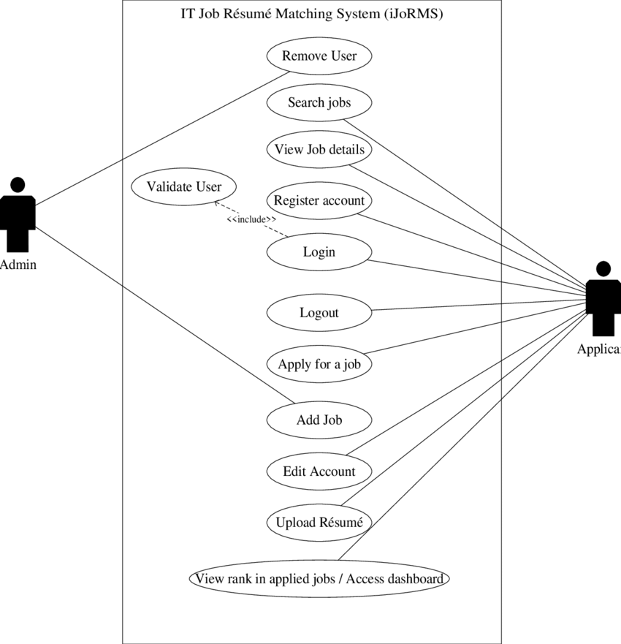

## 5. Other Nonfunctional Requirements:

**5.1 Performance Requirements:**

Any performance requirement in not added. User’s system speed may increase performance.

### 5.2 Safety Requirements

If there is extensive damage to a wide portion of the database due to catastrophic failure, such as a disk crash, the recovery method restores a past copy of the database that was backed up to archival storage (typically tape) and reconstructs a more current state by reapplying or redoing the operations of committed transactions from the backed up log, up to the time of failure.

### 5.3 Security Requirements

Security systems need database storage just like many other applications. However, the special requirements of the security market mean that vendors must choose their database partner carefully.

### 5.4 Software Quality Attributes

**Availability**: All the recruiters of the particular company should be able to to use the system.

**Correctness**: The software should provide the right information about the jobseeker and even the admin which are controlling it.

**Maintainability:** The administrator should maintain correct of the data available.

**Usability**: The system should be useful for both jobseeker and recruiter.

# 

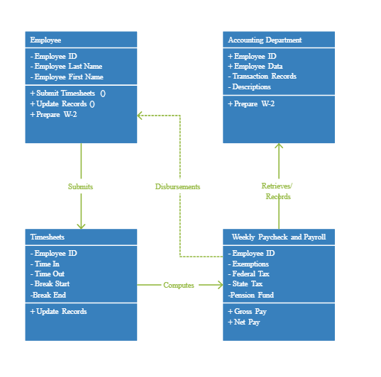



**E-R DIAGRAM:**



