Assignment 2
Total marks: 100 (equal marks for each question)
1. Given the following initial rate data for the reaction at 25ºC:
Experiment Initial Initial Initial Rate of Reaction
[NH₄⁺] [NO₂⁻] M⁻¹ s⁻¹
1 0.24 0.10 7.2 × 10⁻⁶
2 0.12 0.10 3.6 × 10⁻⁶
3 0.12 0.15 5.4 × 10^{–6}
- What is the rate law for the reaction?
- Calculate the reaction rate constant.
- Determine the rate when [NH₄⁺] = 0.39 M and [NO₂⁻] = 0.056 M.
2. The following data were obtained in a kinetic run from the decomposition of gaseous dinitrogen pentoxide at a set temperature.
Time (s) | 0 | 100 | 200 | 300 | 400 | 500 | 600 | 700
[N₂O₅] | 0.0200 | 0.0169 | 0.0142 | 0.0120 | 0.0101 | 0.0086 | 0.0072 | 0.0061
- Graphically determine the order of the reaction.
- Calculate the rate constant for the reaction.
- Calculate the concentration of dinitrogen pentoxide in the reaction vessel after 350 seconds.
3. The natural uranium / lead “clock” technique can be used to estimate the age of rocks. Assume that, at the time of solidification from the molten state, a rock contained the radioactive isotope uranium-238. U-238 decays to a stable end product, lead-206, through a series of disintegrations. This decay is known to have a half-life of 4.5 × 10⁹ years. Each uranium atom that decays eventually results in the formation of one lead atom. Assuming that the rock did not contain any lead-206 atoms originally, find the age of the rock when the ratio of uranium to lead atoms is 8 to 1.
4. The reaction
is known to be second order in NOCl. The rate constant for the reaction at 127ºC is 2.8 × 10⁻⁵ M⁻¹ sec⁻¹.
a. Given an initial concentration of 0.45 M at this temperature, calculate the concentration of NOCl(g) after 3.5 hours.
b. How long would it take for the reaction to go to 95% completion?
5. Calculate the activation energy, E_{a}, for the reaction
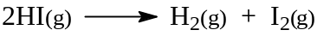
given that the rate constant at 356ºC is 3.02 × 10⁻⁵ M⁻¹ s^{–1} and at 508ºC is
3.95 × 10⁻² M^{–1} s^{–1}.
6. The decomposition of gaseous nitryl chloride, NO₂Cl, on heating is thought to occur by the following mechanism:
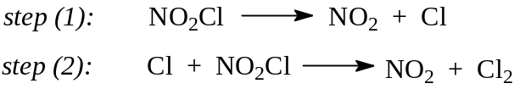
a. What is the overall reaction?
b. Identify any reaction intermediates.
c. What is the molecularity of each step?
d. Assuming this mechanism is correct, which is the rate-determining step if the experimental rate law is first order in nitryl chloride? Briefly explain your answer.
e. Assuming this mechanism is correct, which is the rate-determining step if the experimental rate law is second order in nitryl chloride? Briefly explain your answer.
7. a. Suggest a method for measuring the rate of the following reactions.
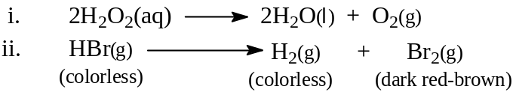
b. For the dimerization reaction
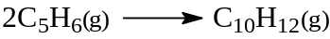
–Δ[C₅H₆]/Δt was found to be 4.4 torr sec⁻¹. What would be the value of Δ[C₁₀H₁₂]/Δt during the same period of time?
c. Explain why a catalyst for a forward reaction must also be a catalyst for the reverse reaction. Include an energy level diagram in your answer.

