Assignment 3
Total marks: 100 (equal marks for each question)
1. When 0.500 mol of N₂O₄ gas is placed in a 2.50 L reaction vessel and heated to a set temperature, 63.5% of the N₂O₄ decomposes. Calculate K_{c} for the decomposition reaction
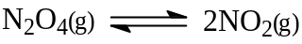
at this temperature.
2. For the equilibrium,
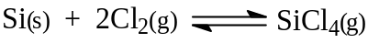
Indicate in the spaces of the table below the effect on the direction of the reaction and the effect on the equilibrium constant of the given changes to the system. The forward reaction is exothermic.
Change | Direction of Reaction | Equilibrium Constant
- Removal of Cl₂
- Addition of solid Si
- Decrease of temperature
- Decrease of volume
- Addition of He gas
- Addition of a catalyst
3. For the reaction
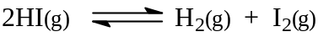
at 458°C, K_{c} is 2.59 × 10⁻². A one-litre cylinder at 458°C is found to contain 0.36 moles of HI(g), 0.15 moles of I₂(g), and 0.18 moles of H₂(g). Is this system at equilibrium?
4. K_{P} for the equilibrium
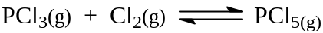
is 0.952 at 250°C. Calculate K_{c} at this temperature.
5. For the reaction
K_{c} = 0.771 at 750°C. Find the resulting concentrations of the H₂ and H₂O gases when 1.00 mol of H₂ and 1.00 mol of CO₂ are placed in a 5.00 L container and permitted to reach equilibrium.
6. One mole of NOCl gas is added to a 4.0 L container. The NOCl undergoes slight decomposition to form NO gas and Cl₂ gas. If the equilibrium constant, K_{c}, for the reaction
is 2.0 × 10⁻¹⁰ at 25°C, calculate the concentration of all the species at equilibrium at this temperature.
7. The equilibrium constant for the reaction
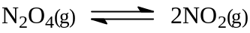
is K_{c} = 4.66 × 10⁻³ at 298 K. Calculate the following when 0.800 mol of N₂O₄(g) is injected into a closed 1.00 L container.
a. The concentration of each gas once equilibrium is reached
b. The new equilibrium concentrations if the volume is suddenly halved (still at 298 K)
8. Using the K_{sp} values given in Table 16.2 of your textbook, find the solubility in moles per litre of the following.
a. Calcium phosphate in water
b. Calcium phosphate in 0.010 M CaCl₂ solution
9. Suppose the two hydroxides, YOH and Z(OH)₂, both have K_{sp} = 1.0 × 10⁻¹² and that initially both Y⁺ and Z²⁺ are present in a solution at concentrations of
0.0010 mol L⁻¹.
a. Which hydroxide precipitates first as NaOH is slowly added to the solution?
b. What is the molar concentration of the first cation precipitated when the other cation just starts to precipitate out of solution?
10. 2.20 g of solid NaOH are added to 250 mL of a 0.10 M FeCl₂ solution. Given that K_{sp} for Fe(OH)₂ is 1.6 × 10, calculate the following.
a. The mass of Fe(OH)₂ formed
b. The molar concentration of Fe²⁺ in the final solution

