Assignment 5
Total marks: 100 (equal marks for each question)
1. a. Identify the following systems as open, closed, or isolated.
i. Coolant in a refrigerator coil
ii. The combustion of liquid hexane in a bomb calorimeter
b. A gas sample heated in a cylinder uses 650 kJ of heat. A piston that compresses this gas does 800 kJ of work. What is the change in internal energy, ΔE, of the gas during this process?
2. From the following data
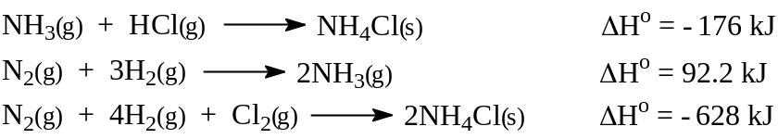
calculate ΔHº for the reaction
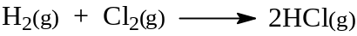
3. At 25ºC, ∆H° for the combustion of liquid octane, C₈H_{18(ℓ)}, to form CO₂(g) and H₂O(ℓ) is –5471 kJ mol^{–1}. Calculate ∆E for this reaction at 25ºC.
4. List the following substances in order of increasing molar entropy at 25°C.
H₂O(l), H₂O(g), H₂O(s), C(s), Ar(g)
Explain your reasoning.
5. The molar heat of vaporization of benzene, C₆H₆, at 1 atm is 30.8 kJ mol^{–1}. The boiling point of benzene at 1 atm is 78.3ºC. Calculate the entropy change when 11.5 g of benzene boils at this temperature.
6. The heat capacity of a bomb calorimeter, such as that shown in Figure 6.8 of your textbook, is 87.5 kJ K^{–1}. (This value is for the total heat capacity, including that of the water jacket around the reaction chamber.) If 67.2 g of methane, CH₄(g), is combusted under such reaction conditions, what will be the increase in temperature of the calorimeter? ∆E_{combustion} for CH₄(g) is –885.4 kJ mol^{–1}.
7. The standard free energies of formation of SO₂(g) and SO₃(g) are –300.4 and
–370.4 kJ mol^{–1}, respectively. Calculate the value of the equilibrium constant at 25ºC for the reaction
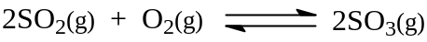
8. Calculate ΔG°_{combustion} at 25°C of octane, C₈H₁₈(l),
using the following thermodynamic data and that given in Appendix 3 of your textbook. For C₈H₁₈(l), ΔH°_{f} = –208.4 kJ mol⁻¹ and ΔS° = 463.7 J K⁻¹ mol⁻¹. Give your answer in kJ mol⁻¹ of C₈H₁₈(l).
9. Determine the temperature at which carbon can reduce iron(III) oxide to iron:
10. ∆H° is +23 kJ mol^{–1} of phosphine (PH₃) for the reaction
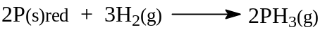
a. Calculate ΔS° for this reaction. Explain how this information allows you to determine the spontaneity or non-spontaneity of this reaction at any temperature. (S° for PH₃ is 210 J K⁻¹ mol⁻¹.)
b. Do these results indicate anything about the possibility of the existence of phosphine? Explain your answer.

