Assignment 6
Total marks: 100 (equal marks for each question)
1. For each of the following cells, write a balanced cell redox equation and calculate E°.
a. Ag(s) | Ag₂S(s) | S²⁻(aq) || HClO₂(aq), H⁺(aq) ‌| Cl₂(g) | Pt
b. Pt | Cr₂O₇²⁻(aq), Cr³⁺(aq), H⁺(aq) || Cl⁻(aq) | Cl₂(g) | Pt
c. Fe | Fe³⁺(aq) || Cl⁻(aq) | Hg₂Cl₂(s) | Hg(l)
Use the standard reduction potentials from Table 19.1 of your textbook or use the following.
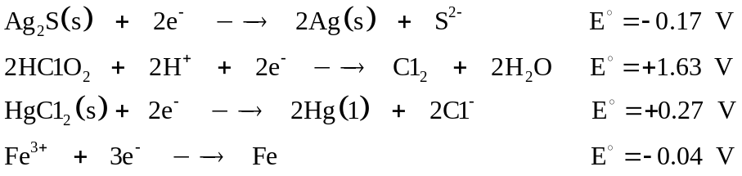
2. If acidic H₂O₂ is mixed with Fe²⁺, which reaction occurs: the oxidation of Fe²⁺ to Fe³⁺ or the reduction of Fe²⁺ to Fe? Give the balanced redox reaction for each possibility and explain your reason for selecting the reaction which will occur. Assume standard solution concentrations and use values from Table 19.1 in your textbook.
3. Give brief explanations (three or four lines) for the following.
a. Silver is oxidized by nitric acid, but gold is resistant to oxidation by nitric acid.
b. Aluminum does not corrode readily in moist air, but iron does.
c. You should not replace a section of galvanized iron pipe with copper pipe when doing plumbing repairs.
d. The density of the electrolyte in a lead storage battery gives an indication of the extent of discharge.
4. a. Calculate the number of moles of electrons needed to produce 5.12 g of
copper from the electrolysis of a solution of CuSO₄.
b. How much time is required to produce 200 g of aluminum metal from molten aluminum oxide dissolved in cryolite, if you use a 12.0 amp current? (Section 20.7 of your textbook discusses the production of aluminum by this method.)
5. For the half-reaction
a. Calculate ΔG° for the reaction
b. Given that the free energy of formation, ΔG°_{f}, of HF(aq) is –276 kJ mol⁻¹, calculate ΔG°_{f} of XeF₂(aq).
6. a. Write the equation for the cell reaction and indicate cathode and anode half-cells for the electrochemical cell formed from a Mg/Mg²⁺ half-cell and an In/In³⁺ half-cell.
b. Calculate E for the cell where [Mg²⁺] = 1.50 M and [In³⁺] = 0.00750 M. Given:
7. Acidic MnO₄– solution reacts with ethanol, CH₃CH₂OH, to produce acetic acid, CH₃COOH.
a. Write a balanced equation for the reaction.
b. What volume of 0.200 M MnO₄– solution is needed to titrate 22.5 mL of a 0.350 M solution of ethanol?
8. The corrosion of iron can be thought of as an electrochemical cell reaction. Calculate the voltage difference between two points of corroding iron differing only in their partial pressure of oxygen: 0.20 atm of oxygen at one point and 0.0010 atm of oxygen at the other. The reaction is:
9. a. Give the cell diagram notation of the electrochemical cell that could be used to determine experimentally the dissociation constant (K_{w}) of water. The standard reduction potential for
For other possible half-reactions, see Table 19.1 of your textbook. Calculate E° for this cell.
b. Use your value from part (a) to calculate the dissociation constant at
298 K.
10. The concentration of potassium ions inside a nerve cell is around 20 to 30 times that outside the cell. Calculate the potential difference between inside and outside a nerve cell, if it depends only on this ionic imbalance.

