Practice Exercise 2
- Nitrogen dioxide, NO₂, decomposes on heating according to the equation
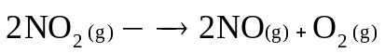
At the start of the experiment, the amount of NO₂ gas in a one-litre vessel was 0.1103 moles. After 60 seconds, the measured amount of NO₂ was 0.1076 moles.
- Calculate the average rate of decomposition (in mol L^{–1} sec^{–1}) of NO₂ during this time interval.
- Calculate the average rate of production (in mol L^{–1} sec^{–1}) of O₂ during this time interval.
2. The following kinetic data was obtained for the reaction
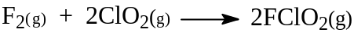
at 250 K.
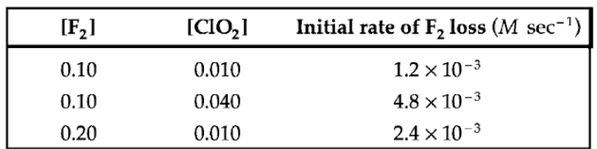
- Give the rate law for the reaction.
- Calculate the reaction rate constant.
- What is the rate of formation of FClO₂ at the time that [F₂] = 0.030 M and
[ClO₂] = 0.050 M?
3. At 227°C butadiene isomerizes to cyclobutene.
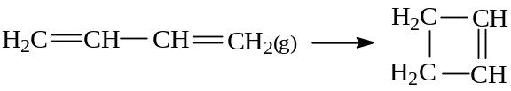
The following data was obtained by following the decrease in the concentration of butadiene during the course of one kinetic run.
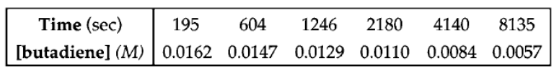
Determine (graphically) the order of this reaction and calculate the rate constant.
4. The methanolysis of α-fenchyl tosylate produces α-fenchyl methyl ether and tosylic acid (p-toluenesulfonic acid), H-OTs, according to the equation
α-fenchyl-OTs + CH₃OH → α -fenchyl-OCH₃ + H-OTs
The reaction can be followed by titrating the H-OTs (acid) produced, against NaOH solution. This titration does not measure α-fenchyl-OTs concentration directly. A final titration value is obtained after all the α-fenchyl-OTs has been converted to acid. Then the [α-fenchyl-OTs] is proportional to
(final titer value) – (titer value at time t)
The following data was obtained by withdrawing and titrating constant volume samples at various time intervals. The reaction temperature was 65°C.
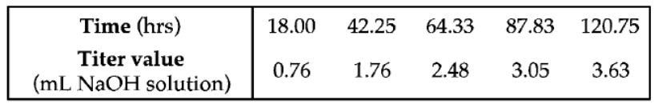
The final titer value for this kinetic run was 4.90 mL. From this data determine whether the reaction is first or second order with respect to the concentration of
α -fenchyl-OTs.
5. Tritium, an artificial isotope of hydrogen, is radioactive with a half-life of 12.5 years.
- Calculate the first-order reaction rate constant for this disintegration.
- If initially you had 1.00 × 10^{–5} moles of tritium, calculate the amount remaining after 4.50 years.
6. The gas phase decomposition of NO₂Cl to form NO₂ and Cl₂ has been to take place by the following mechanism.
(1) NO₂Cl(g) → NO₂(g) + Cl(g) slow
(2) NO₂Cl(g) + Cl(g) → NO₂(g) + Cl₂(g) fast
a. Give the overall balanced equation for the reaction.
b. What is the rate law that is consistent with this proposed mechanism?
7. Compound A decomposes by a first-order reaction. The concentration of A decreases from 0.1160 M to 0.0940 M in 5.2 minutes.
- Calculate the rate constant for the decomposition reaction.
- What fraction of the compound remains after 6.70 minutes?
c. Calculate the instantaneous reaction rate when the concentration of A reaches 0.0880 M.
8. The activation energy of a certain enzyme-catalyzed reaction occurring in the body is known to be 45.6 kJ. During a fever, the body temperature rose from 37.0ºC to 40.0ºC. By what factor is the rate of this particular enzyme-catalyzed reaction increased during this illness?
9. Briefly explain the effect of a catalyst on the following. (Draw energy diagrams where applicable.)
- The heat of reaction
- The activation energy of the reaction

