Practice Exercise 5
1. Calculate the ΔH for the reactions
given the following.
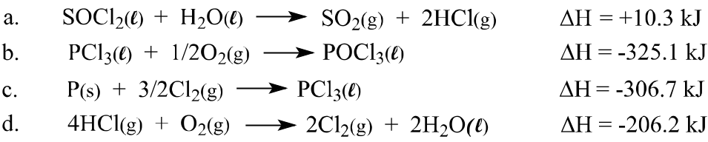

2. Two moles of an ideal gas at 25.0°C and a pressure of 4.00 atm are allowed to expand against a constant outside pressure of 1.00 atm until the volume increases by a factor of 3.00. The expansion occurs at constant temperature. Calculate the following.
a. ΔV b. w
c. ΔE d. q
3. Using the average bond energies for the Br–Br and F–F bonds given in Table 9.4 of your textbook and the ΔH°_{f} of BrF₃(g), given as –256 kJ mol⁻¹, calculate the average bond energy of the Br–F bond in BrF₃(g).
4. a. Using the values of ΔH°_{f} given in Appendix 3 and given that ΔH°_{f} of NH₄Br(s) is –270 kJ, calculate ΔH° for the reaction
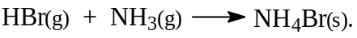
b. Also calculate ΔE° for this reaction.
5. Calculate the ΔS° value for each of the following reactions using the absolute entropy values given in Appendix 3 of your textbook as well as the following S° values:
C₂H₄(g) 220, P₄(g) 280, PCl₃(g) 217 (J K⁻¹ mol⁻¹)
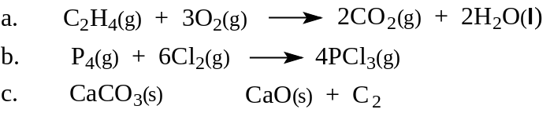

6. Ethane gas, C₂H₆, burns in excess oxygen to form carbon dioxide and water. Calculate ΔG°_{combustion} of ethane in kJ per mol as follows:
a. Using ΔG°_{f} values given in Appendix 3 of your textbook and ΔG°_{f} (C₂H₆, g) = –33 kJ mol⁻¹.
b. Using the Gibbs equation and appropriate values from Appendix 3 as well as ΔH°_{f} (C₂H₆, g) = –85 kJ and S° = 230 J K⁻¹ mol⁻¹.
7. Calculate the normal boiling point of ammonia, given that for ammonia
ΔH_{vaporization} = + 23.3 kJ mol⁻¹ and ΔS = + 97.2 J K⁻¹ mol⁻¹.
8. The enzyme triose phosphate isomerase catalyzes the interconversion of glyceraldehydes 3-phosphate (G 3-P) and dihydroxyacetone phosphate (DHAP),
G 3-P → DHAP
If the thermodynamic equilibrium constant, K, in the direction written is 22.0 at 298K, calculate ΔG° for this reaction. (Don’t be put off by the biochemical terms in this problem. You can calculate ΔG° here even if you have no knowledge of biology. This does show that thermodynamic calculations are not restricted to chemistry.)
9. A 1.45 g sample of acetic acid, C₂H₄O₂, was burned in excess oxygen in a calorimeter. The calorimeter contained 750 g of water and had a heat capacity of 2.67 kJ/°C. The temperature of the calorimeter and its contents increased from 24.32°C to 27.95°C. Calculate the molar ΔH°_{combustion} of acetic acid. The specific heat capacity of water is 4.184 J/°C/g. (You can neglect the heat capacity of the small amount of acetic acid and its combustion products.)
10. For the reaction
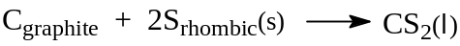
ΔH° = + 87.9 kJ/mol and ΔS° = + 81.5 J/K mol
a. Is this reaction spontaneous at 25°C?
b. Assuming that ΔH° and ΔS° do not change with temperature, calculate the temperature at which the reaction will occur.

