Practice Exercise 6
1. In each of the following give the oxidation number of
a. The chlorine atom in: Cl₂O, ClO₃⁻, HCl, Cl₂O₇
b. The phosphorus atom in: H₃PO₄, P₄O₆, P₄O₁₀
c. The uranium atom in: UF₆, UO₂²⁺, UCl₃, UO₃
d. The nitrogen atom in: NH₃, N₂O, H₂NNH₂, NO₃⁻, N₂O₄
2. Balance the following redox equations using either the oxidation number change method or the ion-electron method.
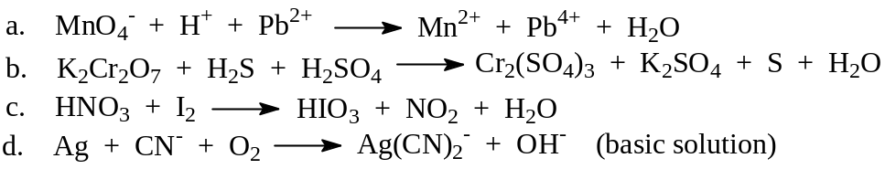
3. From the following electrolysis data, calculate the charge on the electron, expressed in coulombs.
A current of 0.61 A was passed through a 3.0 M solution of H₂SO₄ for 60.0 minutes. The evolved hydrogen gas, H₂, was collected over water and was found to occupy a volume of 288 mL at 27°C and total pressure of 767 torr. You will also need the following values.
Avogadro’s number: | N = 6.02 × 10²³
Ideal gas constant: | R = 0.0821 L atm K^{–1} mol^{–1}
Vapour pressure of water at 27°C: | 26.7 mm Hg
4. Draw a diagram of the cell and give a cell notation diagram for the standard galvanic cell you would construct based on each of the following balanced redox reactions.
(Label all parts of your cell diagram and indicate the direction of electron flow.)
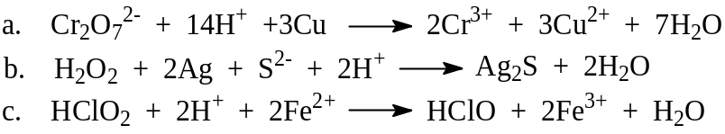
5. Use the following standard reduction potentials and Table 18.1 in your textbook to calculate the standard cell potential, E°, for each of the cells in Question 4 above. Are all the given equations spontaneous in the direction written? Briefly explain your answer.
Ag₂S(s) + 2e⁻ → 2Ag(s) + S²⁻ E° = –0.71 V
HClO₂ + 2H⁺ + 2e⁻ → HClO + H₂O E° = +1.64 V
- Given the standard reduction potentials
Au³⁺ + 2e⁻ → Au⁺ E° = +1.29 V
and
2MnO₄⁻ + 2e⁻ → 2MnO₄^{2–} E° = +0.56 V,
calculate ΔG° and K at 298 K for the reaction
Au³⁺ + 2MnO₄²⁻ → Au⁺ + 2MnO₄⁻
- Given the standard reduction potential
VO²⁺ + 2H⁺ + e⁻ → V³⁺ + H₂O E° = +0.36 V,
calculate the cell potential, E, for the electrochemical cell shown in the following cell notation
Pt | V³⁺ (0.05 M), VO²⁺ (0.01 M), H⁺ (0.01 M) || Au³⁺ (0.5 M) | Au
- a. Determine the cell potential of a cell prepared from two Ga³⁺ / Ga half-cells.
In one [Ga³⁺] = 2.00 M, and in the other [Ga³⁺] = 0.300 M.
b. Write an equation for this “cell reaction.” Does the oxidation reaction occur at the
0.300 M electrode or the 2.00 M electrode? Briefly explain your answer.
- A non-standard thallium half-cell, Tl/Tl³⁺ (0.01 M), was connected with a hydrogen half-cell where the pressure of the hydrogen gas was 2.50 atm and the half-cell pH was 1.0. A potential difference of 0.72 V was measured between the two half-cells. At the end of the experiment the pH of the hydrogen half-cell had dropped. From this information, calculate a value for the standard reduction potential of the thallium half-reaction
Tl³⁺ + 3e⁻ → Tl

