      - Draw structural formulas for all the constitutional isomers of:
- C₇H₁₆ with one or more tertiary hydrogen atoms.
- C₆H₁₂ cycloalkanes. Indicate which of these also exist in cis and trans forms.

2. a. Give the correct IUPAC name for each of the following:
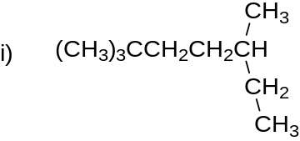
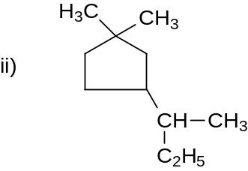

b. Draw condensed structural formulas for:
    - 3-ethyl-4,4-dimethylheptane
    - 3,5-dimethylcyclohexanol
    - 1,1-dimethyl-3-(1-methylpropyl)-cyclopentane

3. a. Draw Newman projection formulas for the anti conformation and the two eclipsed conformations of 1,2-diiodoethane, CH₂ICH₂I. Which of the two eclipsed conformations is more stable?
- Which conformation or isomer in each of the following pairs is more stable? Explain.
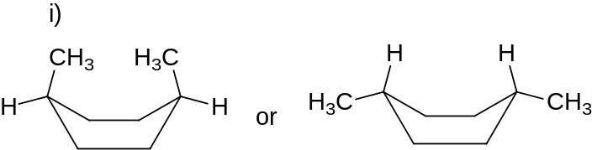
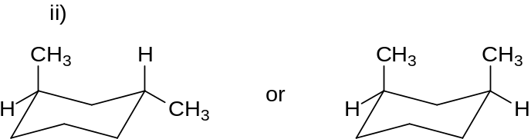
iii) cis-1,4-dimethylcyclohexane or trans-1,4-dimethylcyclohexane

4. Explain each of the following terms in your own words. Give an example and draw a diagram (if appropriate) for each.
- Angle strain
- Equatorial position
- Comparative heat of combustion
- Torsional strain
  - Draw a 3-D representation using the zigzag dashed-wedged line representation of (2R, 3R, 4S)-2,3-dibromo-4-chloropentane.

  - Which of the following are chiral molecules? Place an asterisk next to any stereogenic carbon atoms.
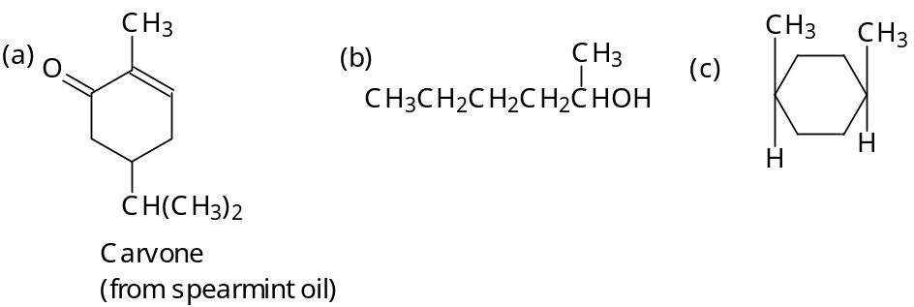
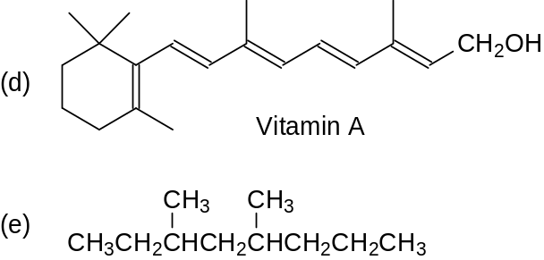

  - Designate the following structures as either (R) or (S).
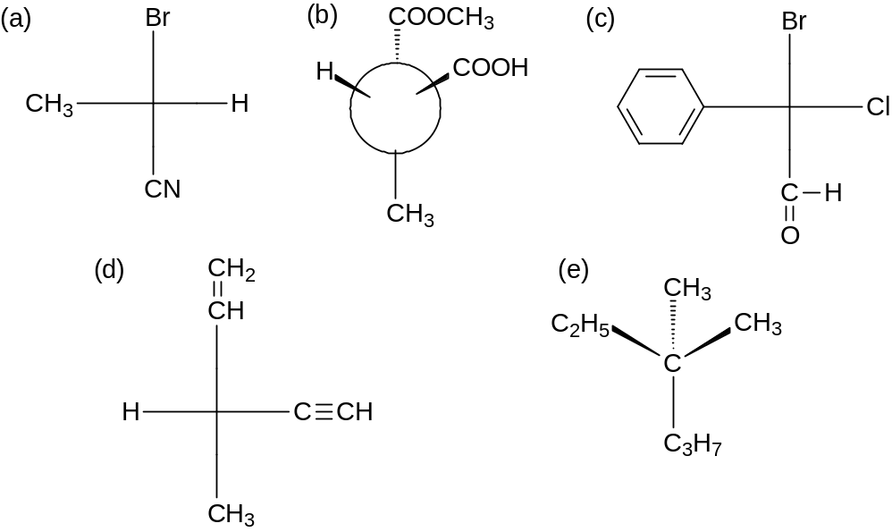

  - Give the IUPAC name for each of the following:
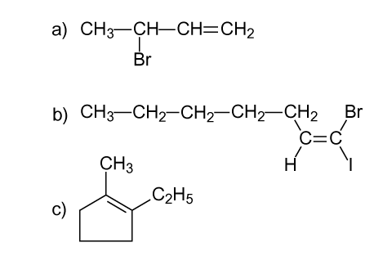

  - Write the structural formula for:
- cis-2-octene
- (2Z, 5E)-heptadiene
- 1,2,3,3-tetrachlorocyclohexene
  - For which of the following compounds is cis-trans isomerism possible? Draw the cis and trans isomers of those compounds and label them using the
(E)-(Z) system, if appropriate.
- cyclopentane
- 1-bromocyclopentane
- 1,1-dibromocyclopentane
- 1,2-dibromocyclopentane
- 1,2-dibromocyclopentene
- 1,2-dibromopentene
- 2,3-dibromopentene

- A 0.300 g/mL solution of morphine was observed to rotate polarized light
–40.0° in a cell of path length 10.0 cm.
- Calculate the specific rotation of morphine.
- Is this enantiomer of morphine dextrorotatory or levorotatory?
- Is this enantiomer of morphine (R) or (S)?

- a. Draw Fischer projection formulas for:
- (R)-2-chlorobutane
- (2S, 3R)-2-bromo-2-iodo-3-methylpentane
b. Convert the following three-dimensional formulas to Fischer projection formulas and designate them as (R) or (S). Use your model kit to help you whenever necessary.
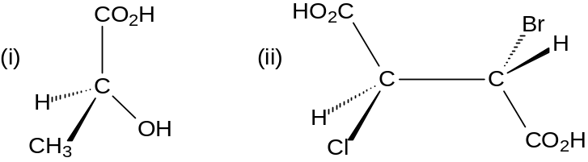
c. Which of the following Fischer projections represent:
- Enantiomers
- Diastereomers
- A meso form
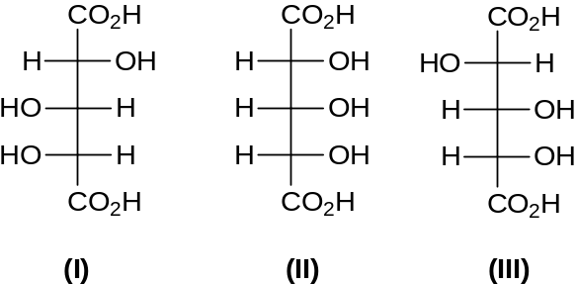

- The four-carbon sugar threose has the formula CH₂(OH)CH(OH)CH(OH)CHO and has the configuration (2S, 3R).
If the aldehyde group (CHO) of threose were oxidized to an acid group (COOH), would the resulting compound still have optical activity?

