- Below is a list of four pairs of reactions. For each pair, which reaction would you expect to occur more rapidly via an S_{N}2 mechanism?
or

or

or

or

- Arrange the following carbocations in order of increasing stability.
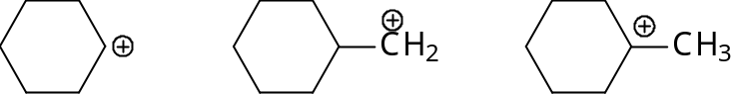

- Give the products of the following S_{N}2 reactions. In each case, identify the leaving group.
- 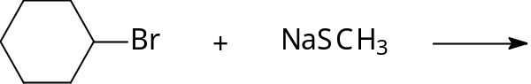

- 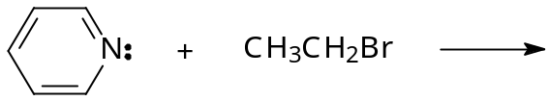

- 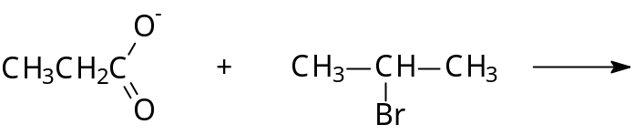

- 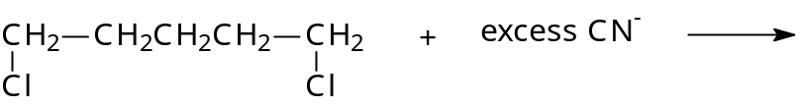

- a. Which of the following are protic solvents?
    - acetic acid (CH₃COOH)
    - water
    - dimethyl sulphoxide (CH₃SOCH₃)
    - chloroform (CHCl₃)
    - liquid ammonia

- Identify the stronger nucleophile in each of the following pairs of reagents:
  - F– or Br– (in a protic solvent)
  - F– or Br– (in an aprotic solvent)
  - OH– or H₂O
  - H₂O or H₂S

- Complete the following reactions by giving the major substitution product(s).

- 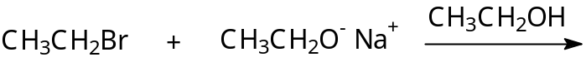

- 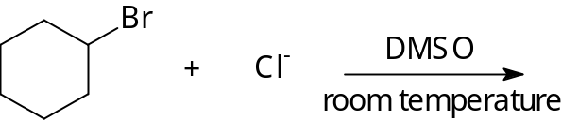

- 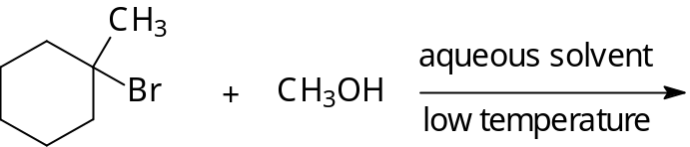

- The following reactions are steps in the free radical bromination of propane. State whether each is a chain-initiating, chain-propagating, or chain-terminating step.

- 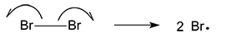

- a. Only one possible monochlorination product is obtained from an alkane with the molecular formula C₅H₁₂. What is the structure of this alkane?
- What would be the relative percentage of the monobromination products of propane if all its H atoms were equally reactive? What are the actual values more likely to be? Why?

- Draw the structure and name the product or products of the following reactions of (R)-2-iodobutane:
- S_{N}1 replacement of the iodine atom by OH–
- S_{N}2 replacement of the iodine atom by OH–
- Free radical chlorination (abstraction of H from carbon 2)

- When isopropyl alcohol is heated with H₂SO₄, some diisopropyl ether is obtained:
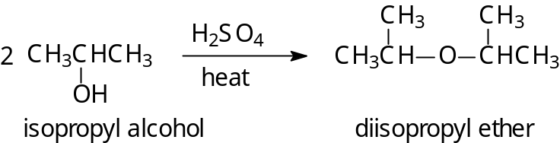
- Draw out the mechanism for this reaction as though it were:
  - An S_{N}1 reaction
  - An S_{N}2 reaction
- Why will this reaction not occur if H₂SO₄ is absent?

