GXLD – GSI Extra Large Device

Description:

GXLD is a library which performs a KNN with L1 metric between records and queries.
The program gxld, run a test on the device, checks for radiation errors on the card and vaildate the output.
If an error is detected, the program alerts the user and repair it (by reloading the defected data from L4).
If the output is invalid, the program alerts the user.

Usage:

Extract with:
tar xvf gxld.tar

The extraction will open a folder named gxld.
Move to gxld folder and run.

Run with:
./run <NUMBER_OF_QUERIES>
@NUMBER_OF_QUERIES – number between 1 and 2250000.
In order to run gxld, the following command need to be executed:
REF_INCREMENT=<REF_STRIDE> ./gxld_run -t=4 -f=192 -q=<NUM_OF_QUERIES> -r=32768 -b=256 -k=64 -g=32
NUM_OF_QUERIES / REF_STRIDE should be around 1000 in order for the reference running time to be fast.
The script named run, will execute this command.

Timings:

Number of queries | Time in seconds
1000000 | 12.5
2000000 | 25

Screenshots:
Image of radiation error detected on the card:

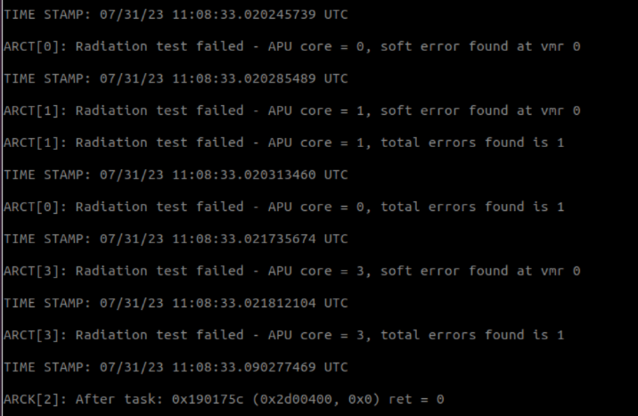

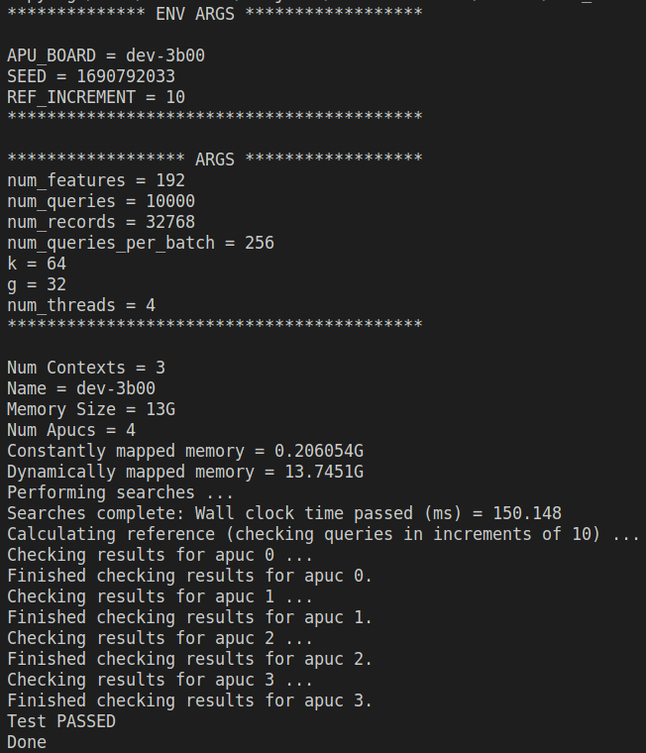
Output example:

