The University of Vermont

College of Engineering and Mathematical Sciences

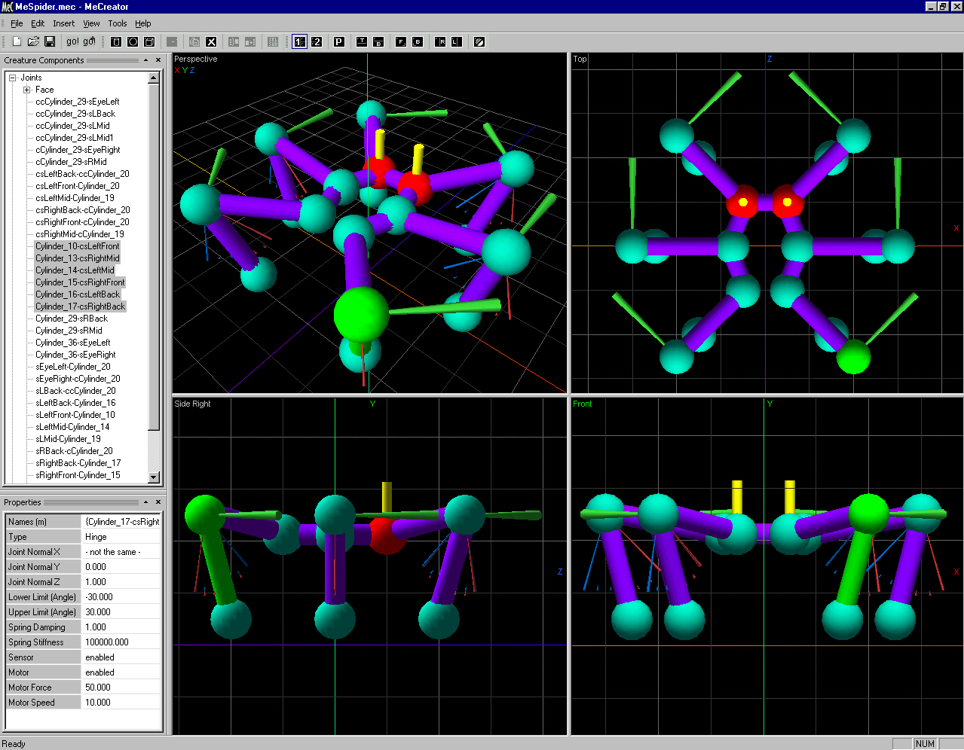

Department of Computer Science
Students learn about and build robots in simulation. Students can then use existing robot construction kits--such as Lego Mindstorms-- to build their creations. Once built, they can start to investigate questions from Artificial Intelligence, such as how could you build a robot that would become self-aware?

The Department of Computer Science emphasizes long-term academic preparation and short-term economic importance, providing research and graduate education through focused research areas and collaborations with other strong research areas in the University. Our curriculum provides a broad basic training in Computer Science with required courses in the theory of computing, computer organization, and software techniques.
At the undergraduate level, we offer three programs leading to Bachelor's degrees:
- Bachelor of Science in Computer Science - our most technical program in computer science complemented with physical sciences and mathematics;
- Bachelor of Science, Major in Computer Science and Information Systems - an interdisciplinary major combining computer science and business administration;
- Bachelor of Arts, Major in Computer Science, in the College of Arts and Sciences - a flexible program providing computer science in the context of a liberal arts degree, allowing a wide range of double majors and minors.
At the graduate level, we offer three programs through the Graduate College: two leading to a Master of Science (MS) degree and an interdisciplinary PhD program.
- The Master's Program is a traditional two-year degree program, which offers both a thesis, and a non-thesis option.
- The Accelerated Master's Program (AMP) enables exceptionally motivated students to complete both a Bachelor's and Master's degree in Computer Science within a five year period.

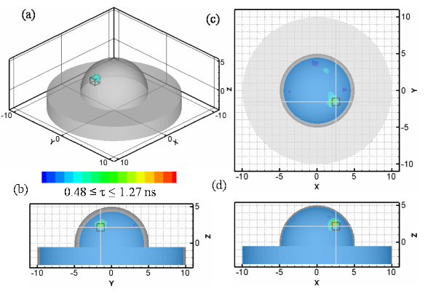
- The interdisciplinary PhD program in Computer Science offers study in both traditional and cross-disciplinary areas such as bioinformatics and ecological modeling, and includes graduate assistantships specifically designated for students involved in interdisciplinary areas.

Algorithms have been developed for detecting receptors on the surface of cancer cells that have been tagged with fluorescent dyes can help in cancer detection and in understanding cancer biology.

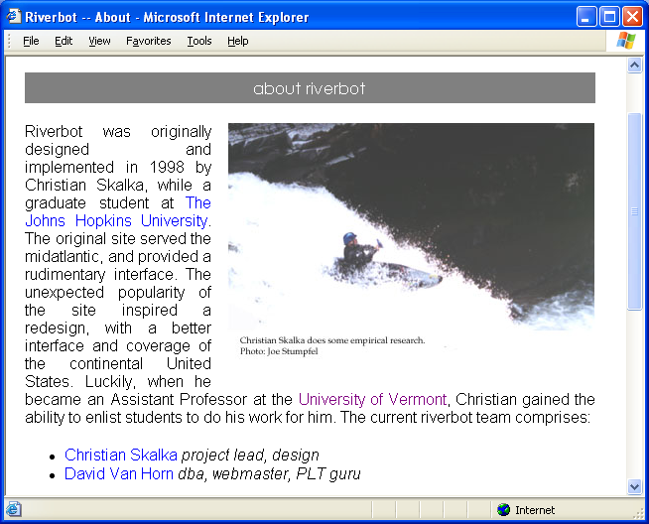

A website designed by a CS undergraduate
for retrieving real-time whitewater river level gage information, so that whitewater kayakers and canoeists can find out what's running before they head out. The website uses advanced programming language and web server technologies to access USGS (US Geological Survey) river gage databases, that are connected to physical gages via satellite and are continuously updated.

Faculty in Computer Science are involved in the forefront of research in three thrust areas: computational biology, data mining, and distributed systems. Our interdisciplinary work cuts across all areas of campus, with current emphasis in bioinformatics and ecological modeling. Faculty publish in prestigious journals and conferences in Computer Science, have significant research grants from federal agencies (such as NSF, NIH, DOD, and DOE), and serve on journal editorial boards, conference committees, NSF/NIH/DOE review panels, and leading professional societies, and have won international society awards.
Computer Science students (both undergraduate and graduate) are invited to join the Computer Science Student Association (CSSA). The CSSA organizes its own seminars, public service activities, receptions and picnics for new students, and frequently articulates the student point-of-view for departmental issues. Socially, it serves the Department by providing a sense of community for our students, and allows for students from different years to become acquainted with each other.
-
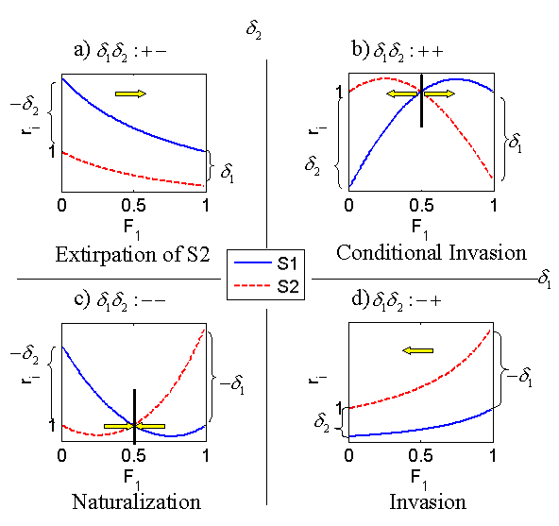

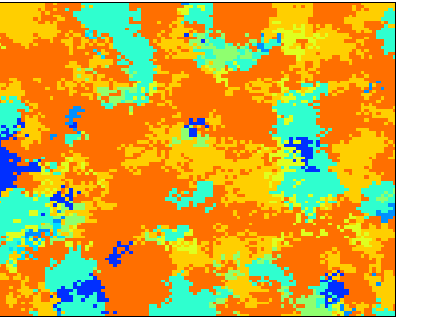

Spatio-temporal computer models help us to understand how the ecosystem works.

New theory helps us predict which species are likely to become invasive, and therefore enables us to more efficiently and effectively craft strategies to help maintain biodiversity

.

