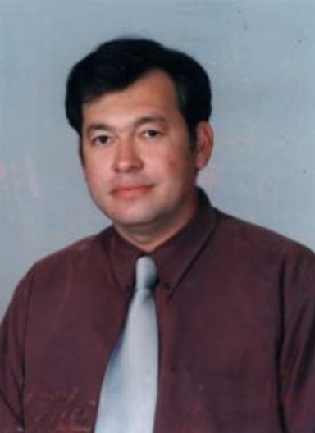

Abdullah N. Arslan

Assistant Professor of Computer Science

Education
Ph.D. Computer Science, University of California, 2002
M.S. Computer Science, University of North Texas, 1996
B.S. Computer Engineering, METU, Turkey, 1990

Research
Algorithms on Strings, Computational Biology

Courses

Analysis of Algorithms

Theory of Computation
Operating Systems

Arslan grew up in a small city in Turkey. He was in love in school first with math and then with physics courses. For him, listening to the lectures in these courses was no different than seeing Jurassic Park 1 the first time, which he enjoyed a lot (Maybe part of the reason is that there was no Jurassic Park-type movie then). However he dreamt about becoming a professional soccer player until he became a student in a prestigious university in Turkey. Then his life started to become more of a dining philosopher than a sportsman.

He started working for industry when he was a junior in the university. He and one of his classmates developed an authoring tool for a company.

After his graduation he worked for the Turkish central bank where he participated in development and maintenance of several in-house software projects.

After spending more than three years in the bank he made up his mind on pursuing a career in academia. He became a student again.

He had always been interested in problem solving before, therefore it was very natural that analysis of algorithms, and theory of computation became his focus of interest during his graduate study. He was fascinated with the problems that arise in computational biology. He developed algorithms for normalized local sequence alignment in his PhD thesis. He recently got his degree, and joined the computer science department.

Dr. Arslan is planning to continue pursuing research in computational biology by tackling problems such as multiple local sequence alignment, and protein folding. He is also interested in the general area of similarity search that has applications in many different fields.

Selected Publications

- (with Omer Egecioglu) Dictionary look-up within small edit distance. Lecture Notes in Computer Science 2387, pp. 127-136, 2002.
- (with Omer Egecioglu and Pavel A. Pevzner) A new approach to sequence alignment. Bioinformatics, Volume 17, Issue 4, pp. 327-337, April 2001.
- (with Omer Egecioglu) An improved upper bound on the size of planar convex-hulls. Lecture Notes in Computer Science 2108, pp. 111-120, 2001.

