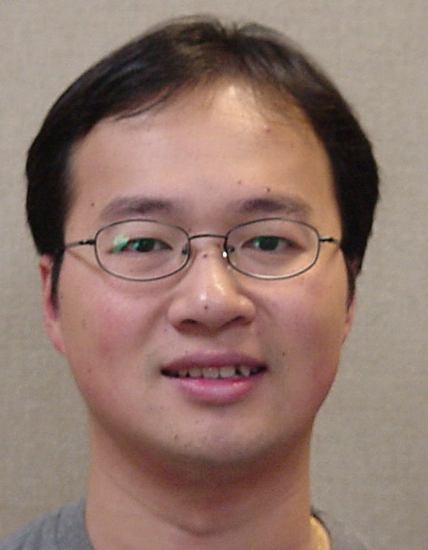
Alan C.H. Ling

Assistant Professor of Computer Science

Education

B.Math., Combinatorics and Optimization, University of Waterloo,1994
M.Math., Combinatorics and Optimization, University of Waterloo, 1995
Ph.D., Combinatorics and Optimization, University of Waterloo, 1997

Research Areas

Combinatorics

Courses

Programming Languages

Network Security
Theory of Computation

Dr. Ling received his Ph.D. from the University of Waterloo when he was 23. Since then, he worked as a postdoctoral fellow at various universities. He was an assistant professor in Michigan Technological University before joining the University of Vermont. Beside various academic experiences, he worked as a credit risk analyst for one year in the Bank of Montreal.
Dr. Ling’s research is on combinatorics and its applications into computer science. In his Ph.D. thesis, he pioneered a connection of a combinatorial object called, Steiner triple systems, with erasure codes that are used for redundant inexpensive disk arrays. By drawing the newfound connection, Chee, Colbourn and Ling managed to extend the existing results in the subject. Furthermore, Dr. Ling is currently a Principal Investigator of a research grant from Army Research Office on disk arrays.
Another application of his work is found in bioinformatics. Dr. Ling has used a combinatorial object called balanced binary codes to construct the manufacturing probes for DNA microarray. DNA microarry is a new technology that builds various different DNA sequences into a DNA chip, it allows a test of blood sample to be done at a fraction of the old cost and in a very time efficient manner. Dr. Ling’s work allows the manufacturer to detect if the microarrays function correctly.
Recently, Dr. Ling is focused on software testing using a combinatorial object known as covering arrays.
Dr. Ling’s research is being recognized by the Institute of Combinatorics and Applications for awarding him a Kirkman medal for his excellent research records in his early career.
Dr. Ling grew up in Toronto. It was his dream to be a professor since he was in high school. He is very pleased to be an Assistant Professor at the University of Vermont.
Beside research, Dr. Ling is known to be a motivated teacher. He routinely helps out students whenever they need. He always replies to students’ emails promptly, even at 11:00pm on Saturday night.
Dr. Ling is always working in his office seven days a week and twelve hours a day in order to obtain the next research results, as well as preparing the next classes.

Awards

- Kirkman Medal (2002), Institute of Combinatorics and Applications.

Selected Publications:

- Y.M. Chee, C.J. Colbourn, A.C.H. Ling, Asymptotically optimal erasure-resilient codes for large disk arrays, Discrete Applied Mathematics 102 (2000), 3-36.
- C.J. Colbourn, A.C.H. Ling and M. Tompa,, Construction of optimal quality control for Oligo arrays, Bioinformatics, 18 (2002), 529-535.
- A.C.H. Ling, Difference triangle sets from affine planes, IEEE Transactions on Information Theory, (to appear).
- A.C.H. Ling, C.J. Colbourn, M.J. Grannell and T.S. Griggs, Construction techniques for anti-Pasch Steiner triple systems, Journal of London Mathematics Society 61 (2000), 641-657.

Current Research Grants:

- Alan C.H. Ling, Combinatorial Constructions for Oligo Arrays, (DOE EPSCoR Computational Biology Pilot Award), July 1, 2001 - June 30, 2003.
- Alan C.H. Ling (PI), Reliability and Performance of Large Scale Disk Arrays, U.S. Army Research Office, Grant No. DAAD19-02-1-0178. April 1, 2001 - March 31, 2004.

