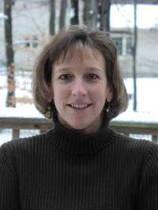
Jackie Redmond
Lecturer, Computer Science

Education
B.S. Electrical Engineering, University of Vermont, 1987
M.S. Computer Science, University of Vermont, 1995

Courses
Computer Programming I
Computer Programming II
Object-oriented Programming
Java for Novices

Jackie first arrived on the UVM campus in the fall of 1987 as an undergraduate Electrical Engineering major. Upon successful completion of that degree, she accepted a position in Quality and Reliability Engineering at Digital Equipment Corporation. In six years at DEC, she held positions including Quality engineer and Sales Support Engineer.

In 1993, Jackie's desire to pursue the software side of computing brought her back to UVM. She accepted a graduate teaching fellowship from the Department of Computer Science commencing in the fall of 1993. During the two years of study, she provided teaching assistant support for the introductory programming sequence. Her research activities, under the direction of Dr. Sanjoy Baruah focused on scheduling algorithms. Her research concluded with a thesis entitled "Preemptive On-line Scheduling in Overloaded Real-time Systems".

Upon completing her M.S. degree, Jackie returned to industry. A position in IBM Microelectronics Division was her next venture. Working in microprocessor verification provided the perfect opportunity to combine her engineering and computer science knowledge. Over the next three years, she provided verification support for IBM's Blue Lightning Processor and became leader of the verification team.

In 1998 Jackie decided to pursue a life-long dream of teaching. She was offered a lecturer position in UVM's Computer Science Department. Now, in her fifth year in the position, Jackie has taught Programming I, Programming II and Object-Oriented Programming. In the spring, she will be offering a new Java course targeted at non-programmers. In addition to teaching, her service activities include advising and Open House and Outreach activities.

