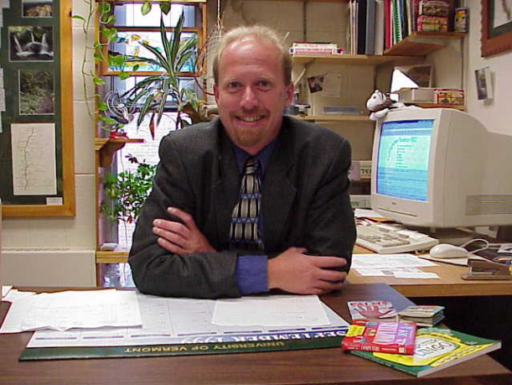
Robert Erickson
Lecturer, Computer Science
Education
M.S. Information Systems, Clarkson University, 1991
B.S. Computer Information Systems, Castleton State College, 1987
Research Areas:
Graphical User Interfaces, Menu Design
Courses
Applications Software
Information Technology and Management
Introduction to Visual Basic Programming
Introduction to World Wide Web Design
TAP for Computer Science
World Wide Web Design (Advanced)

I grew up in the NJ Pine Barrens where I developed a love for the outdoors. After high school I followed my folks up to the mountains of Vermont where I have stayed ever since. My all time favorite activity is back country skiing where ever the wind takes me. If I am not skiing I will be snow-shoeing or snowmobiling.
When the weather warms I look forward to gardening and hiking away in the Green Mountains. In 1993 I hiked the Long Trail from end to end, one of my most memorable journeys. I also enjoy kayaking on the lake and work part time as a canoe guide teaching guests about the amazing beavers that frequent our lakes, ponds and rivers. I am a member of the chaplain kayak club and the green mountain hiking club serving on various boards and committees over the years.
I am an active mentor in the Community Friends Program working with area children providing guidance, support and really just a good friend to area children.
After spending seven years working for several companies in a wide range of positions the company I worked for closed its doors. I took this opportunity to pursue a masters degree so that I could get involved in teaching, what I really enjoy is helping others to learn. After graduating in 1991 I have been teaching every since and loving every minute of it! I have been nominated twice for the Kroepsch-Maurice Instructional Award since teaching at UVM and hope someday to receive the award.

