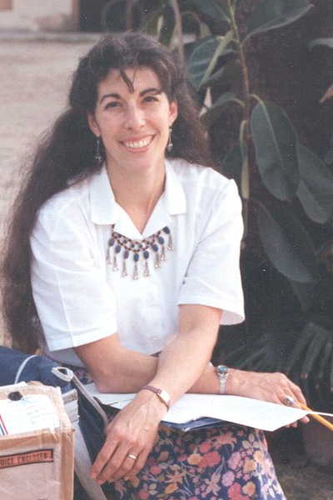
Alison Pechenick
Lecturer, Computer Science

Education
B.S. Engineering, Princeton University 1978
M.S. Computer Science, University of Vermont 2003

Courses
Computer Programming I
Computer Organization
Visual Basic
Software for Embedded Systems

Alison has interwoven careers in technology and technology education since her undergraduate days. Her experience includes systems analyst for the Hydra-matic division of General Motors and industrial engineer for IBM, technical trainer and network engineer for a technology consultation firm, and computer analyst for University of Vermont’s Computing and Information Technology. In addition, she has taught physics, mathematics, and computer science, in locations that include Taiwan, Pakistan and Sweden.

Alison’s professional interests are focused on the hardware-software interface of digital design. She has taken several relevant courses at the graduate level in electrical engineering, and is an active member of the local IEEE chapter.

Among other courses, Alison teaches the computer organization course, required of all undergraduates and graduate students in computer science. She strives to make computer science concepts valuable to electrical and computer engineers, as well as exposing computer science students to the concepts and trends in computer engineering. Given the ever-expanding area of embedded processor design, Alison hopes to generate an appreciation of the overlapping skills the computer scientists and engineers will share in designing the systems of the future.

She is developing a new course for this spring, exploring the concepts required for the design of software for embedded systems, which will serve both the computer science and electrical & computer engineering communities.

In addition to her academics, Alison is a student advisor to computer science majors, minors, and software certificate participants, departmental liaison to Continuing Education, and College representative to the Curricular Affairs Committee of the Faculty Senate. She actively participates in Open Houses and high school outreach programs, including the Rube Goldberg competition, Design TASC, EPSCOR Career Day, and Governor’s Institute (“Robot Wars”).

Alison lives in town, enjoys the many pleasures of life in Vermont, and has two sons at the University.

