Chaoyang (Joe) Zhang
Research Assistant Professor of Computer Science

Education

Ph.D. in Computational Analysis and Modeling, Louisiana Tech University, 2001
M.S. in Computer Science, Louisiana Tech University, 2001
M.S. in Computational Mechanics, Wuhan University, 1992
B.S. in Applied Mathematics, Wuhan University, 1989
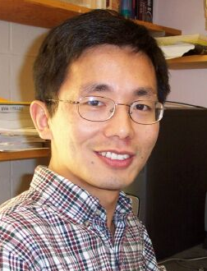

Research Areas
3D Image Reconstruction, Parallel/Distributed Computing,
Computational Biology, Inverse Problems, Microfabrication

Courses
Developing Web Application in Java, Information Retrieval

Dr. Zhang joined the Department of Computer Science at UVM as a research assistant professor in 2001. His current research focuses on inverse problems and high performance computing, and their applications in computational biology and 3D image reconstruction. He enjoys the challenging interdisciplinary research problems that arise in computational imaging.

Dr. Zhang received his Ph.D. at Louisiana Tech University in 2001. During his doctorial study he built an inverse model for optimizing the process of fabricating microstructures. He developed a novel component-based distributed computing algorithm and implemented the solution.

In addition to his research, Joe has been involved in teaching since Fall 2002. His teaching motivation comes from a strong desire to activate students’ interests and guide them to analyze and solve real problems using fundamental concepts and skills. He strives to explain the material in many different ways and provide additional examples and illustrations coming from the real world. He makes himself readily available to students outside class in order to provide extra help.

Although he often works weekends, Joe loves to enjoy life in Vermont with his wife, a Ph.D. candidate, and his seven-year-old son who studies the piano. Joe likes playing ping pong and doing calligraphy.

Recent Publications:

- R. Nassar, C. Zhang, W. Dai, H. Lan and J. Maxwell, Mathematical Modeling of Three-Dimensional Laser Chemical Vapor Deposition, Microelectronic Engineering, vol. 60, pp. 395-408, 2002.

- Ben Choi and Chaoyang Zhang, Component-Based Distributed Computing for Numerical Simulation, International Conference on Parallel and Distributed Processing Techniques and Applications, 2002.

