Margaret J. Eppstein  Assistant Professor of Computer Science  Co-Director, Complex Systems Center  Education  B.S., Zoology, Michigan State University, 1978  M.S., Computer Science, UVM, 1983  Ph.D., Civil & Environmental Engineering, UVM, 1997  Research Areas  Forward and Inverse Modeling and Analysis of Complex Systems in Biological and Environmental Domains  Courses  Parallel Computing  Evolutionary Computation  Modeling Complex Systems | 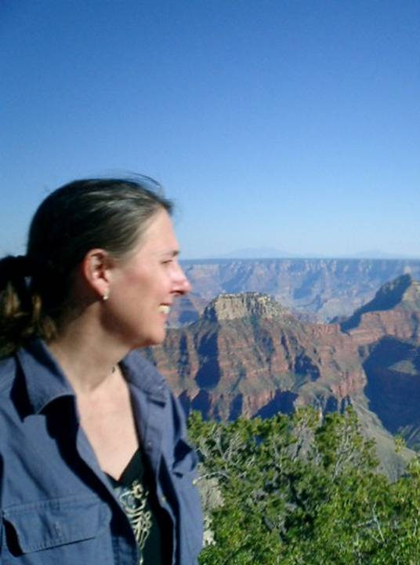

Dr. Eppstein first joined the Computer Science Department at UVM as a lecturer in 1983, and after earning her Ph.D. became a research assistant professor in 1997, a tenure-track assistant professor since 2002, and since 2006 she has been a founding co-Director of the Complex Systems Center. She has published extensively on her work regarding high-dimensionality, nonlinear, multi-scale, tomographic inverse image reconstruction problems in subsurface hydrology, geophysics, and deep-tissue near-infrared fluorescence imaging. Current projects include developing, studying, and using novel evolutionary and agent-based computational approaches for a wide range of important problems, including plant species’ invasiveness in ecological communities, biological speciation, the impact of spatial topologies on information flow through complex interaction networks, identifying nonlinear interactions between single nucleotide polymorphisms that predispose for complex disease traits, and agent-based integrated assessment modeling of transportation energy alternatives.
Dr. Eppstein has been awarded $1,537,705 in research grants and contracts, has published 53 research papers and holds a patent on a new method for Bayesian computed tomography. She has been the recipient of numerous honors and awards, including a National Science Foundation doctoral fellowship, an American Association of University Women Career Development Award, and 3 best-paper awards.

Selected Publications:

- Eppstein, M.J., Hawrysz, D.J., Godavarty, A., and Sevick-Muraca, E.M., "Three-dimensional, Bayesian image reconstruction from sparse and noisy data sets: Near-infrared fluorescence tomography", Proc. Natl. Acad. Sci. USA, 99(15): 9619-9624, 2002.
- Eppstein, M.J. and Molofsky, J. "Invasiveness in plant communities with feedbacks". Ecology Letters, 10:253-263, 2007.
- Eppstein, M.J., Payne, J.L., White, B.C., and Moore. J.H. "Genomic mining for complex disease traits with 'Random Chemistry'", Genetic Programming and Evolvable Machines, in press, 2007.

Current Grants:
- P.I. for “Regulatory Control Prediction for Transportation Alternative Energy Usage via a Multiscale Agent-Based Model”, University of Vermont Transportation Center, $330,000 direct, 7/1/2008-6/30/2010.
- Core faculty and significant author on “Complex Systems Thinking and Modeling for Ecosystem Analysis”, National Science Foundation EPSCoR RII, $6,692,531 8/15/07-6/30/10.

