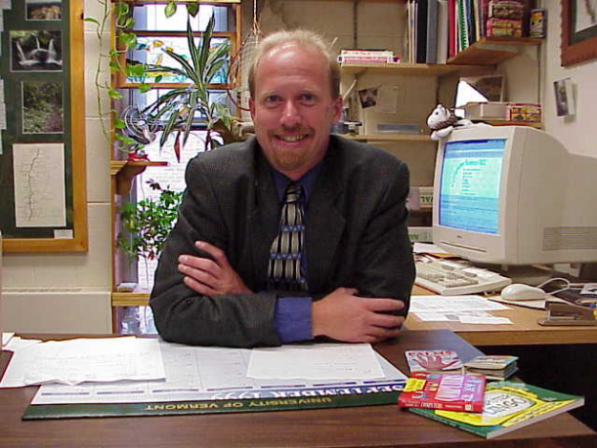
Robert Erickson
Senior Lecturer, Computer Science
Education
M.S. Information Systems, Clarkson University, 1991
B.S. Computer Information Systems, Castleton State College, 1987
Research Areas:
Graphical User Interfaces, Menu Design
Courses
CSS for World Wide Web Design
Digital Revolution
Dynamic Data
Introduction to Visual Basic Programming
Introduction to World Wide Web Design
MS Office: Beyond the Basics
Relational Databases for Web Applications

I grew up in the NJ Pine Barrens where I developed a love for the outdoors. After high school I followed my folks up to the mountains of Vermont where I have stayed ever since. My all time favorite activity is back country skiing where ever the wind takes me. If I am not skiing I will be snow-shoeing or snowmobiling.
When the weather warms I look forward to gardening and hiking away in the Green Mountains. In 1993 I hiked the Long Trail from end to end, one of my most memorable journeys. I also enjoy kayaking on the lake and work part time as a canoe guide teaching guests about the amazing beavers that frequent our lakes, ponds and rivers. I am a member of the chaplain kayak club and the green mountain hiking club serving on various boards and committees over the years.
I am an active mentor in the Community Friends Program working with area children providing guidance, support and really just a good friend to area children.
After spending seven years working for several companies in a wide range of positions the company I worked for closed its doors. I took this opportunity to pursue a masters degree so that I could get involved in teaching, what I really enjoy is helping others to learn. After graduating in 1991 I have been teaching every since and loving every minute of it! I have been nominated five times for the Kroepsch-Maurice Instructional Award since teaching at UVM and received the award in 2007.

