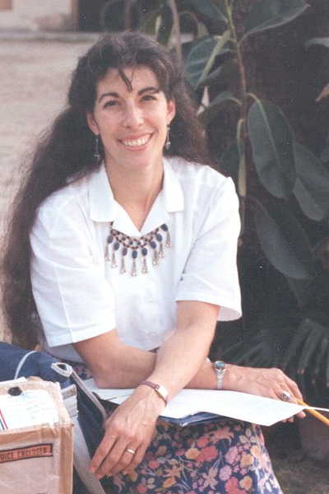
Alison Pechenick
Senior Lecturer, Computer Science

Education
B.S. Engineering, Princeton University 1978
M.S. Computer Science, University of Vermont 2003
Ph.D. student, Computational Modeling/Env’l Eng’g

Courses
Programming in MATLAB for Engineers & Scientists
Computer Organization: HW/SW Interface
Visual Basic Programming
Senior Seminar: Ethical Considerations in Technology

Alison has long interwoven careers in technology and technology education. Her experience includes systems analyst for the Hydra-matic division of General Motors and industrial engineer for IBM, technical trainer and network engineer for a technology consulting firm, and technical support staffer for University of Vermont’s CIT. In addition, she has taught physics, mathematics, and computer science in Taiwan, Pakistan and Sweden.

Alison’s professional interests include ethics and service, the computational aspects of modeling engineering problems, and digital design (hardware-software interface). She has taken several relevant electrical engineering courses at the graduate level and has been an active member of the local IEEE chapter. At present, she is working towards her Ph.D. in environmental engineering, with a focus on computational modeling.

Alison teaches computer organization, required of all CS students, and an elective for engineers. She strives to make these concepts valuable to the engineers, as well as exposing CS students to digital design concepts and trends. Given the relevance of embedded processor design, Alison seeks to engender an appreciation of the overlapping skills these computer scientists and engineers will share in designing the systems of the future.

She also works with a wide spectrum of students not majoring in computer science/engineering, engaging students from non-technical majors in the popular Visual Basic Programming course, and teaching civil, environmental, and mechanical engineers to appreciate the value of computer science considerations while producing professional analyses in the MATLAB language. With the CS seniors, she explores the ethical questions posed by an increasingly-technical society, and provides a range of service opportunities for their participation.

Alison advises majors, minors, and software certificate participants, is liaison to Continuing Education, and co-advisor to the UVM chapter of Engineers Without Borders. She just completed five years as CEMS representative to the Curricular Affairs Committee of the Senate, coordinating Academic Program Review for UVM. She actively participates in Open Houses and high school outreach programs.

Alison lives in town, appreciates the many attributes of life in Vermont, and is proud to have two sons bearing UVM degrees.

