Jackie Redmond
Senior Lecturer, Computer Science

Education
B.S. Electrical Engineering, University of Vermont, 1987
M.S. Computer Science, University of Vermont, 1995

Courses
Computer Programming I
Computer Programming II
Object-oriented Programming
Introduction to Programming
Visual Basic Programming

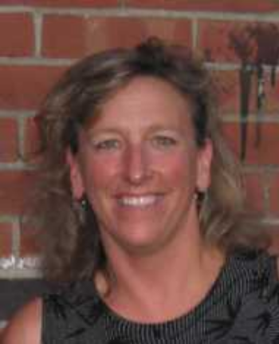

Jackie first arrived on the UVM campus in the fall of 1987 as an undergraduate Electrical Engineering major. Upon successful completion of that degree, she accepted a position in Quality and Reliability Engineering at Digital Equipment Corporation. In six years at DEC, she held positions including Quality Engineer and Sales Support Engineer.

In 1993, Jackie's desire to pursue the software side of computing brought her back to UVM. She accepted a graduate teaching fellowship from the Department of Computer Science commencing in the fall of 1993. During the two years of study, she provided teaching assistant support for the introductory programming sequence. Her research activities, under the direction of Dr. Sanjoy Baruah focused on scheduling algorithms. Her research concluded with a thesis entitled "Preemptive On-line Scheduling in Overloaded Real-time Systems".
Upon completing her M.S. degree, Jackie returned to industry. A position in IBM

Microelectronics Division was her next venture. Working in microprocessor verification provided the perfect opportunity to combine her engineering and computer science knowledge. Over the next three years, she provided verification support for IBM's Blue Lightning Processor and became leader of the verification team.

In 1998 Jackie decided to pursue a life-long dream of teaching. She was offered a lecturer position in UVM's Computer Science Department. In 2004, she was promoted to Senior Lecturer. Now, in her tenth year in teaching, Jackie teaches primarily courses in the introductory programming sequence. In 2003, she developed a new course, Introduction to Programming, targeted at novice programmers and in the spring of 2008, she will be offering a new “Hands-On Robotics” course. In addition to teaching, her service activities include advising and Open House and Outreach activities, with a special interest in the issue of Women in Computing.

