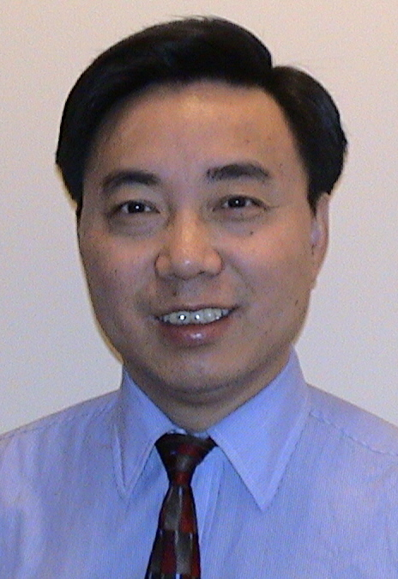
Xindong Wu
Professor and Department Chair, Computer Science

Education
BEng, Computer Science, Hefei University of Technology, 1984
MEng, Computer Science, Hefei University of Technology, 1987
PhD, Artificial Intelligence, Edinburgh University, 1993

Research Areas
Data Mining, Knowledge-Based Systems, Web Information Exploration

Courses
Data Mining, Developing Web Applications in Java, Artificial Intelligence

Dr. Wu comes originally from China. He received his PhD from Edinburgh University in Scotland. Before joining the University of Vermont, he was an Associate Professor in the Department of Mathematical and Computer Sciences at the Colorado School of Mines from August 1998 to August 2001, a Senior Lecturer in the School of Computer Science and Software Engineering at Monash University, Australia, from December 1994 to July 1998, and a Lecturer in the Department of Computer Science at James Cook University, Australia, from July 1993 to November 1994.

He is the Editor-in-Chief of the IEEE Transactions on Knowledge and Data Engineering (TKDE, by the IEEE Computer Society), the founder and current Steering Committee Chair of the IEEE International Conference on Data Mining (ICDM), the founder and a current Honorary Editor-in-Chief of Knowledge and Information Systems (KAIS, by Springer), the Founding Chair (2002-2006) of the IEEE Computer Society Technical Committee on Intelligent Informatics (TCII), and a Series Editor of the Springer Book Series on Advanced Information and Knowledge Processing (AI&KP). He was Program Committee Chair for ICDM '03 (the 2003 IEEE International Conference on Data Mining) and Program Committee Co-Chair for KDD-07 (the 13th ACM SIGKDD International Conference on Knowledge Discovery and Data Mining). He is the 2004 ACM SIGKDD Service Award winner, the 2006 IEEE ICDM Outstanding Service Award winner, and a 2005 Chaired Professor in the Cheung Kong (or Yangtze River) Scholars Programme at the Hefei University of Technology sponsored by the Ministry of Education of China and the Li Ka Shing Foundation. He has been an invited/keynote speaker at numerous international conferences including NSF-NGDM’07, PAKDD-07, IEEE EDOC’06, IEEE ICTAI’04, IEEE/WIC/ACM WI'04/IAT’04, SEKE 2002, and PADD-97.

Since 1987, Dr. Wu has published extensively in the areas of data mining, knowledge-based systems and Web information exploration, including 18 books and conference proceedings and over 160 refereed papers in various journals and conferences.
Selected Publications:
- Y Zhang and X Wu, Noise Modeling with Associative Corruption Rules, Proceedings of the 7th IEEE International Conference on Data Mining (ICDM '07), Omaha, NE, USA, 2007, 733-738.
- Y Yang, X Wu, and X Zhu, Mining in Anticipation for Concept Change: Proactive-Reactive Prediction in Data Streams, Data Mining and Knowledge Discovery, 13(2006), 3: 261-289.
- X Wu, C Zhang, and S Zhang, Database Classification for Multi-Database Mining, Information Systems, 30(2005), 1: 71-88.
- X Wu, C Zhang, and S Zhang, Efficient Mining of Both Positive and Negative Association Rules, ACM Transactions on Information Systems, 22(2004), 3: 381-405.
- X Wu and D Urpani, Induction by Attribute Elimination, IEEE Transactions on Knowledge and Data Engineering, 11(1999), 5: 805-812.
- X Wu, Fuzzy Interpretation of Discretized Intervals, IEEE Transactions on Fuzzy Systems, 7(1999), 6: 753-759.
- X Wu, Knowledge Acquisition from Databases, Ablex Publishing Corp., U.S.A., 1995.
Current Research Funding:
- Xindong Wu (PI), Abdullah Arslan (Co-PI) and Xingquan Zhu (Co-PI), Pattern Matching with Wildcards and Length Constraints, NSF, CCF-0514819. July 15, 2005 - June 30, 2008.

